Training Request form - now available online!
The Training Request form can be found on Webstar at: How Do I >> Get a form >> Internal Forms. Look under “Payroll/OD - Training Application Form”.
The attendee or supervisor must complete the form below and press the Start button to kick off the workflow.
All mandatory fields must be completed.
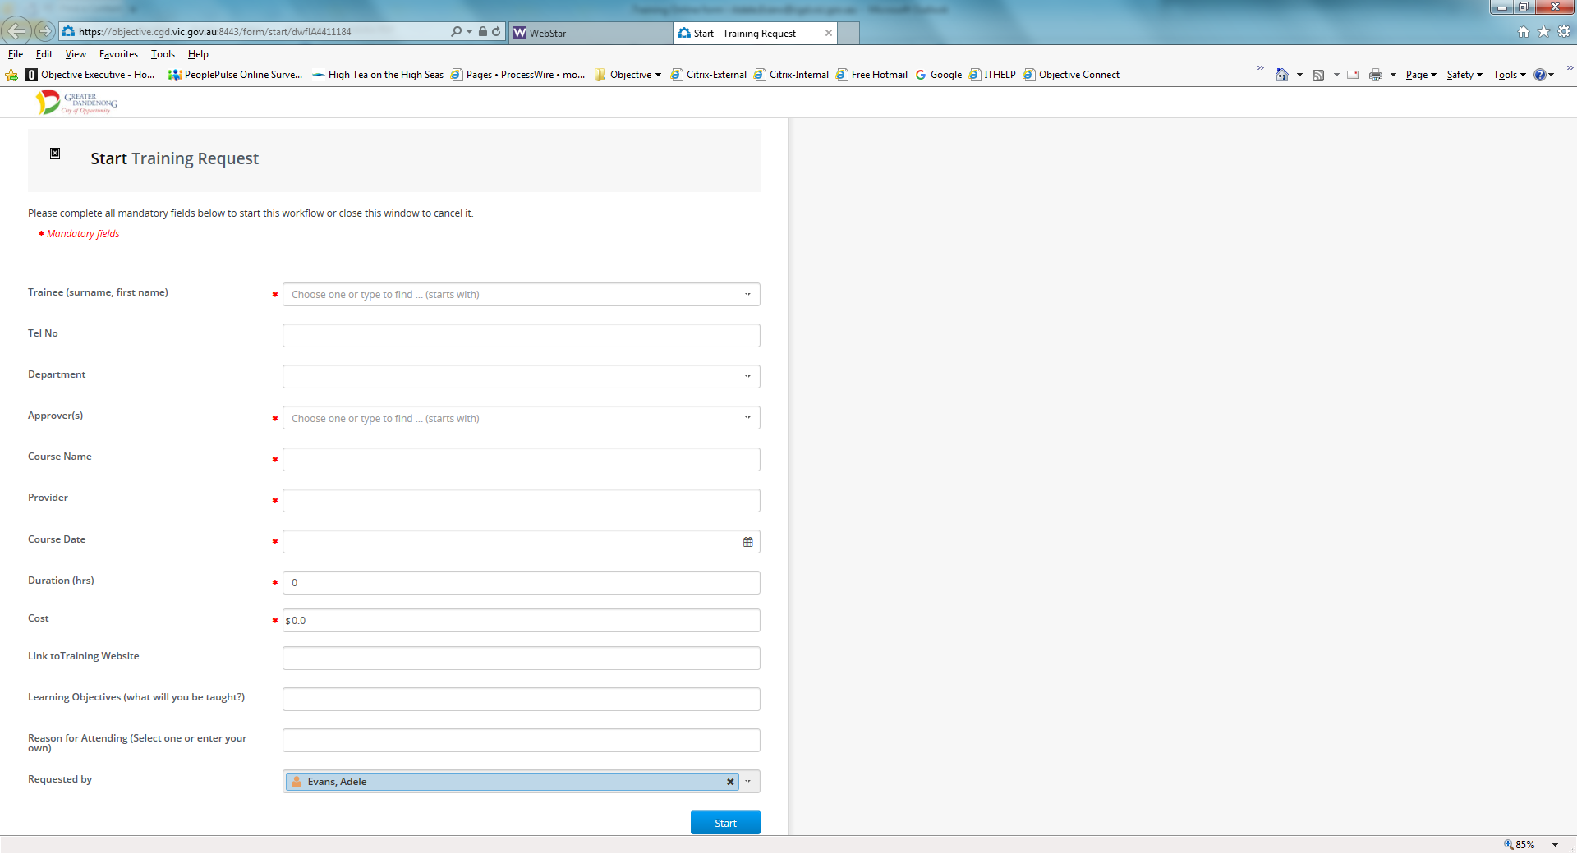
The workflow will be started and the approver will receive an email requesting approval for the training request.

All details of the training request have been completed by the attendee and sent for approval.
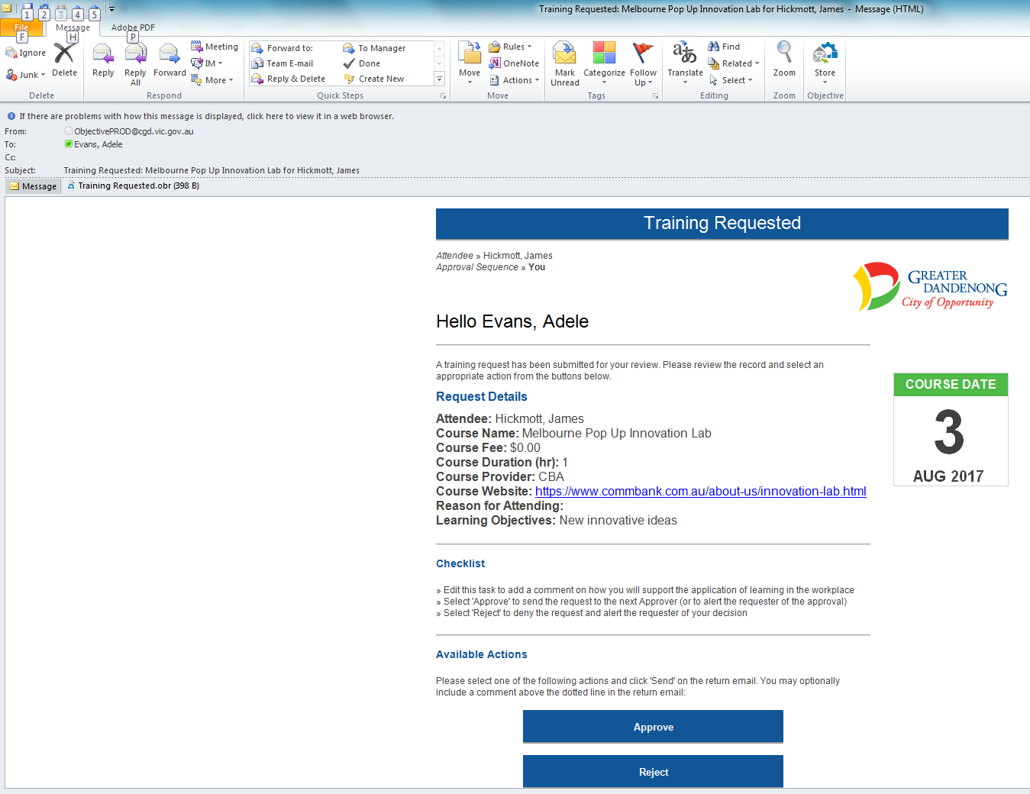
To approve the request, the approver needs to click the Approve button and Send the new email that will be launched by the system allowing for additional comments to be entered by the approver.
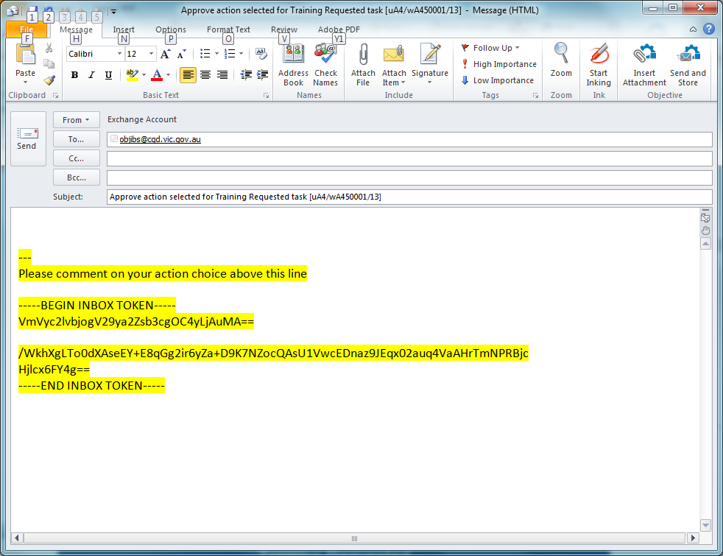
NOTE: Additional comments can be entered but DO NOT delete the text highlighted above.
Both the attendee and the approver will receive an email copy of the training request and a copy will also be automatically filed on the personnel file.
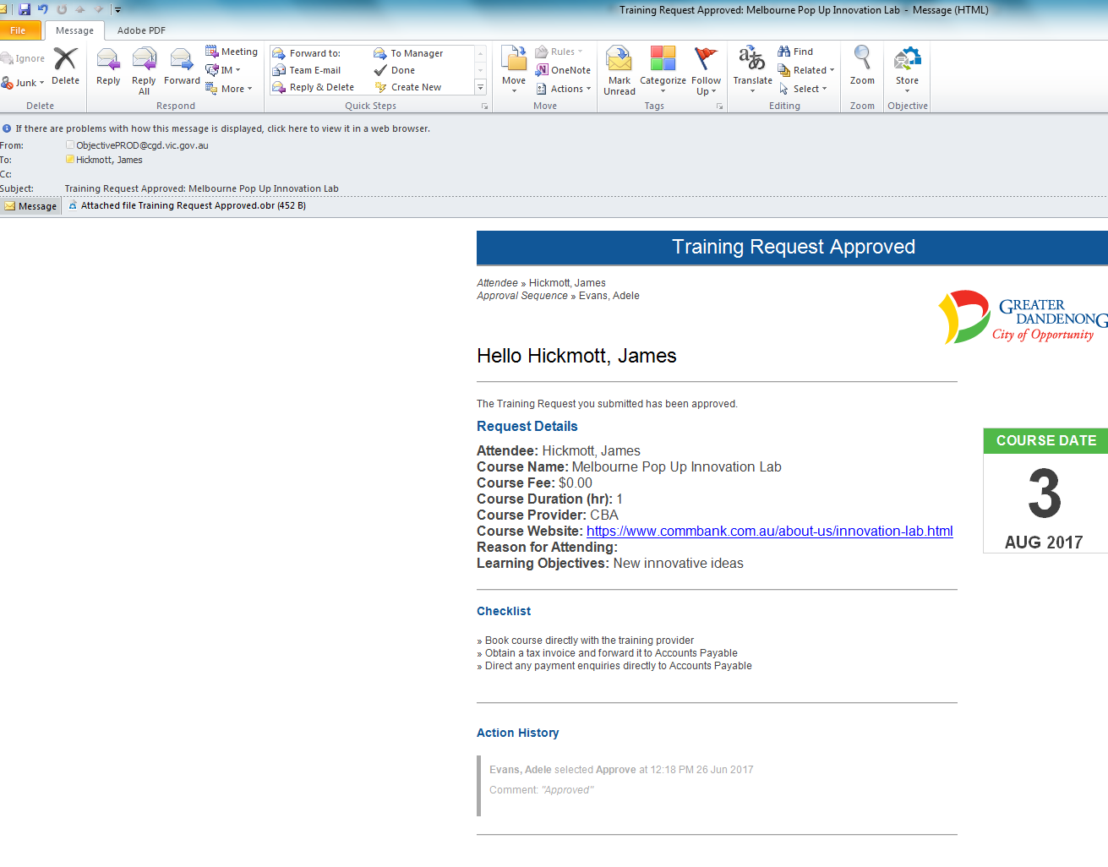
The approver receives an email confirming the approval status of the request.
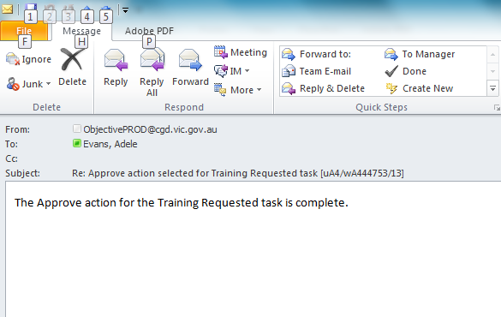

Organisation Development receive the final email with full details of the request and will record the details in Chris21 system.
