Overview  You can send Objective content as attachments in email messages. Attachments can be sent as references to users who have access to Objective. When users do not have access to Objective, copies of documents can be sent as attachments.  To attach an Objective reference in an email  - Select one or more items in Objective.  - Right-click the selected objects and select Send > Send Reference To to start an email with the Objective content attached as references.  - Complete the required email information and send as usual.  When you select and send multiple objects as references, only one reference is attached in the email. It opens a window with all the selected attachments listed.  Note: You can drag Objective content into an email message to attach as a reference.    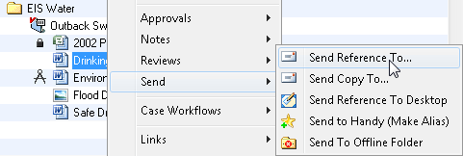    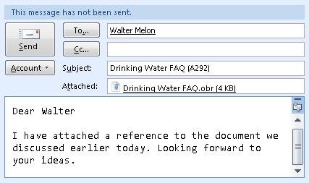 | To attach copies of Objective documents for Non-Objective Users  - Select one or more documents in Objective. Use Ctrl to select multiple objects.  - Right-click the selected documents and select Send > Send Copy To to open the Send a Copy Options window.  - Select the version to be sent and click OK for each selected document. This will open an email message window with the copies attached.  - Complete the required email information and send as usual.  Note: You can hold down the Ctrl button while dragging an objective document into an email message to attach it as a copy.  