If you plan to be out of the office for one or more days, please address the following:
- Conduct handover

- Delegate emails (instructions below – Step 1)

- Activate the Outlook ‘Out of Office Assistant’ (instructions over page – Step 2

- Divert your phone/s (mobile and desk phone) and, if applicable, alter your recorded message (if applicable) (instructions below – Step 3a)
Note: If taking your Council owned mobile device/s overseas (refer Mobile Device Policy below – Step 3b).
Global roaming charges apply. Contact ITSERVICEDESK (8571 5102) who will check the settings on your device. They will also provide up to date advice on how to minimise global roaming charges.
You will need to reimburse Council for these charges upon your return, unless the device was used for business purposes and approved by your manager.
- Alter delegations (where applicable) via workflow by clicking on the link below:

- UConnect approvals. Log into UConnect (refer instructions below – Step 4)

- PULSE approvals and workflow. Log into PULSE (refer instructions below – Step 5)

- Council vehicles (if the vehicle will remain at work). Email Fleet (provide your leave dates and inform them where the vehicle will be held)

- Advent ManageR. Email ZZ Governance (provide your leave dates and advise who will be responsible for your obligations)

- Commensura (C.net) – Agency Hire Portal. Log into C.net (refer instructions below – Step 6)

- Building Access (if the person acting for you requires additional security access to buildings and requires keys, access card changes or alarm codes). Email Building Maintenance (provide name of the person and details of the additional security access required and the specific building)

Step 1: Delegate Emails

NOTE: Please note that accessing another staff member’s email (or other CGD computer system) using their personal computer login details is not permitted.

It is a breach of Council policy to:-

- Provide your computer username and / or password to another staff member to enable them to access your email or other systems.
- To access another staff members computer access using their personal computer username and / or password.

IT Helpdesk will not grant another person access to your emails whilst you are absent, unless exceptional circumstances exist and certain criteria are met.

Simply forgetting to set up ‘delegate’ access does not qualify as an exceptional circumstance. Therefore, it is imperative that if you require another staff member to access your email or other systems in your absence, you give them access as a ‘delegate’ (see instructions below).

When you give another person access to your emails as a ‘delegate’, you allow the other user to access and / or send emails on your behalf. The recipient of emails will be able to identify that the email has been sent by another user on your behalf.

Office 2007  - On Tools, click Options.  - Click the Delegates tab then Add.  - Type the name of the person who you want to delegate to. Click Add then OK.  - In the Delegate Permissions box, you can customise access levels. | Office 2010  - On File, click Info  - Click the Account Settings box  - Click Delegate Access then Add.  - Select the name of the person who you want to delegate to. Click Add then OK.  - In the Delegate Permissions box, you can customise access levels.

Step 2: Outlook - Out of Office Assistant

Office 2007  - On Tools, click Out of Office Assistant.  - Click Send Out of Office auto-replies.  - On the Inside My Organisation and Outside My Organisation tabs, type the response you want to send (suggested text below). | Office 2010  - On File, click Info  - Click the Automatic Replies box  - Click Send Out of Office auto-replies.  - On the Inside My Organisation and Outside My Organisation tabs, type the response you want to send (suggested text below).

Suggested Text
Thank you for your email.

I am away from the office from [Day, Date] until [Day, Date] and will be unable to respond to your email during this time.

Should you require immediate assistance, please contact [Name] on [phone number] or [email address].

Alternatively I will respond to your email on my return.

[Your Name]
[Council email signature]

Step 3a: Call Forwarding
Microsoft Teams
In Microsoft Teams go to Settings > Calls > Turn on Forward all calls and set up where you want your calls to be sent to.

Step 3b: Mobile Device Policy
Council Information > Policies & Codes of Practice > Corporate Policies > Mobile Device Policy

Step 4: UConnect Approvals
- Log into UConnect
- Under "Staff" banner select Out of Office.
- Click Absentee Manager
- From the “Field Picker” choose surname then Go. Click on staff member and save.

When you next log into UConnect, you will be prompted to turn of the out of office.

Step 4: PULSE Approvals and Workflow
- Log into PULSE
- Under "Help Documents”, select PULSE Delegations
- Follow process as outlined in the help document

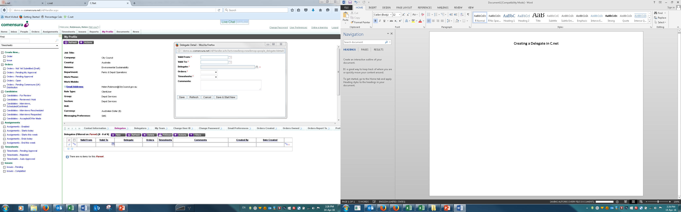
Step 3:
- Select dates the delegate will be required (from/to)
- Search for delegate and
- Select if they need to approve orders and/or timesheets.
- Add comments (optional)
- Click save
Step 2: Click on Delegates then click New
Step 1: Log into C.net then click on My Profile

