

QGIS User Training

Last Update: 4 March 2022
Version: 2.3

Contents
1 Introduction 4
2 What is QGIS? 4
3 What tools are available in QGIS? 4
4 QGIS Basics 4
5 Geospatial Data Abstraction Library (GDAL/OGR) 5
6 Starting QGIS application 5
7 QGIS Projects 6
8 Working with Map layers 6
8.1 Map layer management 7
8.2 Map Editing 8
8.3 Map Navigation Tools 9
8.4 Attribute Table 9
8.5 Measure distance, area, angle 10
8.6 Bookmarks 10
8.7 Information tool 10
8.8 Saving Map layer in another format 11
8.9 Adding Coordinators to a map layer 12
8.10 Delete Unwanted Columns 12
8.11 Create Buffer 12
8.12 To Select part of the layer based on expression 13
8.13 Using labels for map layers 14
8.14 Creating a New Map Layer 15
9 Map Composer for printing maps 17
9.1 The Composer 17
9.2 Select/Move item 19
9.3 Move Item Content 19
9.4 Add Scale Bar 20
9.5 Add North Arrow 20
9.6 Saving the layout 20
9.7 Creating multi layered PDF 21
10 Changing Coordinate System of a map 24
11 Opening Server GIS tables 25
12 Updating attribute using location and spatial join 27
13 QGIS Reference websites 31
14 Useful websites for QGIS tutorials 31

Introduction
Welcome to QGIS (previously called Quantum GIS). QGIS is free to use as it is licensed under the GNU General Public License. QGIS is an official project of the Open Source Geospatial Foundation (OSGeo).

What is QGIS?
QGIS is the software selected for use by Council. QGIS is a very useful, free and open-source cross-platform desktop geographic information system (GIS) application. It can capture, store, manipulate, analyse, manage and present all types of geographically referenced data.
The latest version of QGIS is 3.8.1 ‘Zanzibar’ and was released on 19.07.2019 however, version 3.4.10 ‘Madeira’ is more stable and is recommended. You can download QGIS from https://www.qgis.org/en/site/forusers/download.html. (home use) If you want to use it Council computer, then IT department will install the software on your PC. Please provide ITservicedesk your computer barcode number and they will download it on your PC. Any support issue please contact GIS coordinator on 85715338 or email: gis@cgd.vic.gov.au

What tools are available in QGIS?
QGIS has a standard set of tools and the ability to run custom tools via the plug-in system.
Standard tools available in the system as follows
- A map canvas (main map window) showing map (spatial) objects
- Attribute tables showing attributes data, similar to browser window of MapInfo
- Layer panel to manipulate layer visibility and order
- Composer window similar to layout window of MapInfo which allow user to place maps and other objects, scale bar, north point etc.
- Tool bars, menus and other user controls for managing spatial data
- Dock windows – attribute table (browser) and layer panel (map) are examples of dock panels.

QGIS Basics
QGIS doesn’t have its own file format similar to .tab for MapInfo files or .shp for ArcGIS software. It relies on a range of other open source libraries in order to open and edit a large range of files. Files also referred as datasets and when it is opened it is referred as a layer.
QGIS can open 3 different data types:
- Vector these files use geometrical primitives such as points, lines or polygons to represent objects of graphics.
- Raster these files represent the data as an array of pixels, typically used for imagery.
- Attribute these files contain no geometry information but rather just plain attributes data.

Geospatial Data Abstraction Library (GDAL/OGR)
QGIS uses the GDAL/OGR library to open and save file formats, so many different files can be viewed and transformed with ease. For example, we can open MapInfo.tab file and save it as a GeoJson file or .shp file.
GDAL is a library for raster geospatial data formats that is released under an open source licence. For more information refer:
http://www.gdal.org/ogr_formats.html (for OGR Vector formats)
http://www.gdal.org/formats_list.html (for GDal Raster formats).

Starting QGIS application
When we open QGIS it displays a daily tip about using QGIS which can be dismissed after reading. You can change the setting so it doesn’t display the tip when you open QGIS. You can save your preferences to make QGIS easier to use.
To change preferences, from the Settings menu choose:
- Options - In Options you can define QGIS default behaviour, i.e. how QGIS should function for you
- General - These settings control the general look, feel and operation of QGIS.
Change some the options such as Rendering as shown below:
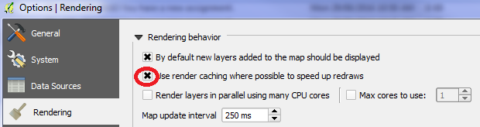
In Maptools, you can choose how the selection should display, zooming scale, preferred measurement units etc.
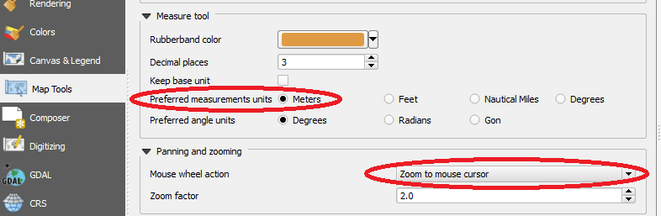
In Coordinate Reference System (CRS), set the default projection for new map layers as shown below.
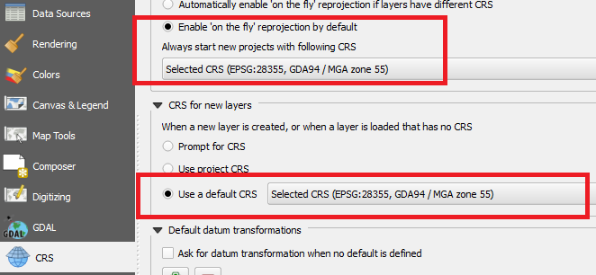

QGIS Projects
QGIS Project: QGIS project is similar to MapInfo workspace, remember to save all map layers because saving QGIS project won’t save map layers in the project.
Project will have file extension xxxxxx.qgs. You can open project from [Project menu Open or select 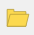 from toolbar.
Project Save As to save a new project

Working with Map layers
Layers QGIS are similar to map layers in MapInfo. You can open it individually or open a group of map layers in a project (workspace equivalent in MapInfo)
There are 2 ways to open map layers. Either using Layers >> Add Layer >> selecting one of the layer type as shown below
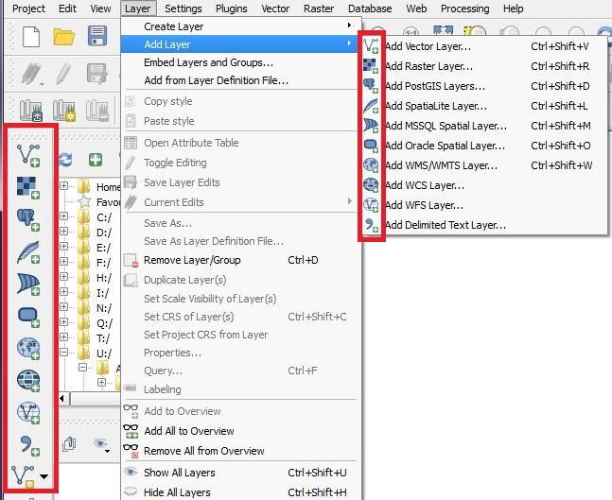

Map layer management
Once any map layer is opened it will get displayed in the Layer tab on the left hand side.
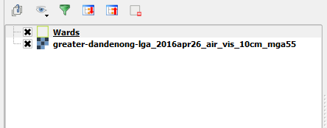

It the tab is not visible you can turn it on by right clicking on tool bar area and adding X in front of Layers as shown below. Similarly other options can be turned on or off.
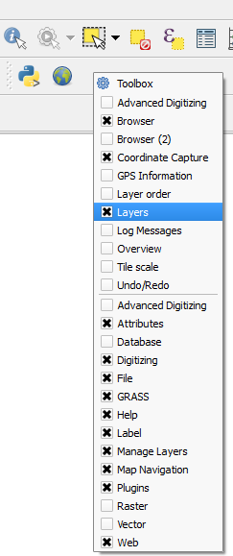

Map Editing
User can double click map layer name to open Layer Properties window as shown below. It displays metadata of the map layer as well as allows user to change map presentation in map style option.
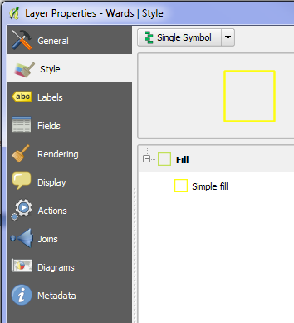

Map Navigation Tools
Following tools are used for map navigation. First tool – pinch zoom is available for touch screen monitors.
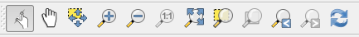

Attribute Table
To view attribute table, click on attribute tool 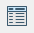 tool in tool area. If you can’t see the tool then right click in tool area and add x in front of Attributes and attribute tool bar gets added.
When you select any attribute in attribute table, corresponding map object is highlighted in the map window.
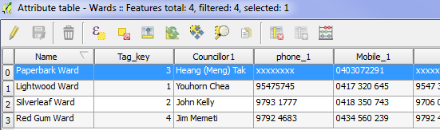

Measure distance, area, angle
Measure distance, area, angle is part of the Attributes tool group. 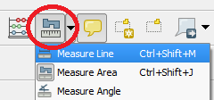
It works similar to MapInfo however to end measurement or area tool user has to click right mouse button instead of double click in MapInfo

Bookmarks
It is possible to save a view of the map using the bookmark tool 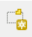.
You can open a bookmark and export data to an .xml file using 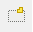.

Information tool
When you click on the information tool and then on a map object, it will display all open map layer names as shown below
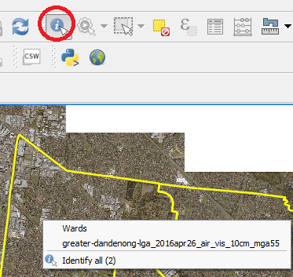
You can select one layer or select Identify all as shown above.
Once a layer is selected, attribute information will be displayed in left side panel as shown below
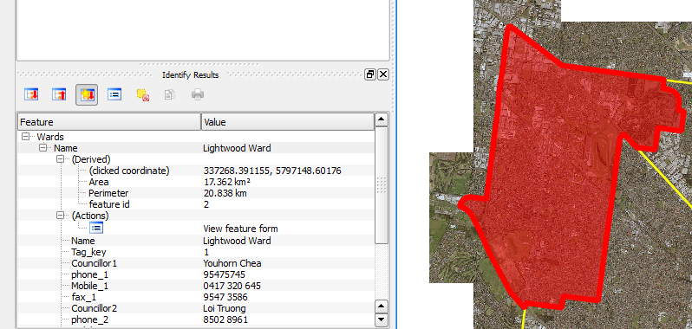

Saving Map layer in another format
You can save map in more than one format. Below is the list the formats available to save the map. User Layer Save as option
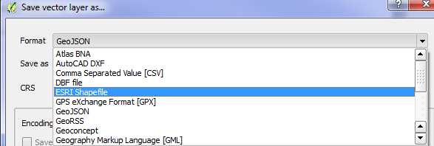
Now it is possible to save the map in MapInfo .tab format as shown below.
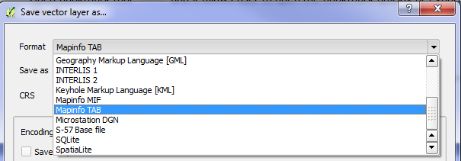

Adding Coordinators to a map layer
- Open Map of Bound
- Vector >> Geometry tools >> Extract Nodes
- This added nodes as a separate map layer.
- That map layer doesn’t have x and y coordinates
- Vector >> Geometry tools >> Export/ Add geometry columns
- This added coordinates to each node based on the coordinate system

Delete Unwanted Columns
- Make the table editable (click on yellow pencil tool or Ctrl+E)
- Click on open attribute table tool
- On attribute table click on ? to see help file related to attribute table
- Select Delete Field tool in attribute window ( Ctrl+L)
- Select the fields you want to delete and click ok
- Click on save edit tool next to yellow pencil (edit tool).

Create Buffer
- Select the map layer you want do buffer
- Select Buffer from Vector Geoprocessing Tools Buffer(s) as shown below
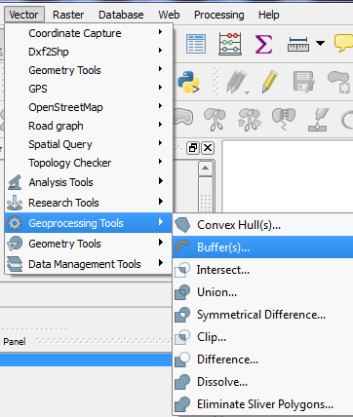
- Type buffer distance and it will get displayed in the map window

To Select part of the layer based on expression
- Select the map layer you want do buffer
- Click on Select by expression icon as below
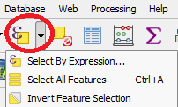
- Click on Browser window icon and then 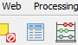
- Select icon - Select by expression as below
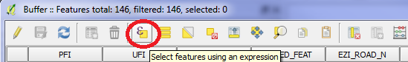
- Type an expression and select either of the tool to see selected rows in browser or in the map window
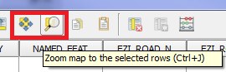

Using labels for map layers
Please go to page below for all the information about labelling map objects.
You can right click on map layer you want to label and select properties.
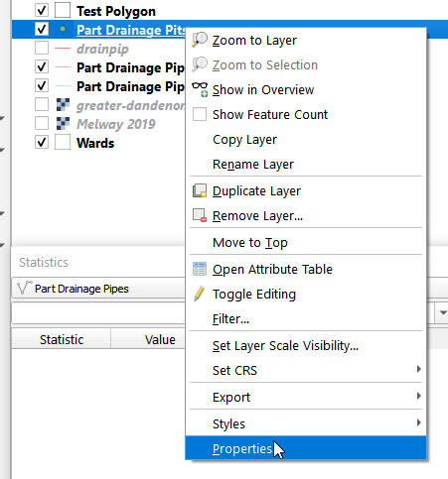
In property window, select label as shown below
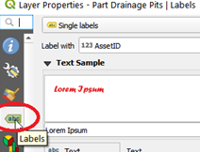
It will open label dialog box.
For more information for using QGIS labels please use the link below:
supporthttps://docs.qgis.org/3.4/en/docs/training_manual/vector_classification/label_tool.html?highlight=label%20toolbar
Or google “QGIS label_tool.html”

Creating a New Map Layer
To create a new map layer follow the steps below
- Create a new map layer using the create a new shapefile layer
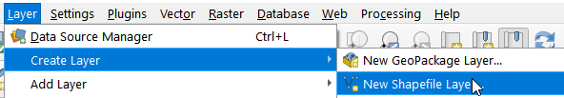
- Specify the directory where you want save the map layer and give the name to the new map layer.
Note: QGIS users in Engineering Services staff can save their maps in U:\Engineering Services\Parks Services or other appropriate folder.
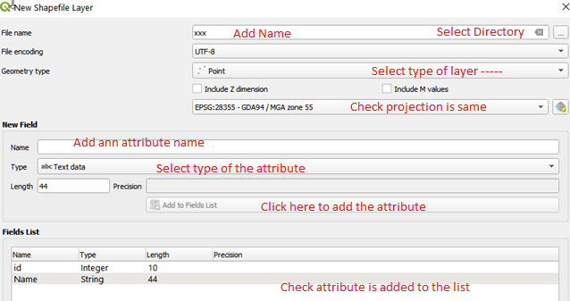
- Click OK button to save
- The saved map layer will be added to the layers
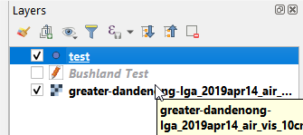
- Select the map layer (highlighted) and right click to select Toggle editing or click on Toggle Editing tool as shown on next page.
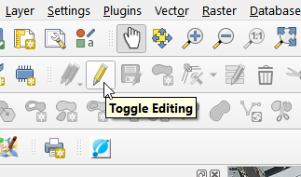
- Click on Add Point Feature tool to create a new map object in the map as shown below. 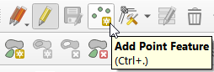
- If you are creating polygon map layer then you will see Add Polygon Feature tool as shown below
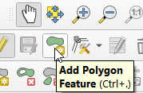

- Add polygons as required and save the new map
- There are other tools available in the digitising toolbar as a part of Toggle Editing tool. When we click on the tool again all editing tools are switched off.
Note: If you can’t see the Toggle Editing tool, then right click on empty space near pull dawn menu and click in the box, front of digitising tool as shown below, to activate all editing tools.
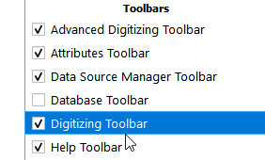

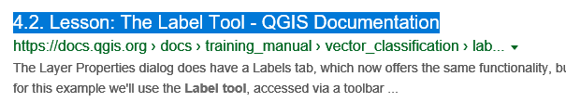

Map Composer for printing maps

The Composer
The Composer contains objects called Composer items. Each Composer item contains its own set of properties in the Composer panel that reflect how the item is displayed.
Map Frame, Labels, Scale bars, North Arrows
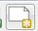 Click the “New print composer” icon.
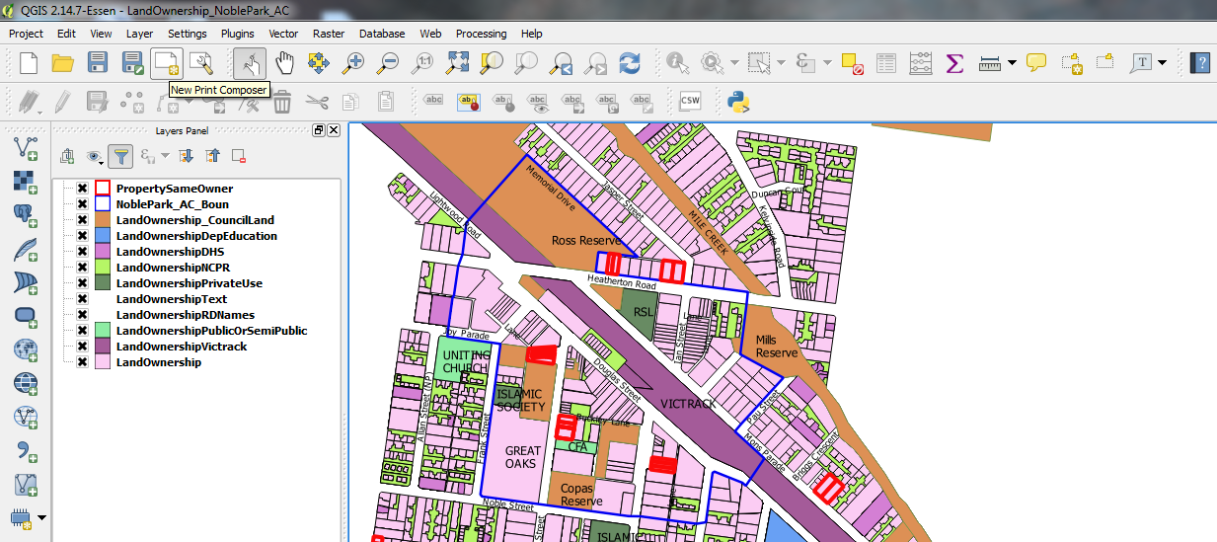

Enter a name for the new Composer.
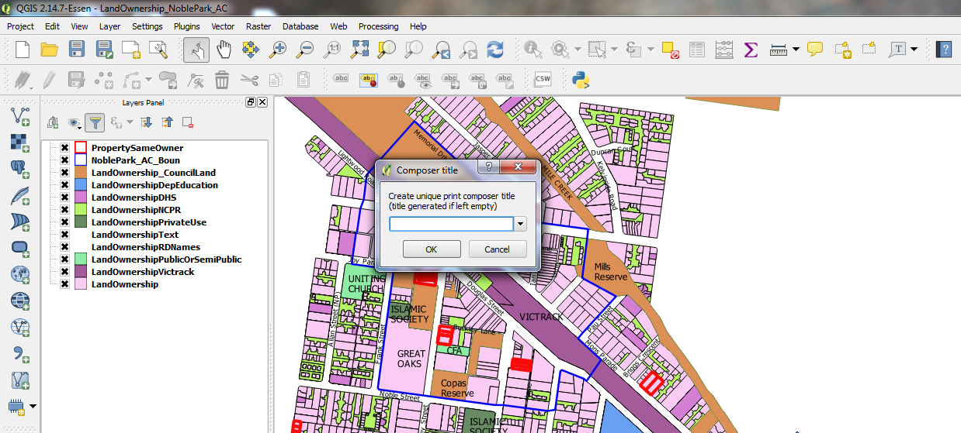

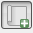 Click the “Add new map” icon.
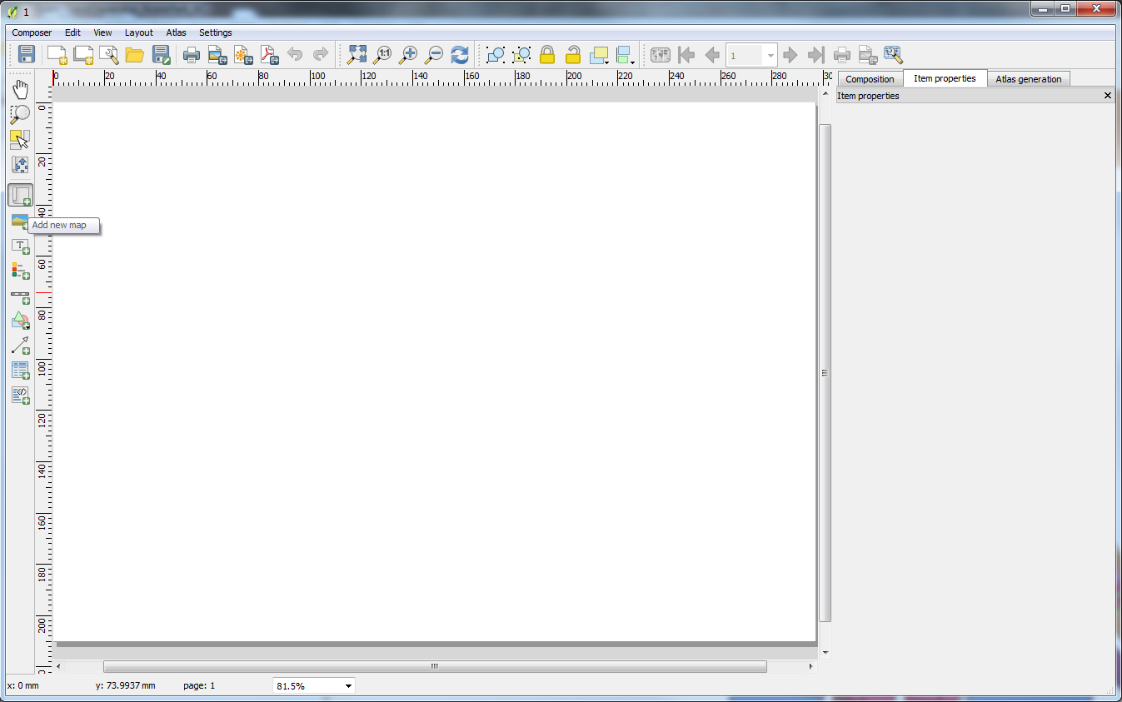
Next drag a rectangle onto the Composer canvas with left mouse button
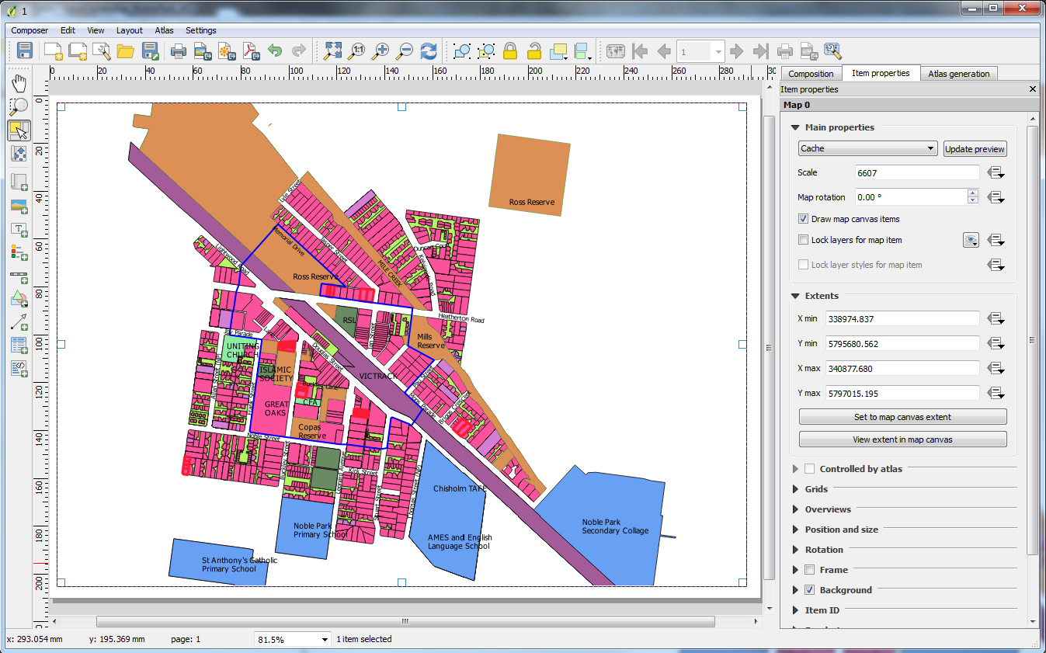

Select/Move item
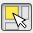 Click the “Select/Move item” icon.
Click on the item; then move it using the mouse while holding the left button.
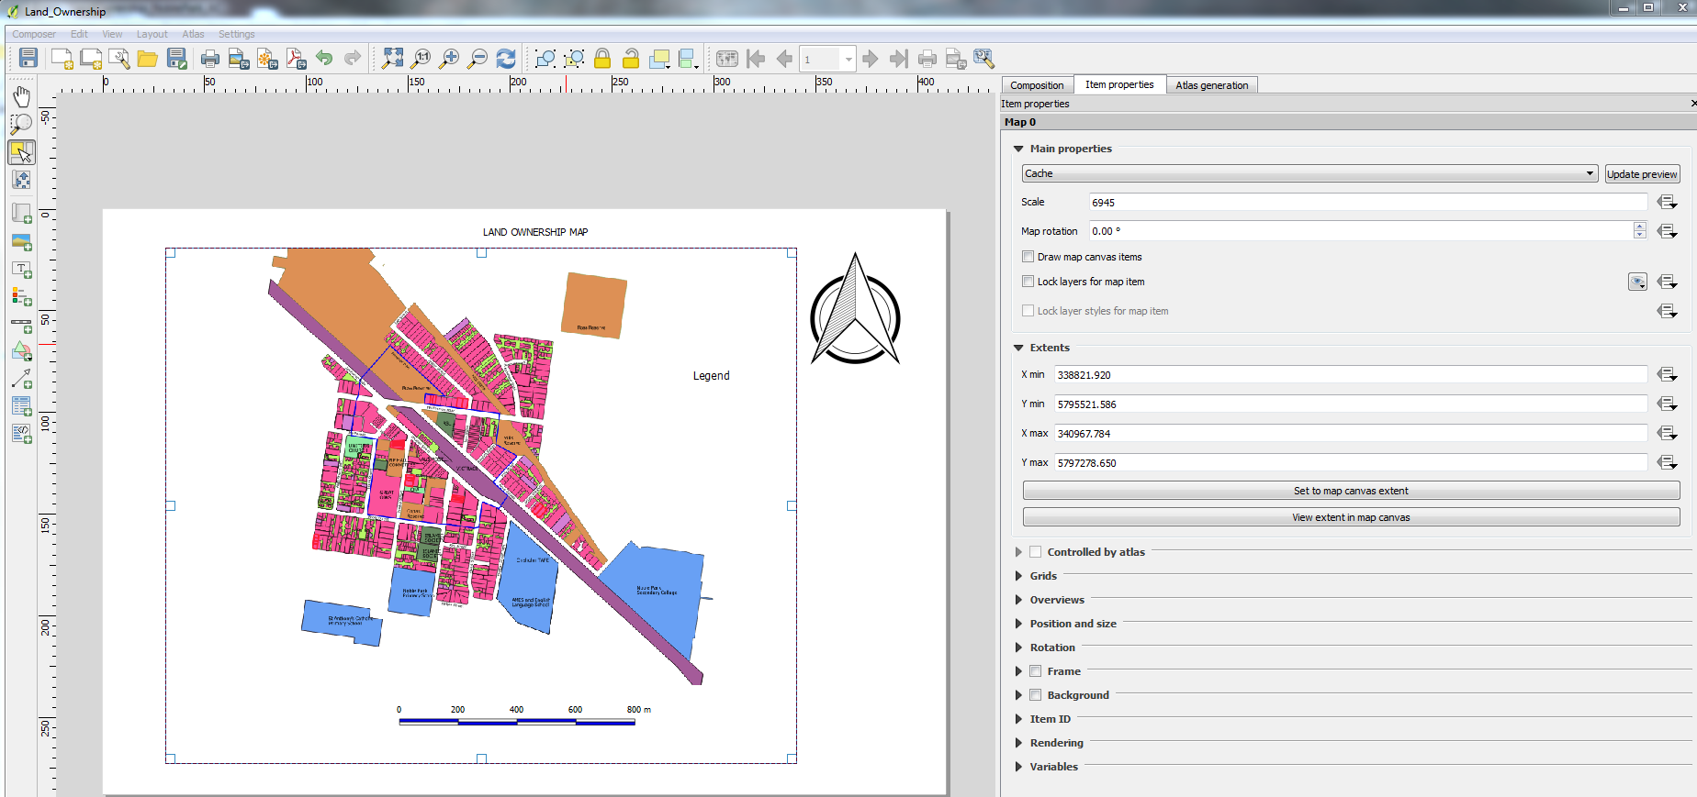

Move Item Content
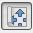 Click “Move item content” icon
Click on map and move layers within map item frame with left mouse
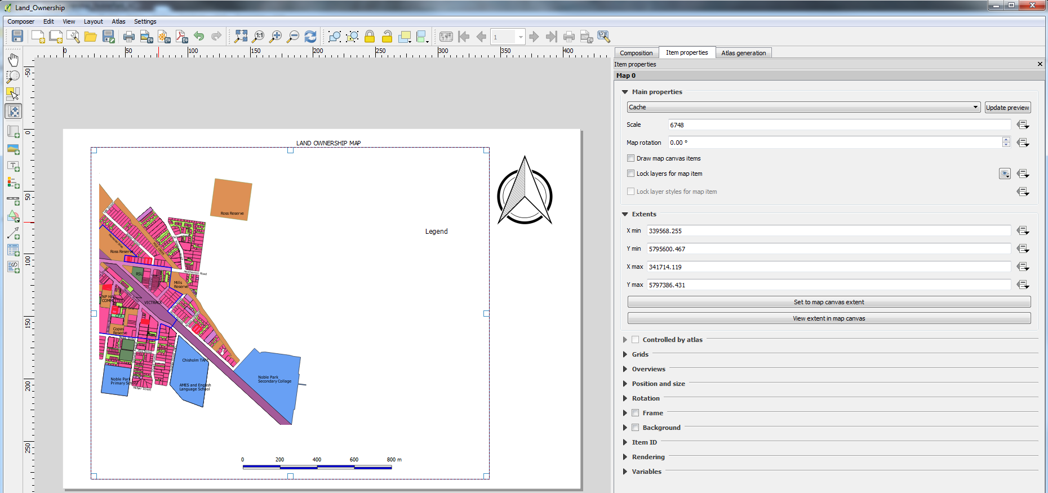

Add Scale Bar
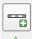 Click the “Add Scale Bar” icon.
Drag a rectangle onto the Composer canvas with left mouse button.
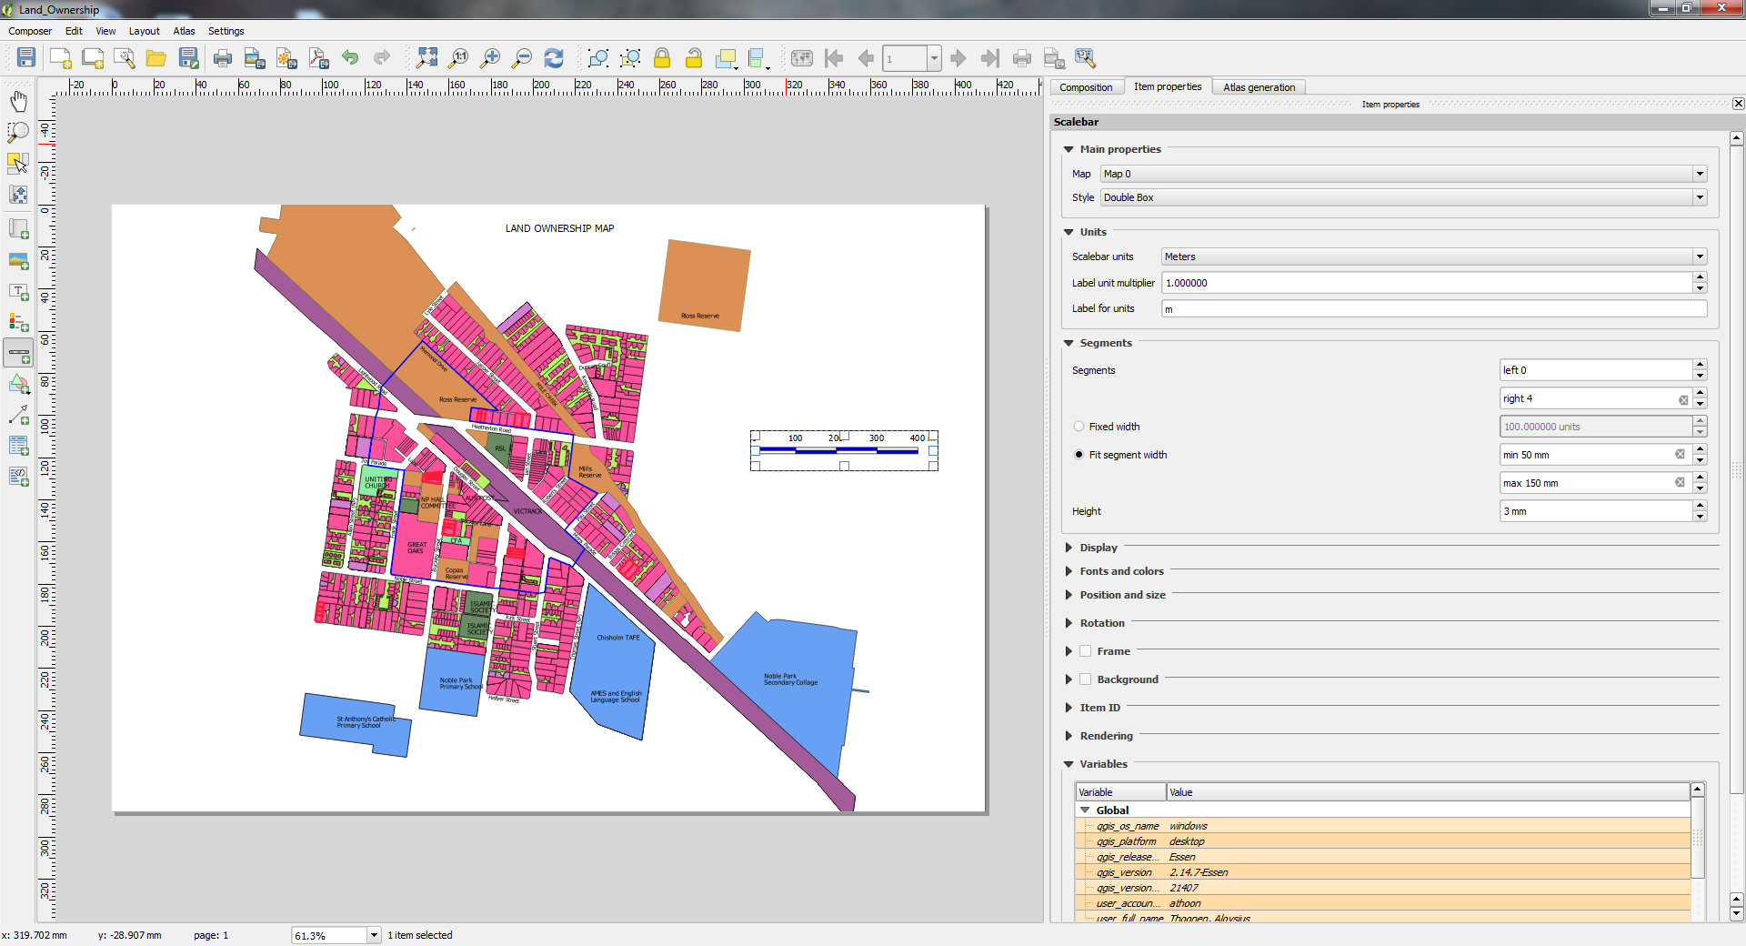

Add North Arrow
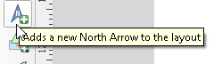
Click add a new North Arrow button to the layout and click on layout window.

Saving the layout
User can save the layout map as an image, SVG file or pdf selecting under Layout menu as shown below. If you want to create a pdf with option for users to turn on and off layer on that pdf please check steps given in on next page.
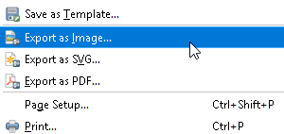

Creating multi layered PDF
In QGIS once you created a map in layout window.
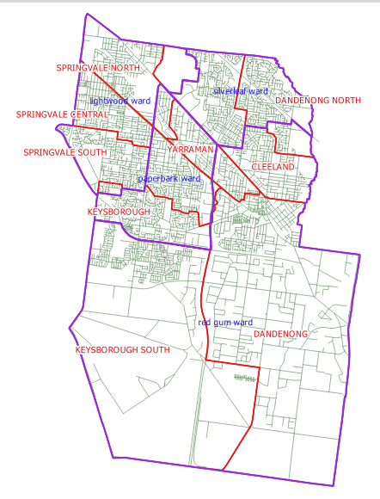
- Select Export as PDF option under Layout menu as below.
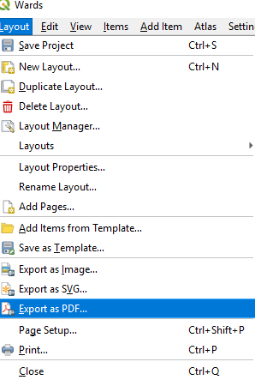
- Add the name of pdf document and where you want save it.
- As soon as user clicks save tab following window will open
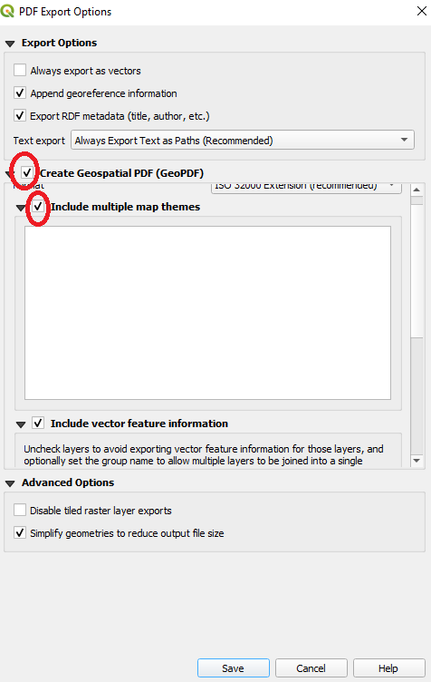
- Add tick mark in front of Create Geospatial PDF and
- In front of Include multiple map themes as shown above.
- Click on Save button and the pdf created will maps opened in your layout window.
- Open the pdf and you will see layers icon in top left hand corner as shown below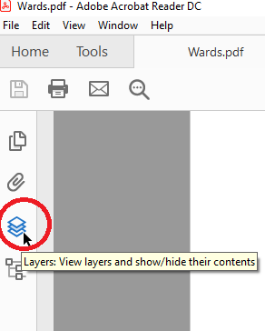

- Click on the icon as shown below to turn On and Off the map layers.
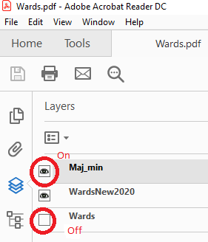

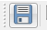
Click the “Save Project” button

Changing Coordinate System of a map
- To change the coordinate system of map in QGIS select map layer and right click to view options
- Select Properties as shown below
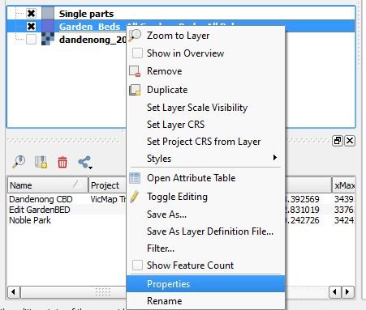
- Select General tab
- Change Coordinate reference system as shown below
- Save map layer.
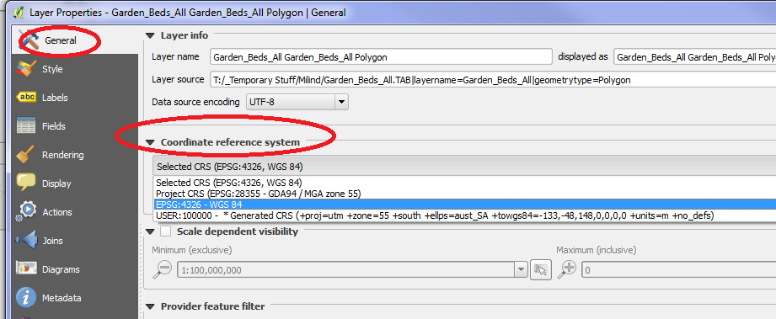

Opening Server GIS tables
Follow the process below to create a link to Asset database on GIS server to edit / update map layer on GIS server
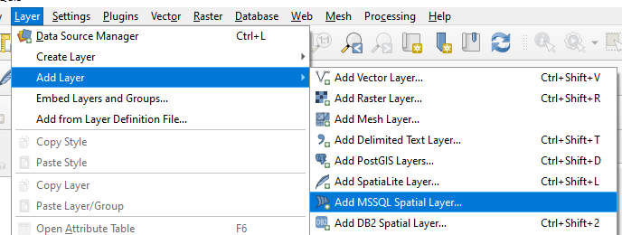
Following window will open to create connection to the SQL server:
Fill in information as below
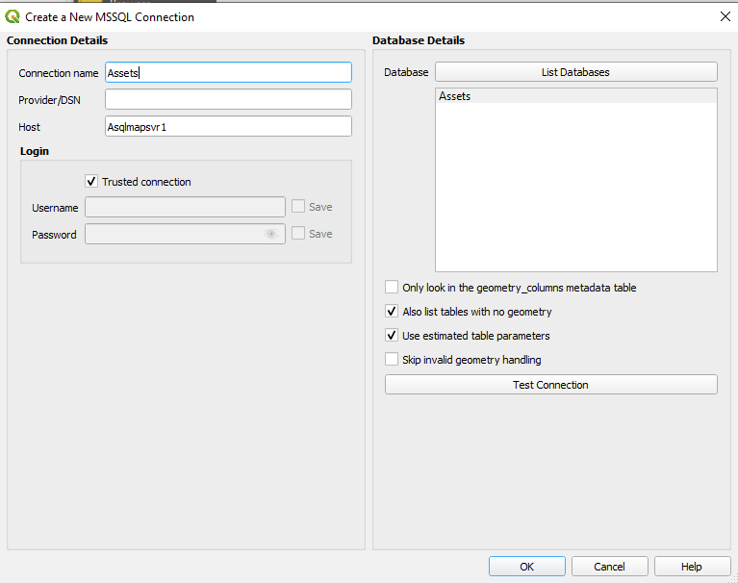
Click on Connect button as shown below
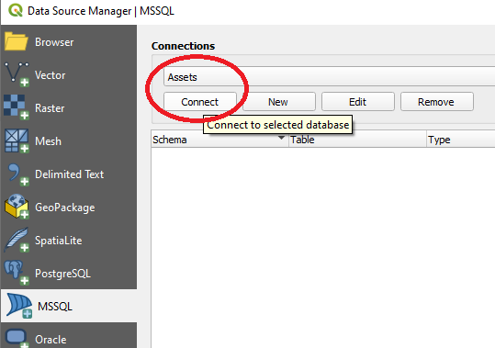
It will display all SQL tables in the asset database as shown below.
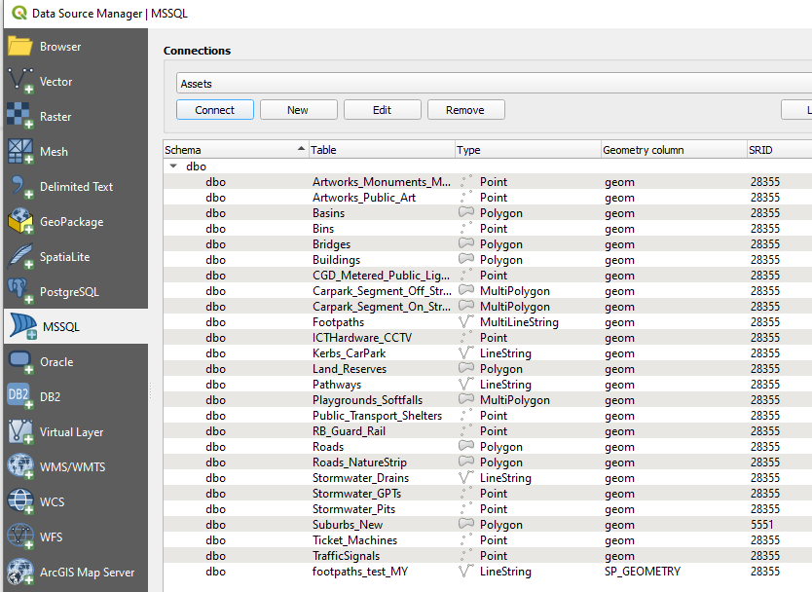
Select a table and click button Add to add the SQL table as a map layer in QGIS as shown below.

Updating attribute using location and spatial join

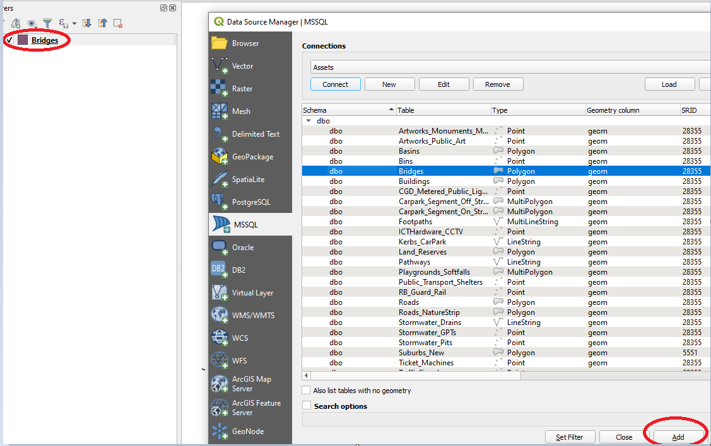
Then the table can be updated and saved directly in SQL server. IntraMaps users will see the changes next day.

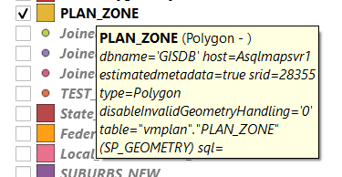

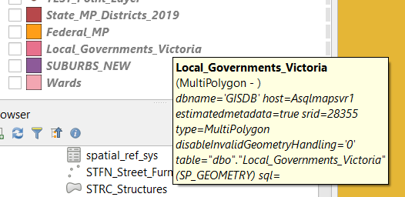

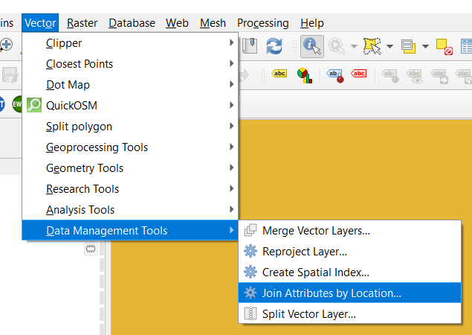

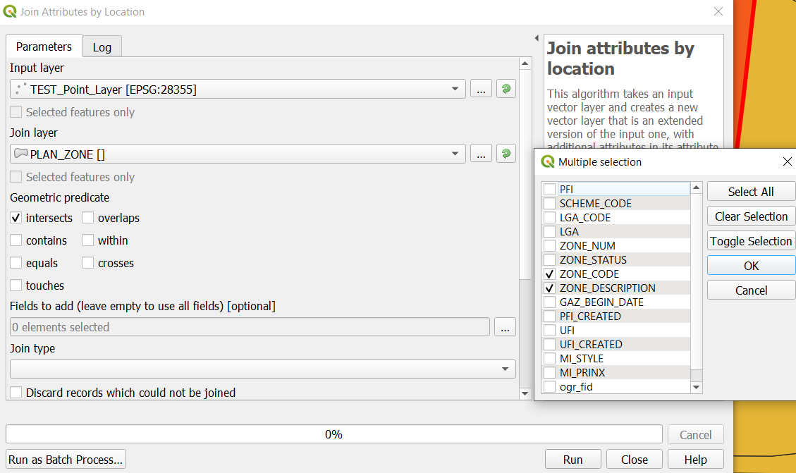

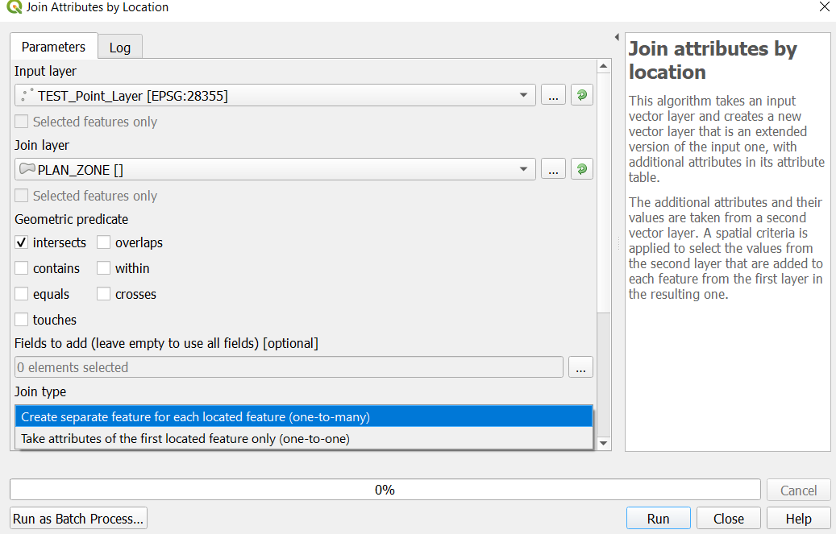

QGIS Reference websites
http://docs.qgis.org/2.14/en/docs/training_manual/foreword/index.html
http://hub.qgis.org/projects/quantum-gis/wiki/How_do_I_do_that_in_QGIS
Provides links to how to do video’s and help files as follows
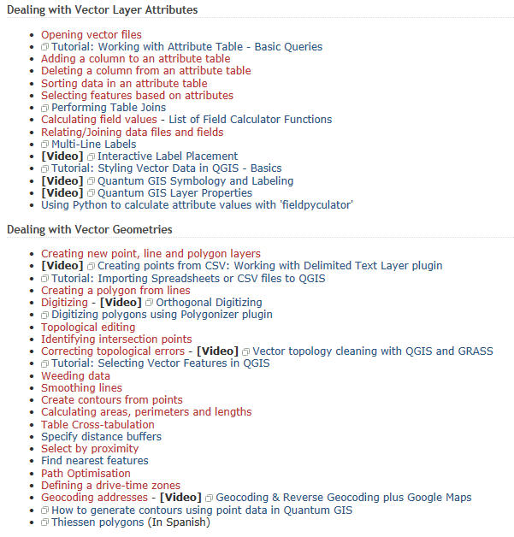

Useful websites for QGIS tutorials
GIS Tutor | http://www.gistutor.com/quantum-gis/
How to create a shapefile from X, Y coordinates | http://www.gistutor.com/quantum-gis/19-beginner-quantum-gis-tutorials/59-how-to-create-a-shapefile-from-xy-data-using-qgis.html
QGIS tutorial 1 | https://www.youtube.com/watch?v=oOtdogz2GWQ
QGIS Tutorial for beginners | https://www.youtube.com/watch?v=ppI6bd-TYyk
Introduction to QGIS | https://www.youtube.com/watch?v=59Oer-i6nVc
QGIS Basics | https://www.youtube.com/watch?v=5QIYZmysDNM

