Automatically Adding Emails to Objective

The Automatic Email Capture (AEC) module enables automated storage of emails into Objective by means of Exchange Links. Use this procedure to setup each instance of automated email capture.
Note: AEC is not to be used for filing emails that need to be stored as a “PR Document” object type as they will not be integrated into the Property & Rating system.

- Click on the Home  button in Objective to return to home and expand the Special Folder. Right-click on the Exchange Links folder and select New, New Electronic Object…
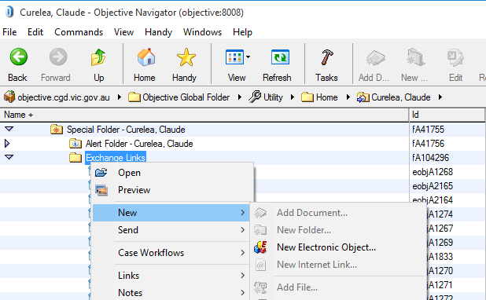
- Enter a brief description in the Name field. Drag-and-drop the Objective file or folder where emails will be stored into the Exchange Link Destination field. Press OK.
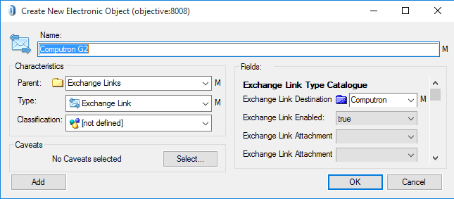
- The Exchange Link will now be visible in the Exchange Links folder.
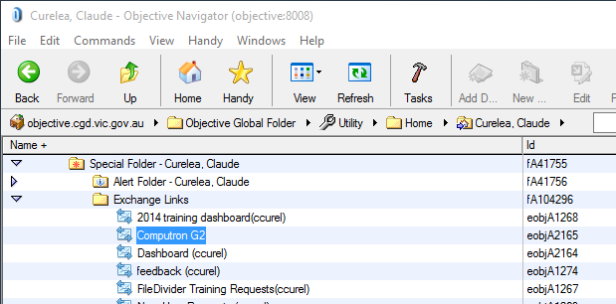
- A sub-folder is automatically created in the Outlook Inbox with the same name as the Objective file or folder (not the name of the Exchange Link).
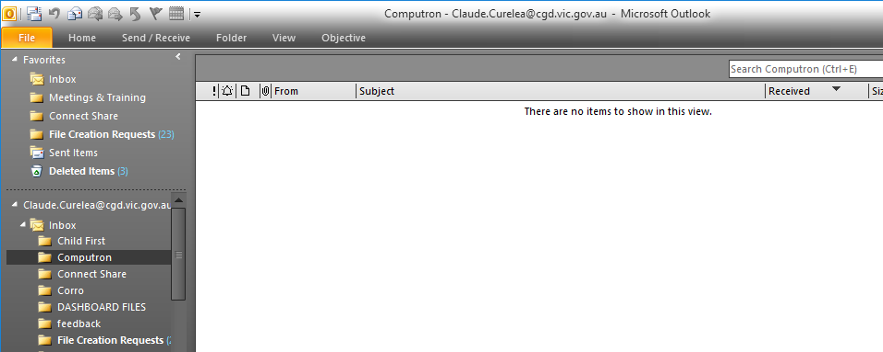
- Click on the newly created folder in Outlook to select it. Right-click on the Subject column and select Field Chooser.
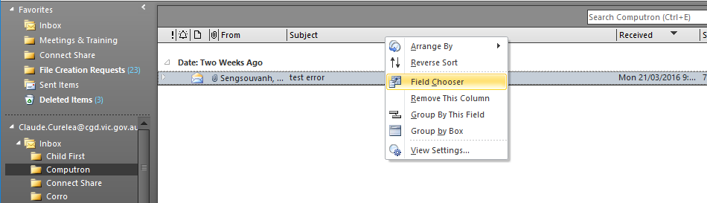
- Click the drop-down arrow change the selection to User-defined fields in folder.
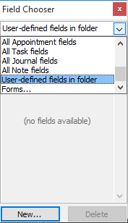
- Press the New… button and create a new column with “Objective” in the Name (must be capital O), select “Yes/No” in Type and “Icon” as the Format.
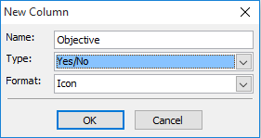
- Drag-and-drop the Objective field/column and position it next to the Subject column.
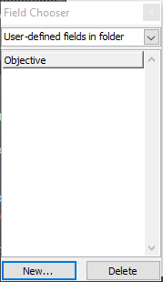

- Drag and email into the folder to automatically send it to Objective. A tick in the Objective column means that the email has been successfully stored in the Objective file or folder.
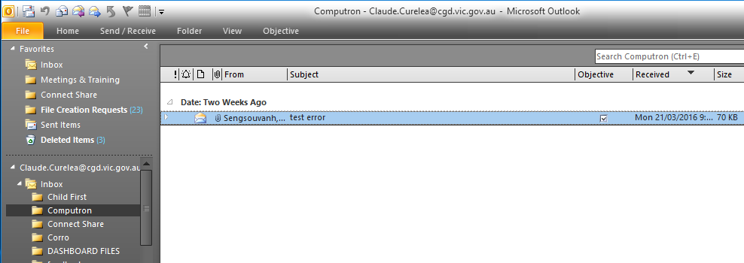
- Browse to the file or folder in the Objective Navigator and press the Refresh 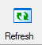 button. The email will now be stored in Objective and the email in Outlook can be deleted.
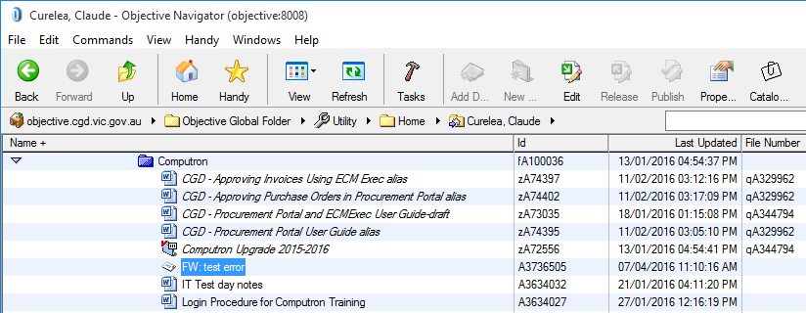

Please contact the IT Service Desk on 8571-5102 or email for assistance with this procedure.

