

COMPUTRON G2

PROCUREMENT PORTAL AND
ECM EXEC USER GUIDE
Approving Purchase Orders

Approving an Order
- Click on the link inside the “Order Waiting for Approval” email.
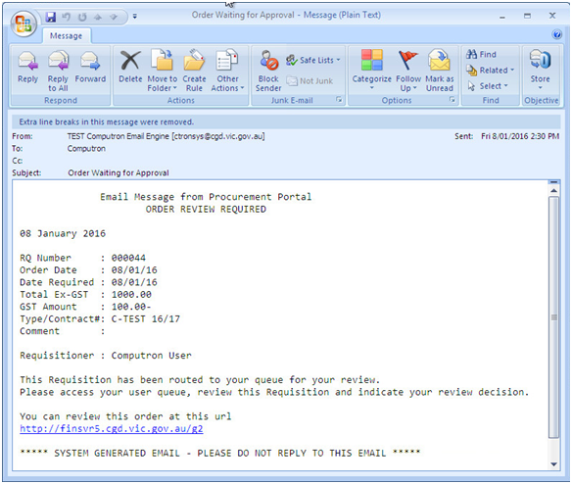
1

- At the Computron G2 Main Menu, click on Procurement Portal.

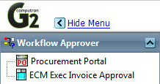
2

- Click either the “Approve Order” tab or the main screen icon and the system will list all orders awaiting approval.
3
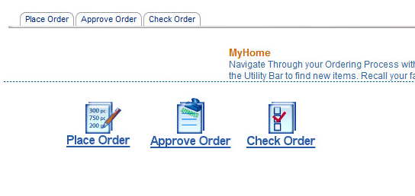

- Click on the order number to see order details.
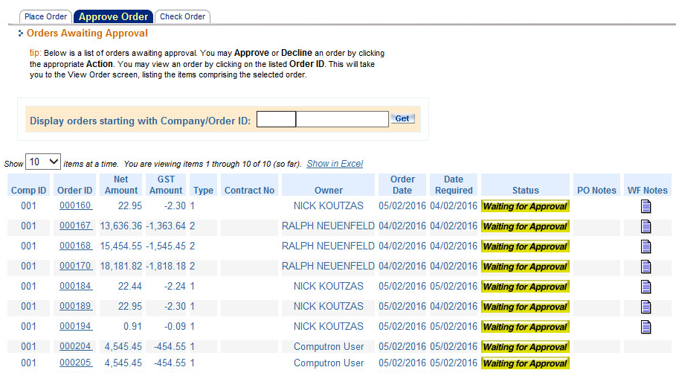
4
Note: You can click the Home button anytime to return to this screen.

- Click the Approve button to approve the order.
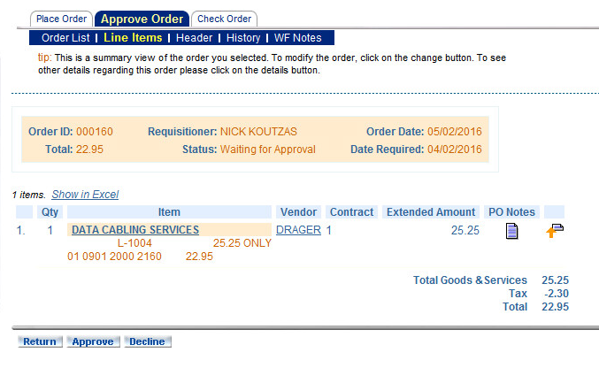
5

A message will confirm order approval and email notification will be sent to the requisitioner.

Decline Order
- Click on the order number to see order details.
1

- Press the Decline button.
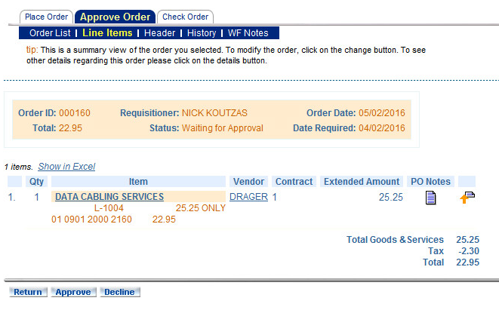
2

- Provide reason for declining order (mandatory). Press Save Note button.
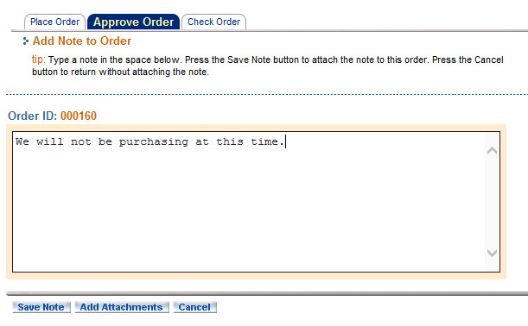
3

You will see a message confirming that the order has been declined and the requisitioner will be sent email notification that order has been declined.

