

COMPUTRON
APPROVING INVOICES USING ECM EXEC

Table of Contents
1 Approving Matched Invoices 3
2 Approving Invoice With a PO Number 5
2.1 Approving Invoices for Blanket Orders 7
2.2 Declining an Invoice 8
2.3 Transferring an Invoice to the Correct Approver 10
2.4 Viewing Invoice Details 12
2.5 Adding Notes and File Attachment 13
2.6 Checking Transaction Workflow (WF) Activities 15
2.7 Checking Scanned Invoice Image 16
3 Approving Invoices Without a PO Number 17
4 Logging Out 21

Approving Matched Invoices

- Click on ECM Exec Invoice Approval from the G2 portal main menu.
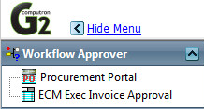
1

- Click on the invoice number of an invoice that has an associated PO Number.
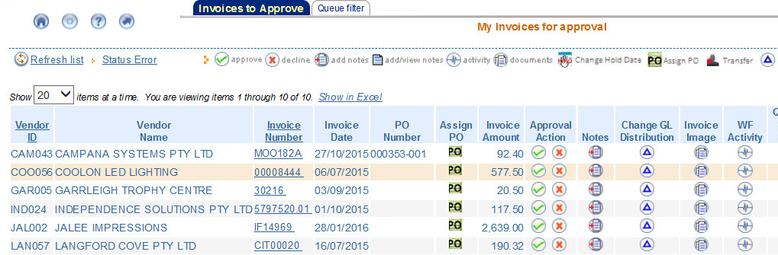
2

- Ensure that the Order Amount and Invoice Amount are correct.
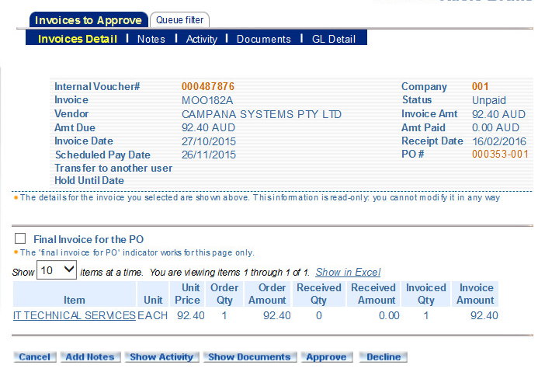
3
- Press the Approve button.

4

- Click OK button on confirmation message.
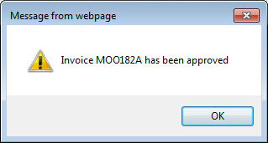

Accounts Payable will be notified by the system and will schedule invoice payment.

Approving Invoice With a PO Number

- Click on ECM Exec Invoice Approval from the G2 portal main menu.
1

- Click Assign PO icon for an invoice.
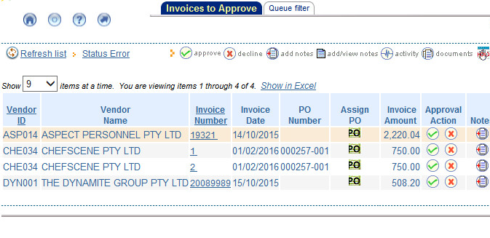
2

- Click on the icon associated with the PO# field to display a list of purchase orders.
- Click on the PO Number to select it.
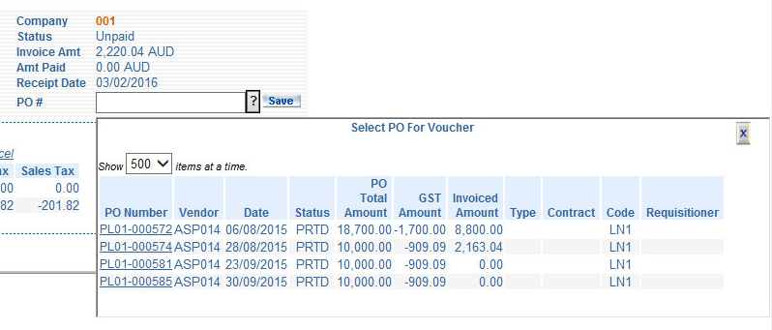
4
3
- Press Save button to save invoice details.
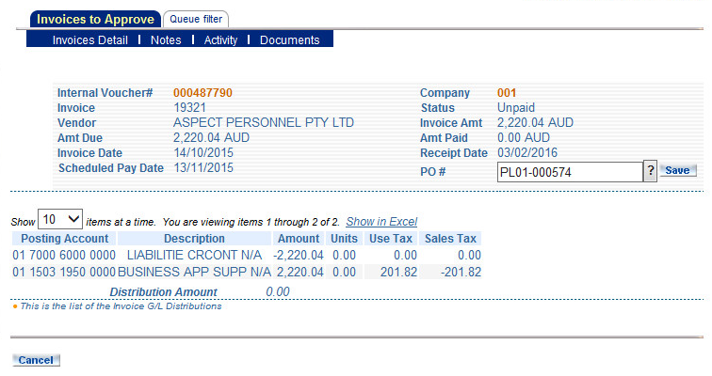
5

- Press Approve/Submit for Changes button.
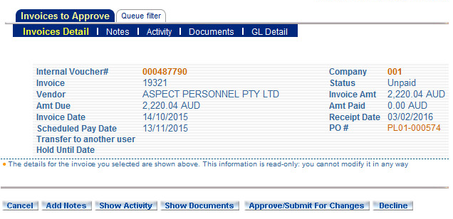
6

A message will appear confirming that the invoice has been associated with the PO.
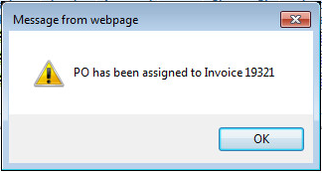

Approving Invoices for Blanket Orders

Blanket orders are orders where spending approval has been obtained for an estimated, larger or yearly amount. Multiple or periodic invoices will be deducted from this approved amount.

- Blanket orders can be approved in the same way as other order with the exception that when the final invoice is to be approved and if there is money left over from what was approved, you need to select the Final Invoice for the PO checkbox.

- Additionally, please be aware that blanket orders are raised with the total amounts in the quantity field and the unit price as set as $1. So for blanket orders you will need to deduct the invoice amount form the quantity field.

If the total approved amount for spending allocated to the blanket order has been spent as agreed/approved you will not need to select the Final Invoice for the PO checkbox when processing the final invoice.

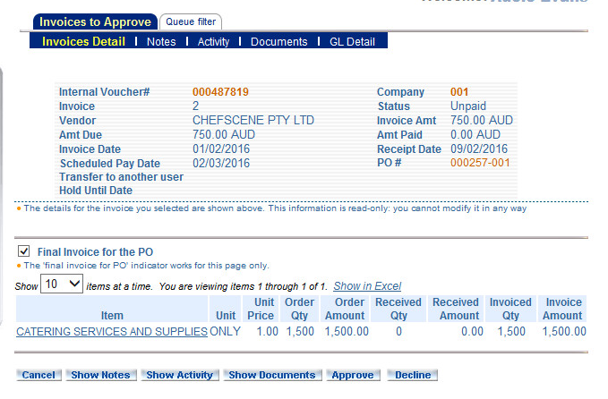
2
1

Declining an Invoice
If you have been sent the invoice in error and you know where to direct it, use the steps in section 2.3,Transferring an Invoice to the Correct Approver. If you do not know which approver to address it to, you can follow the steps below to decline the invoice.

- Click the invoice number to view the invoice details.
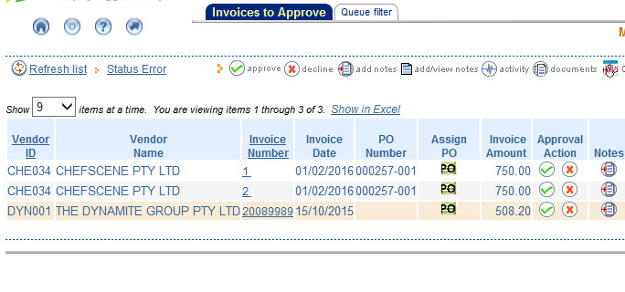
1
Note: You can click on the Invoice Image button to display the scanned copy of the invoice.

- In the Invoices Detail screen press the Decline button.
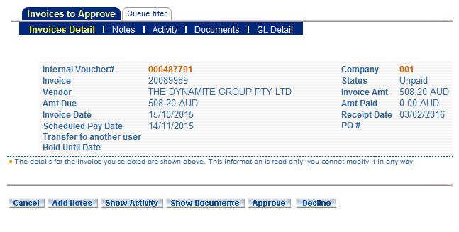
2

Note: The Show Documents button will display the scanned copy of the invoice.

- Provide a reason for declining the invoice and press the Save button.
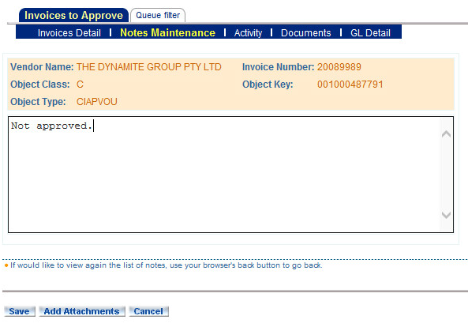
3

A message will appear to confirm the invoice has been declined.

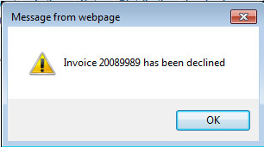

The invoice will be returned to the Accounts Payable queue.

Transferring an Invoice to the Correct Approver
- At the Invoice Approval screen, press the Transfer button.
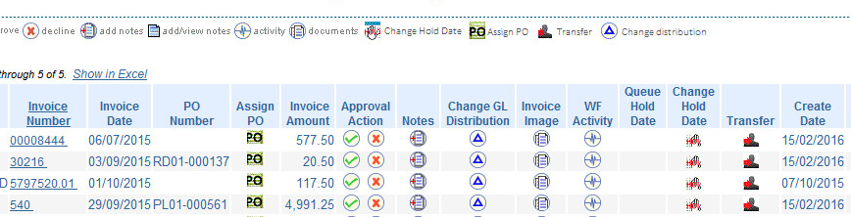
1

- Press the Transfer to another user drop-down button to display a list of users and their codes.
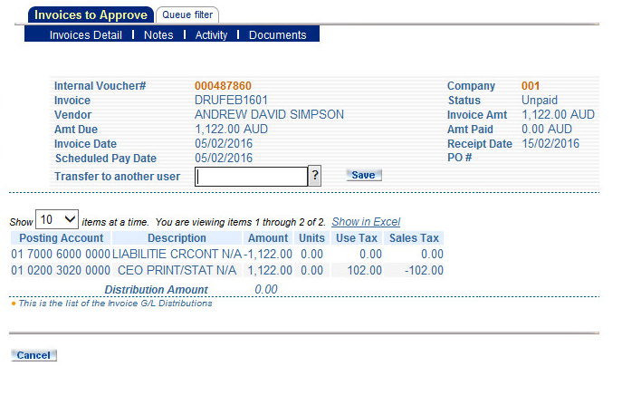
2

- Scroll down and select the code for the individual. Press the Save button.
3
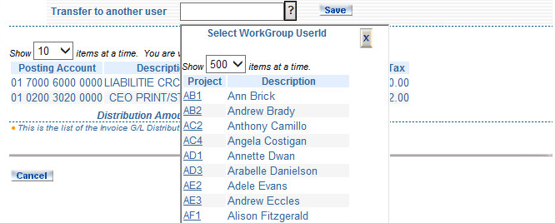
- Press the Approve/Submit For Changes button.
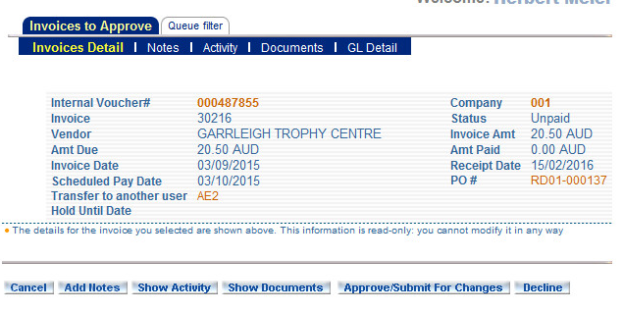
4

- A message will appear to confirm the invoice has been transferred and the invoice will no longer be listed in your Invoices to Approve screen.
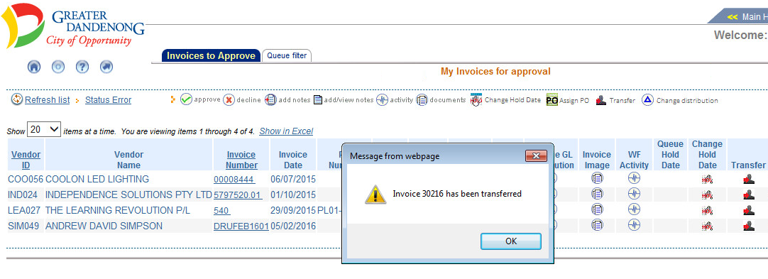

Email notification will be sent to the user you have transferred the invoice to. The invoice will now appear in the queue of that user.

Viewing Invoice Details
- Click on the invoice number to view invoice details.
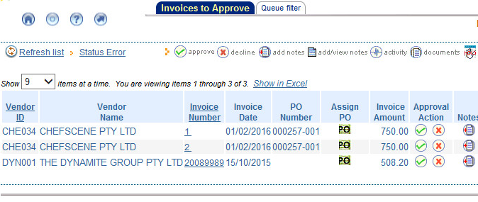
1

- Press Show Documents button.

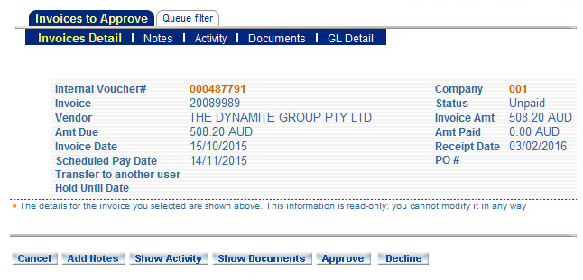
2

- The invoice will appear in a separate window.

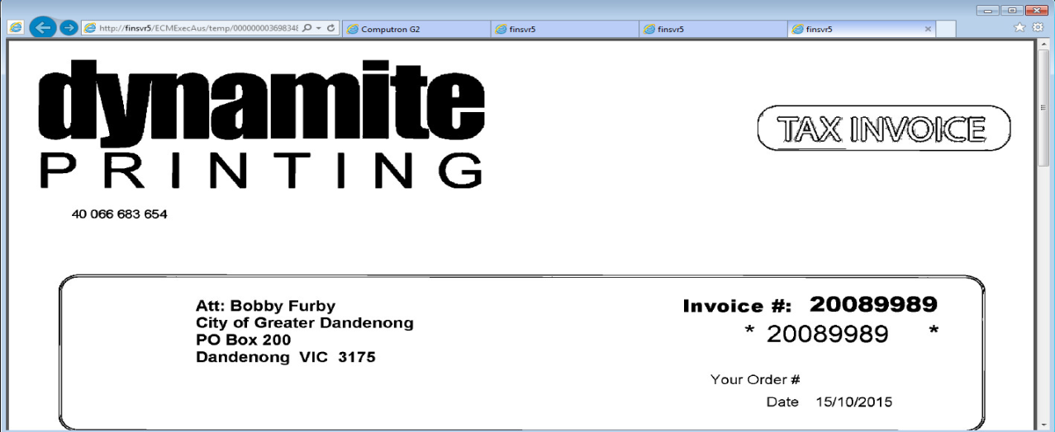

Adding Notes and File Attachment

- Click the Add Notes button from the Invoice Detail screen or Add Notes button from the Invoices to Approve screen.
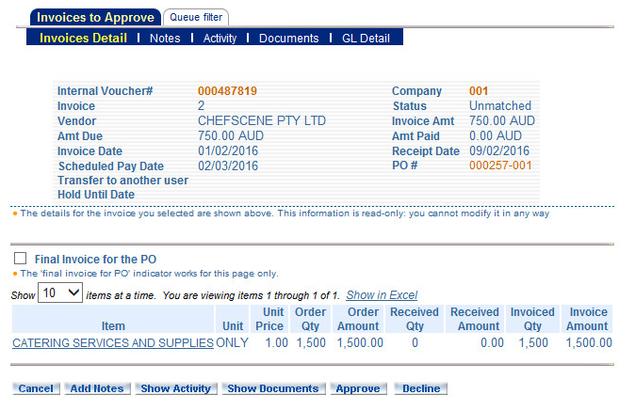
1

- Press Add Attachments button.
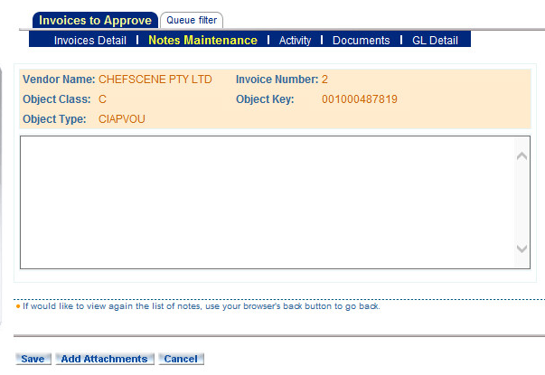
2
- Press Browse button to browse to attachments.
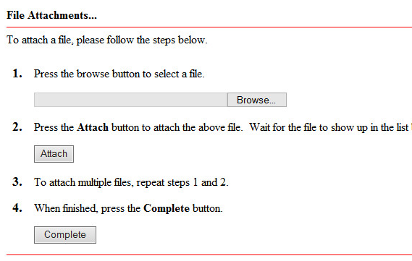
3

- Browse to documents, select the document and press open. Press Attach button in browser. Repeat process for each document. Press Complete button when all documents have been attached.
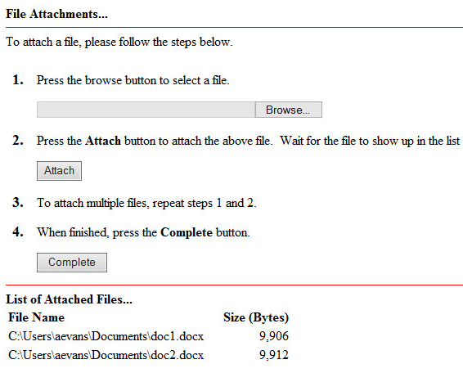
4
- Add note and press Save button.
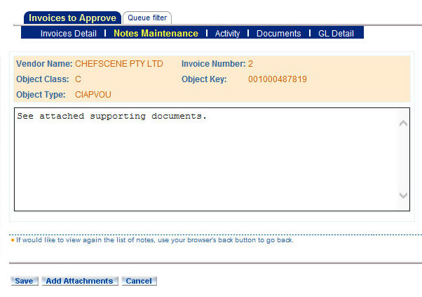
5

Checking Transaction Workflow (WF) Activities
- Click Show Activity button to view the workflow activities.
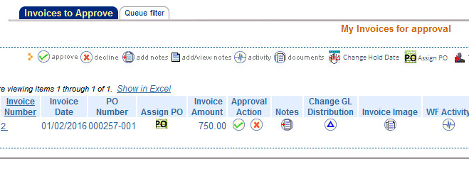
1
Note: You can also press the Show Activities button in the Invoice Detail screen.

- Once you have reviewed the transaction’s activities press the Return button.
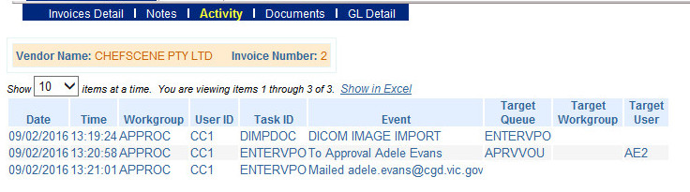
2

Checking Scanned Invoice Image
- Click on the invoice number in the Invoices to Approve screen.
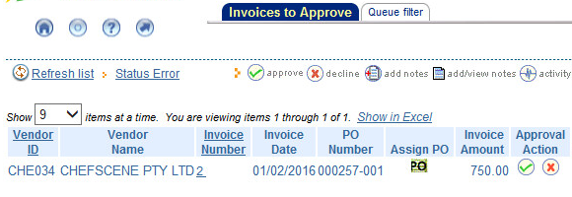
1

- Click the Show Documents button to view the scanned voucher attached to the transaction. Close the window with the scanned image when finished.
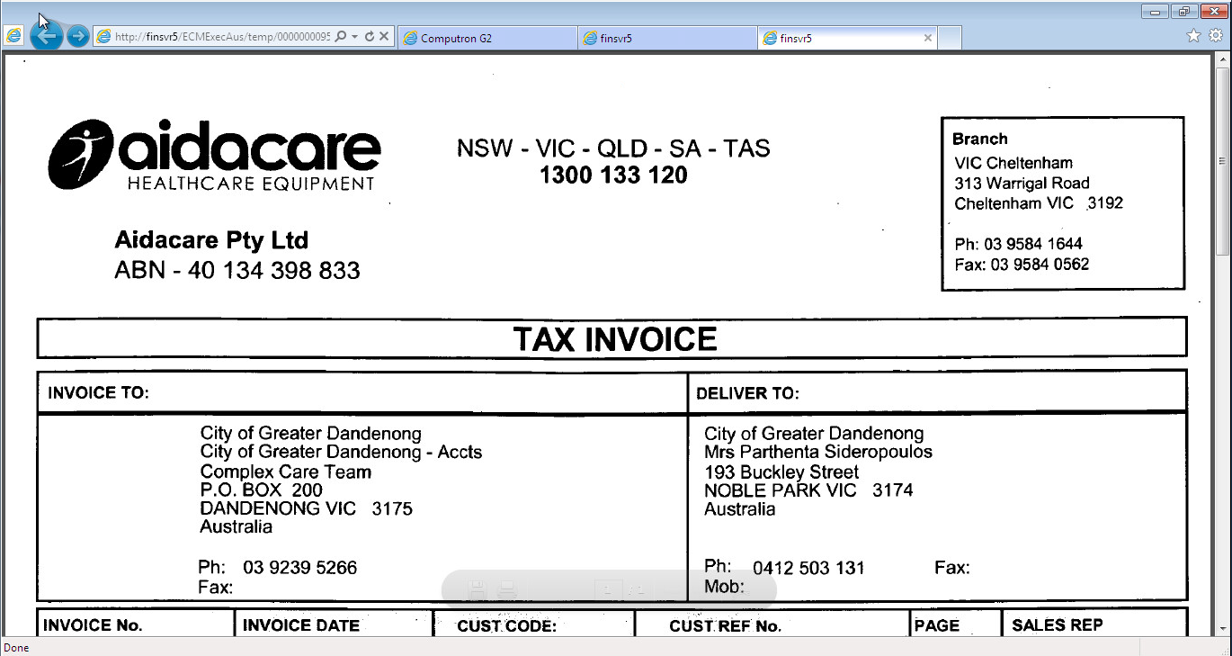
Note: The scanned image of the invoice can also be retrieved by pressing the Invoice Image button in the Invoices to approve screen.
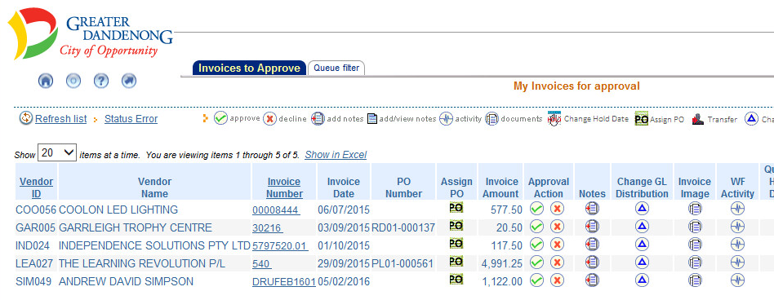

Approving Invoices Without a PO Number
- Once you have received an email with “Invoice Requires Approval” in the subject line, click on the link.
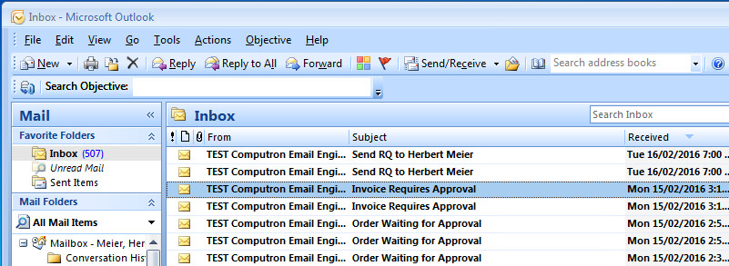

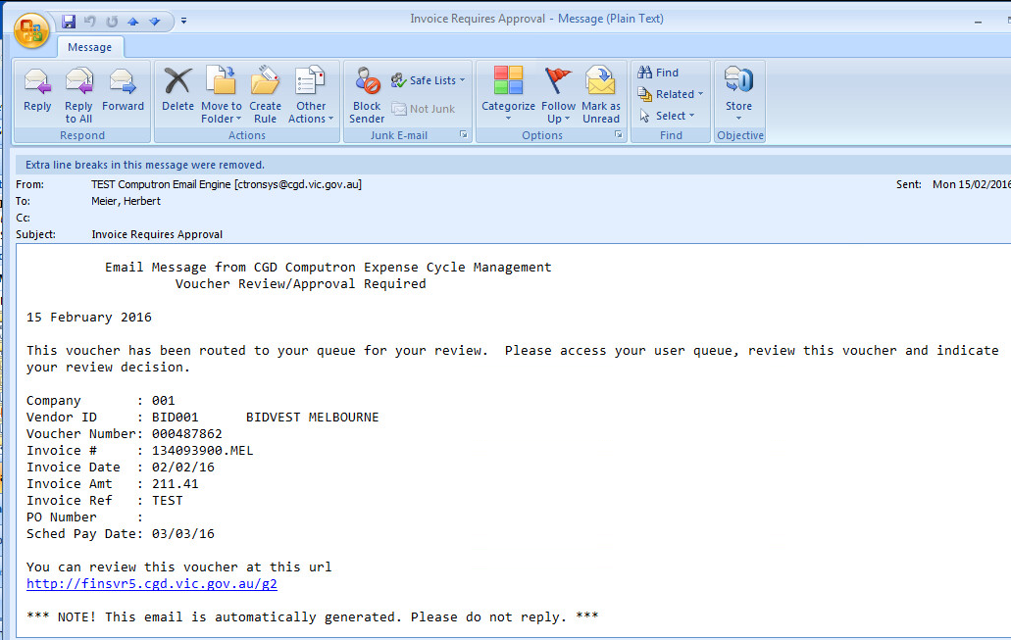
1

- Click on ECM Exec Invoice Approval from the G2 portal main menu.

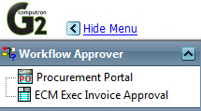
2
- You will be taken to the Invoices to Approve tab where you can click on the invoice number to see the invoice details
- To add the GL Account number click the triangle

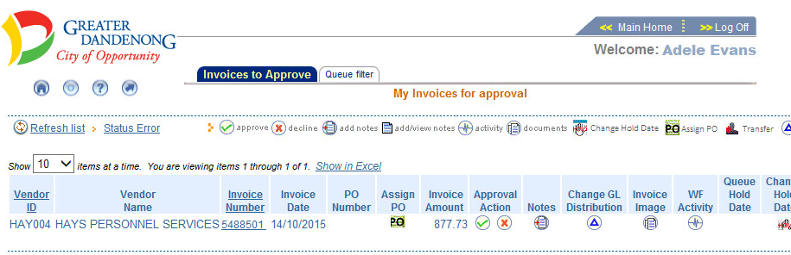
4
3

- Press the Add button.

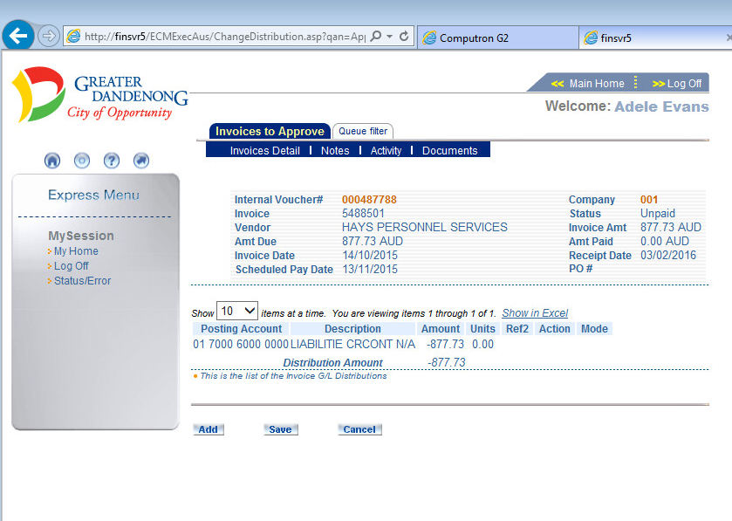
5

- Add posting account, amount and tax details. Press Save button.

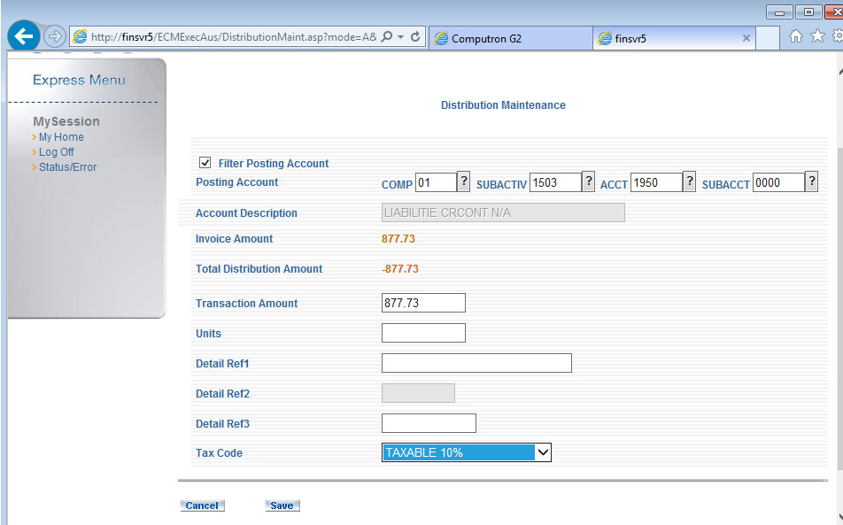
6

- Confirm account information has been added successfully. Press Save button.

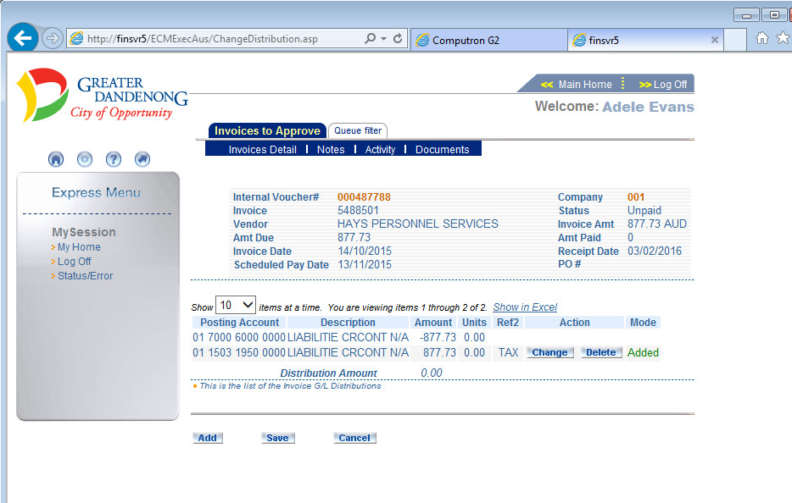
7

- Press the Approve button.

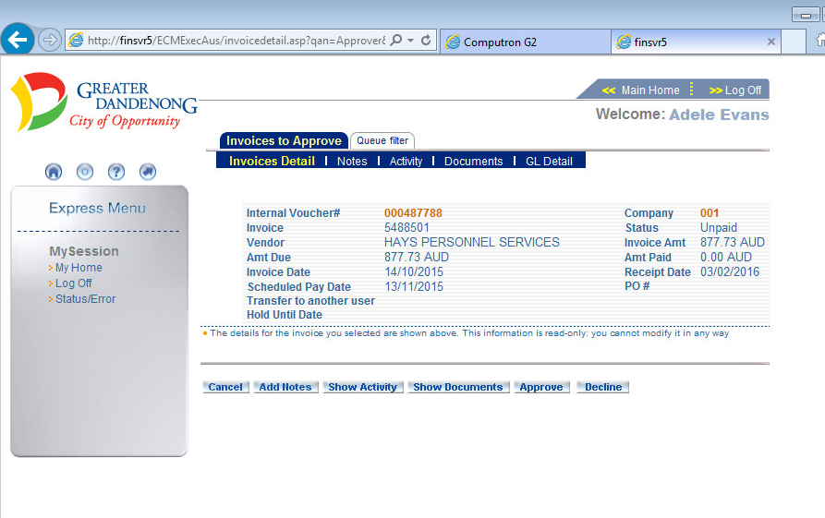
8

- Click the Ok button to approve the invoice.

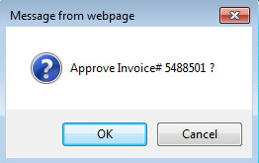

- Click Ok on the message confirming successful invoice approval.

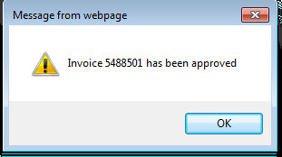

An email will be sent to your approver requesting them to also approve the invoice.

Logging Out

- Click the Log Out Now button at any time to log out of the system.

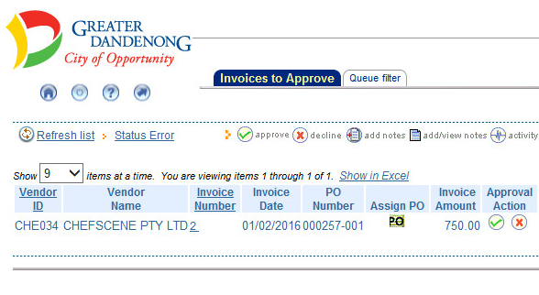
1

