

COMPUTRON G2
PROCUREMENT PORTAL

PROCUREMENT PORTAL USER GUIDE

Table of Contents
1 Overview 3
1.1 Logging on 3
2 Placing Orders By Vendor 4
2.1 Find Your Vendor 4
2.2 Placing an Order 5
3 Placing Orders by Item 11
3.1 Add Item to Order 13
3.2 Adding Additional Line Items 17
3.3 Saving and Completing Order 20
3.4 Resuming Saved Order 20
3.5 Submitting an Order 22
4 Placing Blanket Orders 25
5 Checking Order Status 26
5.1 Check Order By Status 27
5.2 Displaying Order History 28
5.3 Display Order WF Notes 28
5.4 Duplicating an Existing Order 29
Appendix A: Sample Email Forms 30
Appendix B: Process Flow 31
Appendix C: Procurement Guidelines 32
Appendix D: Search Filters 33
Appendix E: Advanced Search 34
Appendix F: Adding Quotes to an Order 35

Overview
The Procurement Portal solution simplifies purchasing processes and restores policy control, reducing overall cost. At the same time, both your procurement department’s need for control and your end user’s need for flexibility are satisfied.
The Procurement Portal transforms the traditional purchasing process beyond the back office to all employees who make purchasing requests.

Logging on
Click on the Computron G2 icon in Webstar to login.

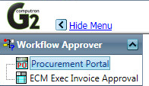

Placing Orders By Vendor
Select Place Order icon from the menu.
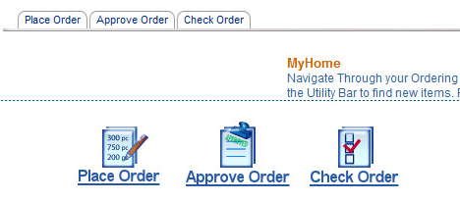
Note: You can click the My Home button to return to this screen at any time.

Find Your Vendor
- Click Place Order tab.
- Enter Vendor Name and press Go button.
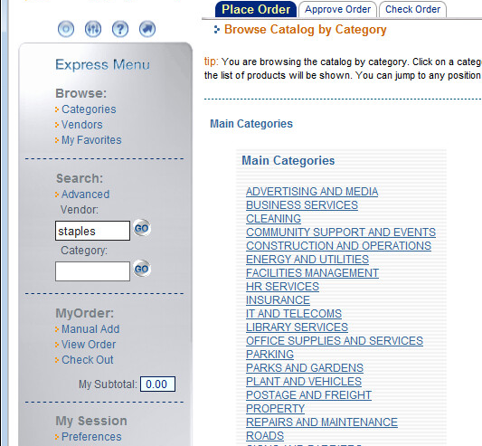
2
1
Note: You cannot press Enter to proceed. You must press the Go button.
- Click on Vendor Name.
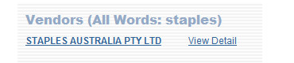
3

Placing an Order
Once you have selected your vendor you can place your order. For efficient order processing it is highly recommended that you have the account number ready before you place your order.

- Enter an amount into the Quantity field.
- Press the Add button.
2
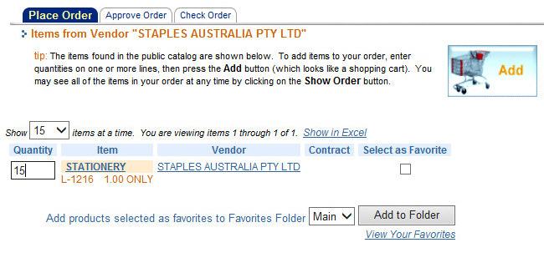
1

Note: Frequently used vendors can be set to favourites by selecting the “Select as Favourite” checkbox. A message will appear confirming vendor has been set to favourites.

Order Entry Fields

Field | Description
Order ID | Automatically generated by the system
Approver | Set by the system. Power users can make selection.
Green Component
Standard versus Social procurement | Select standard unless you are certain its Social.
Order Type | Select Goods and Services or else Works for Capital expenditure.
Order Rule | Refer to Webstar for Purchasing policies.

- Select Green Component and between Social or Standard Procurement.
- Select Order Type, Order Rules and if applicable Contract/Ref ID.
Note: If there is a contract associated with the vendor and your purchase relates to that contract, then you must select that contract when raising your purchase order.
- Press Change button.

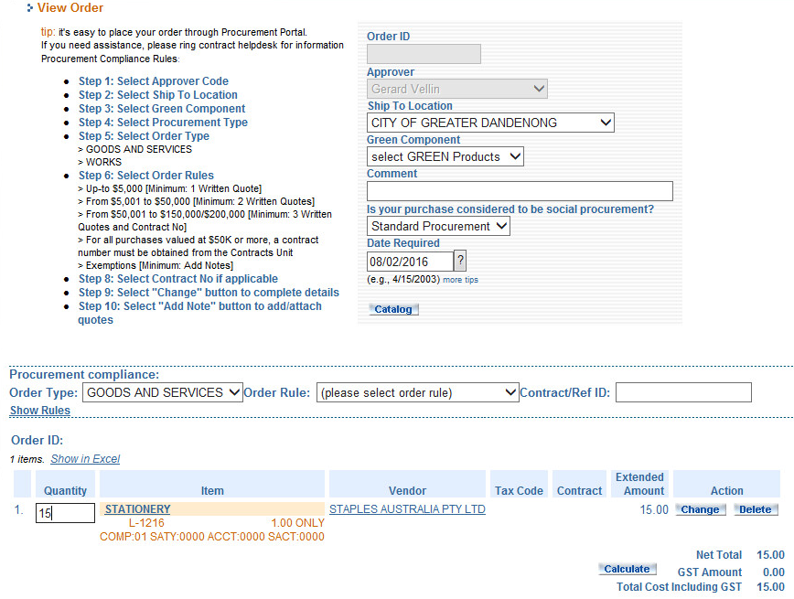
2
3
1

- Enter the unit price including GST in Price and Select EACH in Unit of Measurement (UOM). Select GST FREE or TAXABLE @10% in Tax Code.
- Enter an item description in the Vendor Note field.
- Enter any additional information for this item in Internal Note. This information will not appear on the PO. NB. The approver will see this information.
4
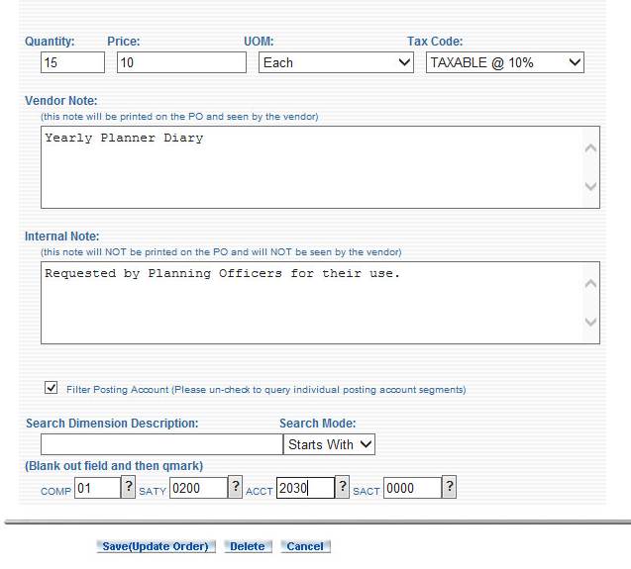
5
6
7
8

Note: It is recommended that Filter Posting Account is left checked and that you have your account number ready before you place your order. Unchecking this option will validate the account number you enter against all existing accounts when you finalise the order and will delay processing as it takes a considerable amount of time.
- Enter account number for the purchase.
- Press Save (Update Order) button.
- Press Add Note button.
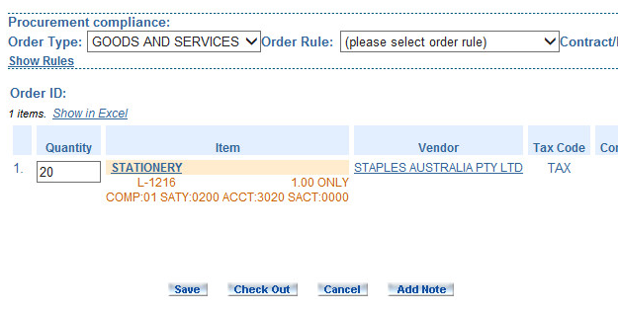
9
Note: You are not required to attach quotes for vendors with existing contracts. If you are placing an order with a vendor that does not have any existing contracts, Press Add Attachments button. A new menu will then appear. Browse to where your attachments are stored and press the Attach button to attach the files and the Complete button when you have finished attaching all quotes. Once that step is complete continue with step 10 below. For more details see Appendix F.

- Add order note and press Save Note button. This field is mandatory.

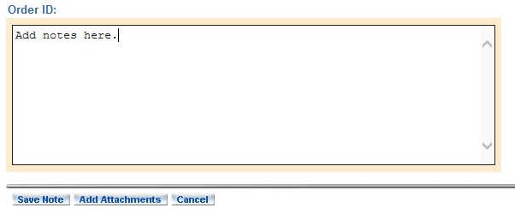
10

- Press Check Out button to complete the order.

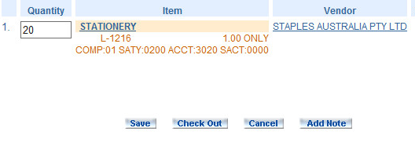
11

You will now be taken to the Final Review of Your Order screen as seen below.

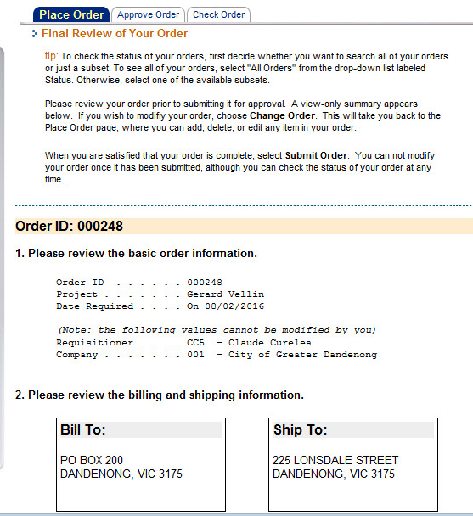

- Scroll down to the Submit Order As Is and press the button to submit the order.

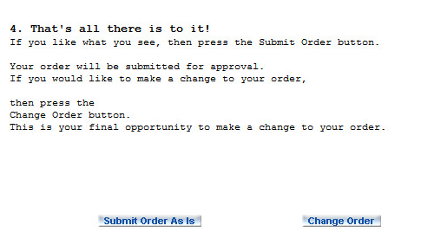
12

A message confirming that the order has been placed will appear as seen below.

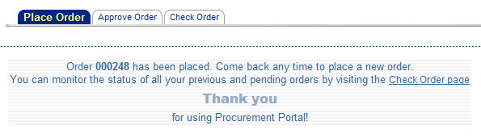

Placing Orders by Item

- Click on Categories under Browse on the Express Menu.
- Click on a Category to display related subcategories.

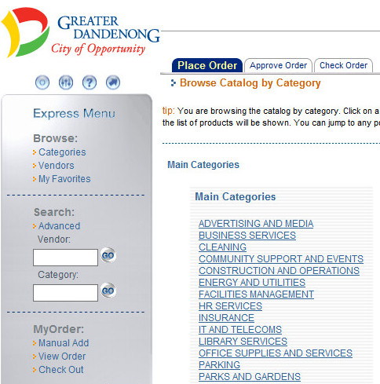
2
1

Note: You can also use Search to find a product or service.
- Click a sub-category to displays items for that category.
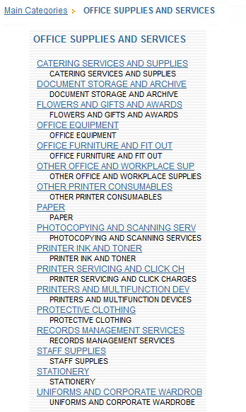
3

- Click on the item or vendor to see related details.
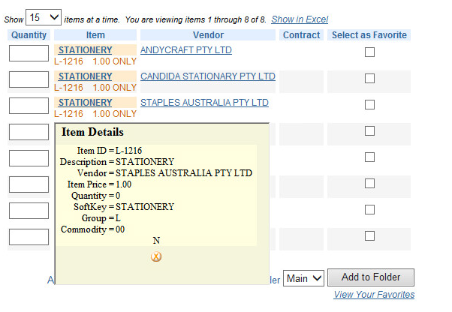
4
Note: click the Close button once you have reviewed item or vendor details.

Add Item to Order
- Enter an amount in the Quantity field.
- Click Add  button.
2
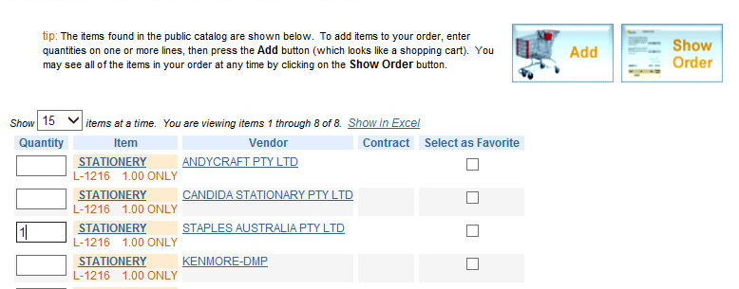
1

- Select Green Component and between Social or Standard Procurement.
- Select Order Type, Order Rules and if applicable Contract/Ref ID.

2
1

Note: For information regarding purchasing procedures and policies please see Webstar menu: HOW DO I > PURCHASE SOMETHING.

Procurement Compliance
Order Rules listed below relate to options in the Order Rules button drop-down menu.

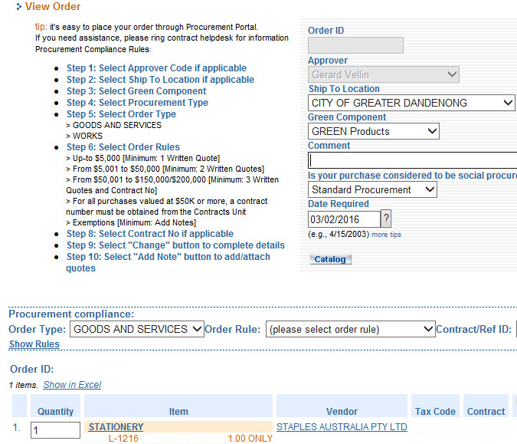

1

- Select Order Rules from drop-down menu.
- Select Contract Awarded option and click Contract/Ref ID drop-down menu.

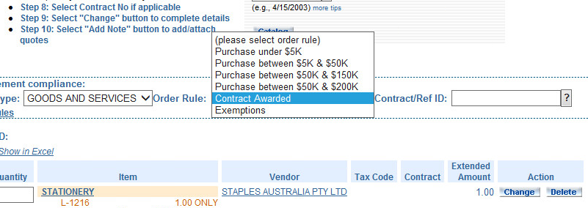

2
- Click on the contract number from listed contracts.

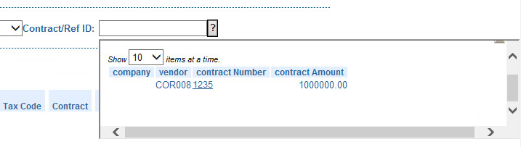
3

- The Contract number will now appear in the field.
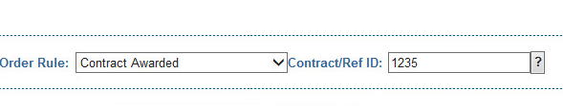
4

Specify Account for Purchase

- Click Change button.
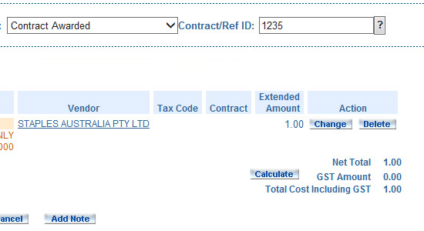
5
- Enter an amount in the Quantity field.
6
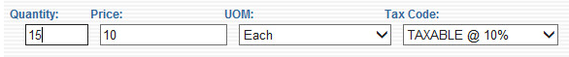
- Use TAB key to move between fields when entering the account code.

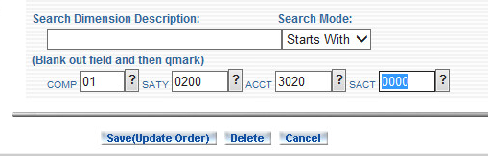
8
7

- Enter an item description in the Vendor Note field and press Save (Update Order).

Adding Additional Line Items

- Press Catalog button.

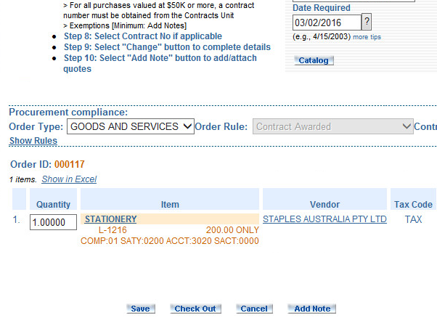
1

- Select from main categories and sub-categories.

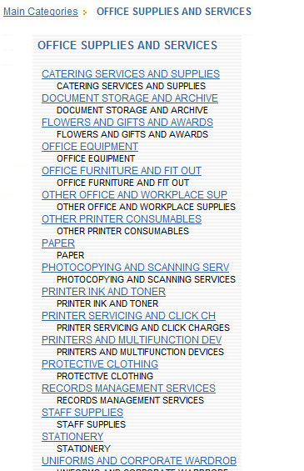
2

Note: You can only select categories that are valid for the current Vendor.

- Enter an amount into the Quantity Field for the existing vendor you are purchasing from.
- Press the Add button.

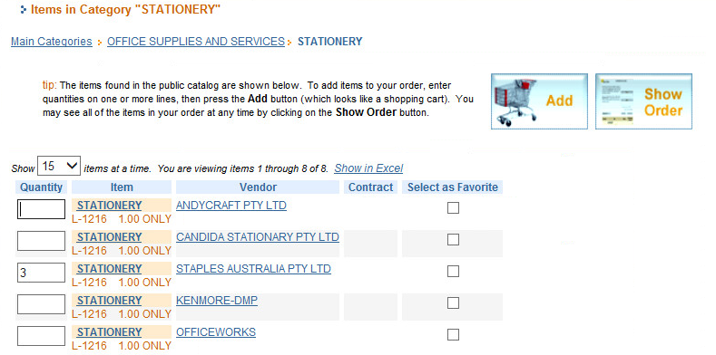
4
3

- The additional line item will now be listed in the order.
- Press Change button that corresponds to the new line item to change the account number as show in step 6 in previous section (3.1.2 Specify Account for Purchase).

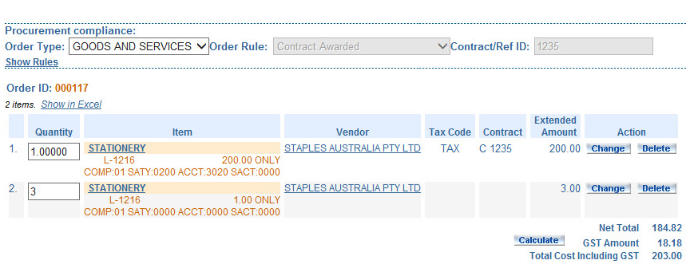
6
5

Saving and Completing Order
At this point you can do the following:
- Save the order and complete it at another time.
- Submit the order using the Check Out button.
- Add more items to the order by pressing the Catalog button.
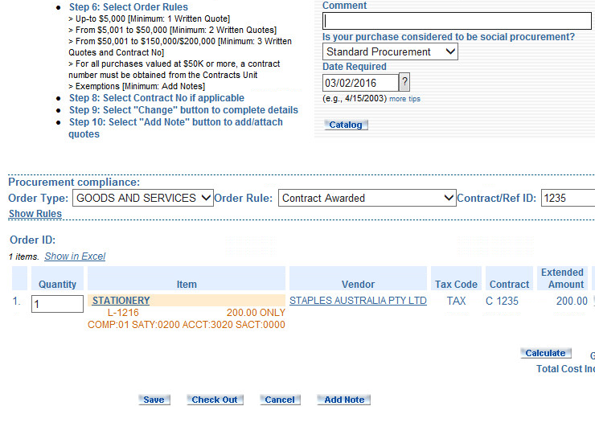
3
2
1

Resuming Saved Order

- If the order has been saved (option 1 above) it can be resumed using the Check Order tab.
1

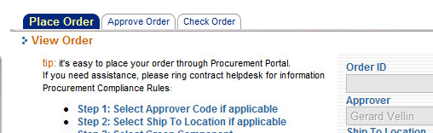

- Select the order from the list by clicking on the order number.
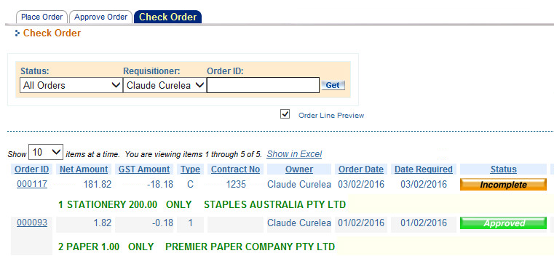
2

- Click Change button.
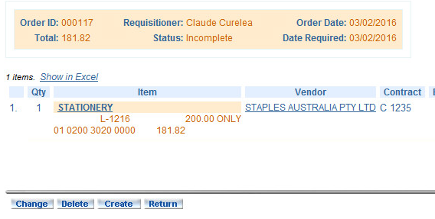
3

To submit the order, follow the steps on the next page.

Submitting an Order

- Once all mandatory fields have been entered and compliance rules have been met, press the Check Out button to submit the order.

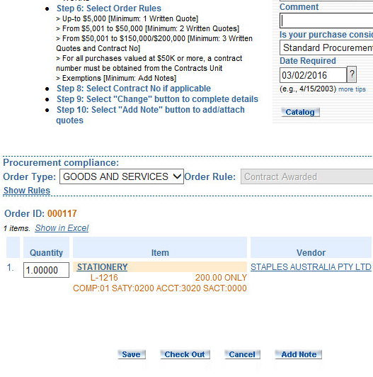
1

- Scroll down to Submit Order As Is button and press it to place the order.

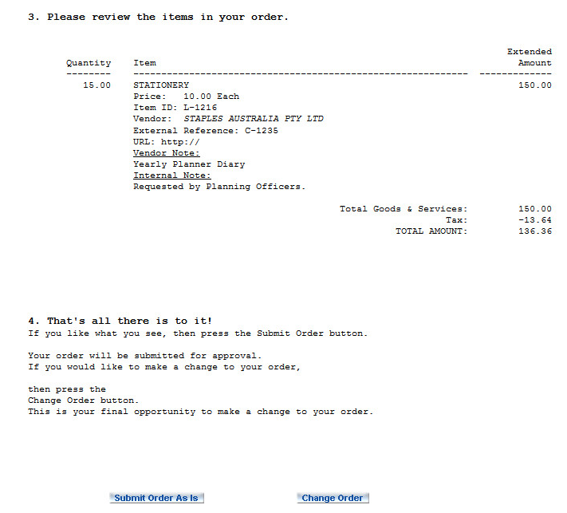
2

You will now be directed to the Final Review of Your Order screen as seen below.

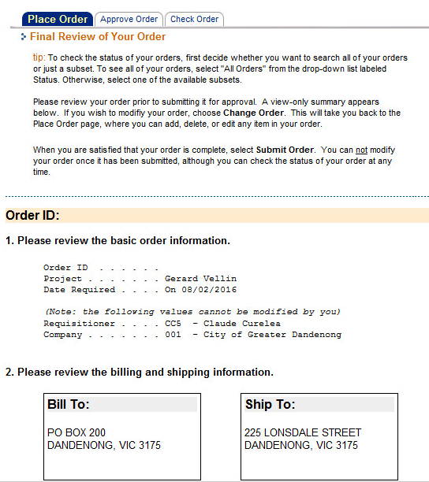

You will see confirmation that your order has been placed.
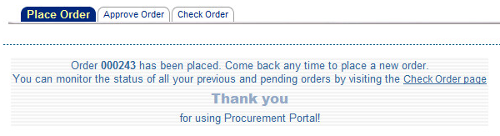

Placing Blanket Orders
Blanket orders are orders where spending approval has been obtained for an estimated, larger or yearly amount. Multiple or periodic invoices will be deducted from this approved amount.

These orders should be raised in the usual way as outlined in this document. The only exception is that they should be raised with the total amounts in the quantity field and the unit price set as $1. Refer to example below.

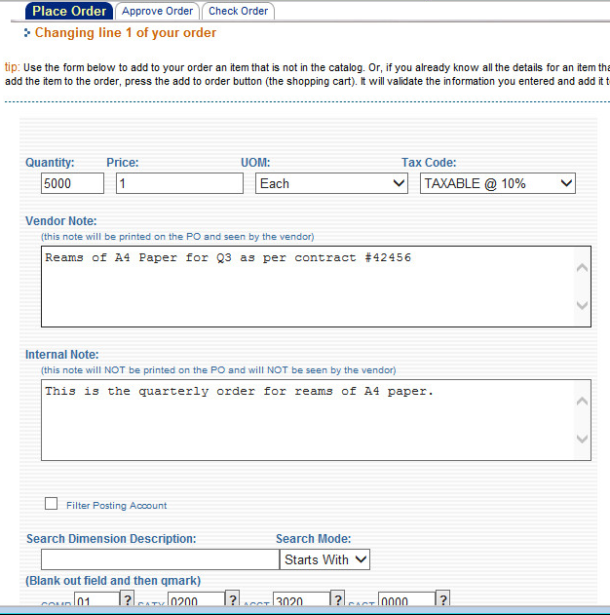

Checking Order Status
- Click either the Check Order tab or icon.
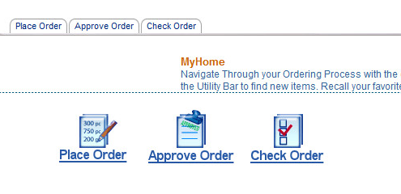
1

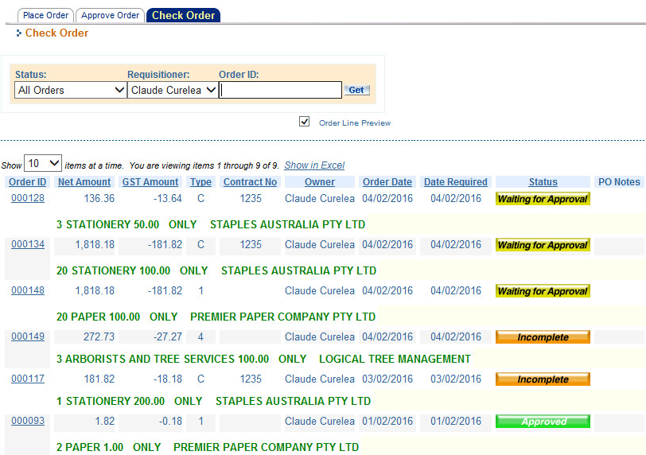

Order status values are as follows:
Order is approved and PO emailed/faxed to supplier.
Order is saved but incomplete.
Order is rejected by Approver.
Order is waiting for approval.

Check Order By Status
- Change status to “Waiting for Approval” and press Get button.
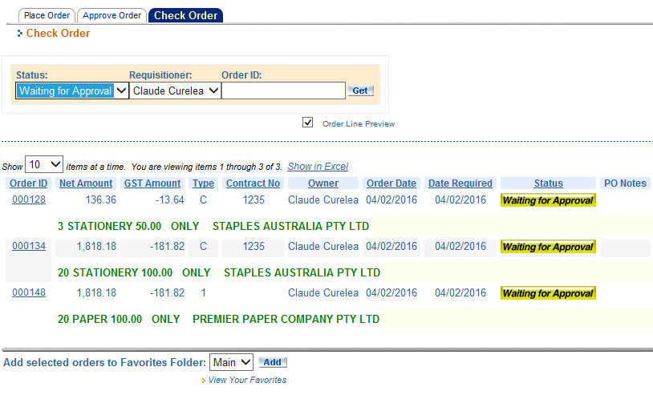
1

Displaying Order History
- Click History to display the order history.
1
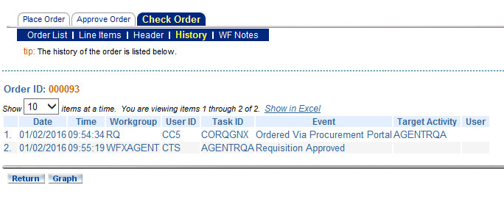

Display Order WF Notes
- Click WF notes to display notes and attachments for the order.
- Click the note to view the note details
- Click the filename to view the attachment
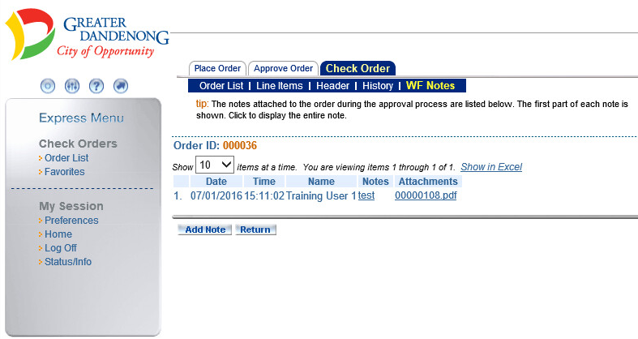
1
3
2

Duplicating an Existing Order

- Press Check Order tab.
1

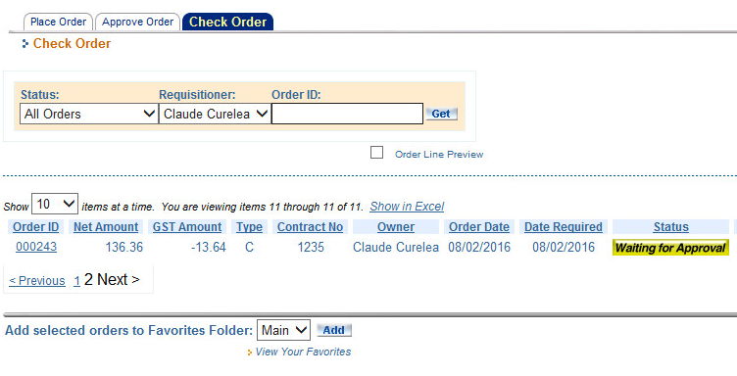
2

- Click on the order number.
- Press the Create button to create an order based on this one.
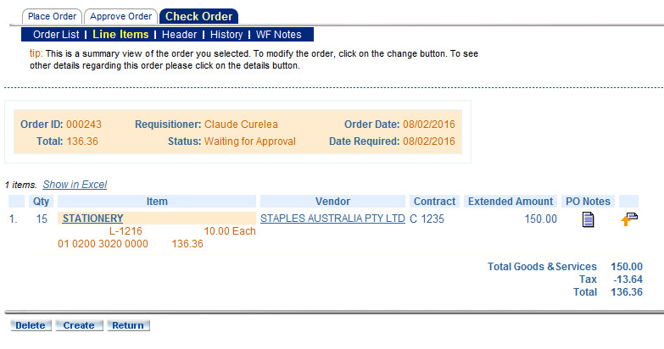
3

- Fill in the order details and submit the order as documented in Section 3.5.

Appendix A: Sample Email Forms
Greater Dandenong City Council has several Procurement Portal email templates to inform users of batch routed items and assist in deciding upon the urgency of requested actions.
Email templates are:
Template | Addresses
RQ/Order Waiting for Approval | Email to Approver
RQ 99999 Rejected | Email to Requisitioner when order is rejected
RQ Approval Reminder | Email reminder to approver from escalation agent
RQ Escalation Email Alert | Email to Approver when order is escalated
City of Greater Dandenong PO Number: XXXXX-XXX | Email to Supplier/Requistioner with PO document attached

Some of the ECM email templates to inform users of batch routed items and assist in deciding upon the urgency of requested actions are:
Template | Addresses
VOUCHER Requires Approval | Email from AP to Requisitioner/Approver
VOUCHER Rejected | Email from Requisitioner/Approver when voucher is rejected
VOUCHER Approval Reminder | Email reminder from escalation agent
VOUCHER Escalation Alert | Email to Approver when voucher is escalated

Sample email generated by ECM
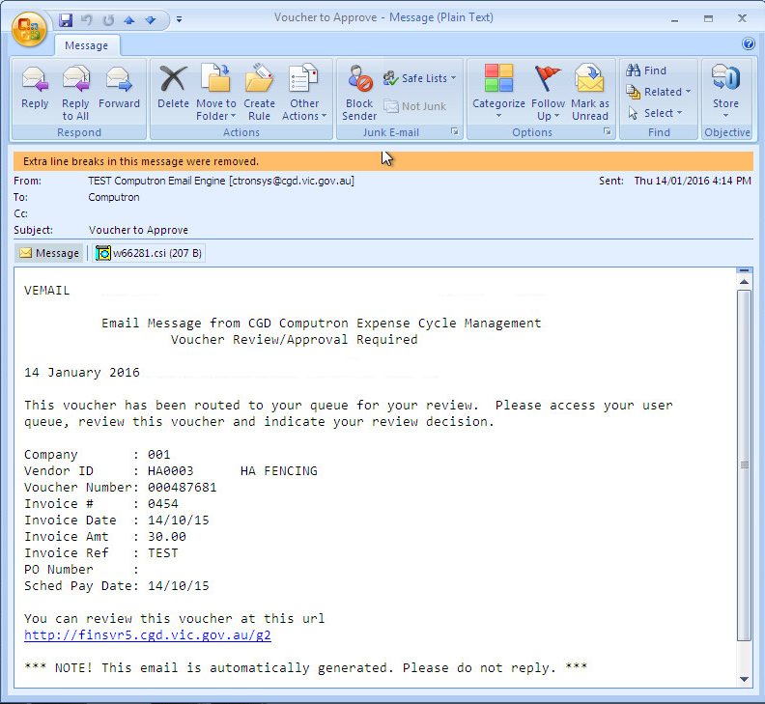

Appendix B: Process Flow
The Procurement Portal & Invoice Approval process flows:

Appendix C: Procurement Guidelines
‘Procurement Guidelines’ are conditional logic defined in the Compliance Rules table. It checks that certain information has been entered based on the total dollar value of the requisition. The compliance rules indicate options for proof of bidding, i.e. number of quotes or type of quote (notes or attachments). If an order above a prescribed amount has to be submitted for approval, it is routed to the procurement team for review before routing to the delegated approver.
Dual approval is compulsory regardless of requisitioner’s approval limit.
The following Order/Compliance Rules have been set up:
Requisitioner Level | Approval Limit
Requisitioner or Procurement Officer | $0

Approval Level | Approval Limit
User defined hierarchy | User defined in the approval table

For more details on the procurement guidelines see:
- Procurement policy dated June 2014 (2014 Final Procurement Policy (A1962481).docx)

Appendix D: Search Filters
The following filters are available:
Filter | Result
All Words | Retrieves descriptions containing all words in your search criteria.  e.g. If you enter ‘computer accessories’ will retrieve any description containing both words such as ‘computer servers, printers, accessories’
Any words | Retrieves descriptions containing any word in your search criteria.  e.g. If you enter ‘computer accessories’ will retrieve any description containing either word such as ‘computer servers, printers, accessories’ and ‘cables, accessories and routers’
Phrase | Retrieves descriptions containing exactly what you have written in your search criteria. e.g. If you enter ‘computer accessories’ will retrieve any description containing that phrase such as ‘computer servers, printers, computer accessories’
To search select a filter, enter search criteria and click Search
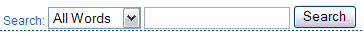

Appendix E: Advanced Search
Enables you to search by Description, Vendor or Item Number
Click Advanced under Search on the Express Menu > >
Enter search criteria “Alpha Sort” and click
Enter search criteria “Item ID” and click
System displays screen listing items and vendors that meet your search criteria.
Add item(s) to an order as per 3.1 Add Item to Order

Express Search Fields

Vendor
Enter search criteria in Search > Vendor and click to search.
You can select a vendor to raise a requisition.
Click View Detail to view supplier details: name, address & contact.
Click Vendor_Name to view products supplied by the vendor.

Category
Enter search criteria Category under Search and click to search
If Vendor cannot be found in search results you may need to contact the Finance Department to setup the vendor on the system

Appendix F: Adding Quotes to an Order

Press the Add Attachments button and from the menu that appears below browse the attachments. Press Attach button to attach files and press Complete button when finished.
