Network Services have set up a system where Council Staff can create a temporary WiFi account for guest presenters to access Council’s wifi system for a limited period.
The Council staff member creates the account and sets the time limit.
In a browser go the following address http://presenterWiFi.cgd.vic.gov.au to add the Presenter’s details.
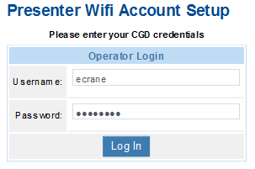
The following screen will appear to be filled out.
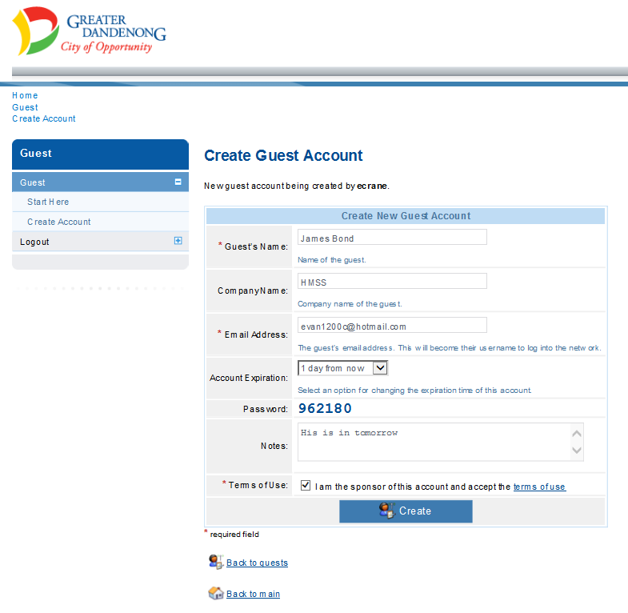

Mandatory Fields

When finished press Create.
Once created you will receive the confirmation screen as shown below.
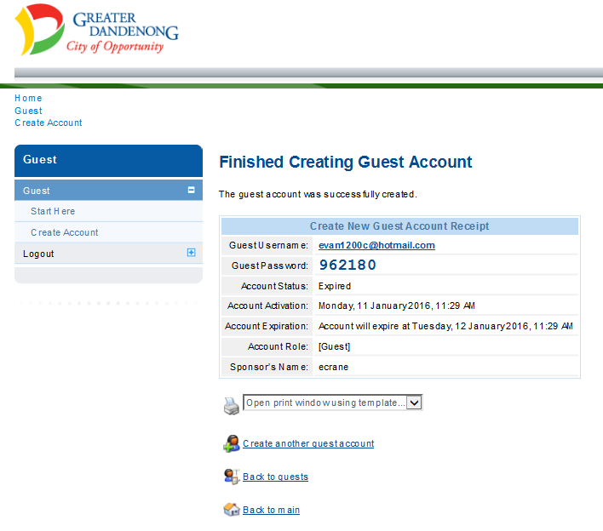
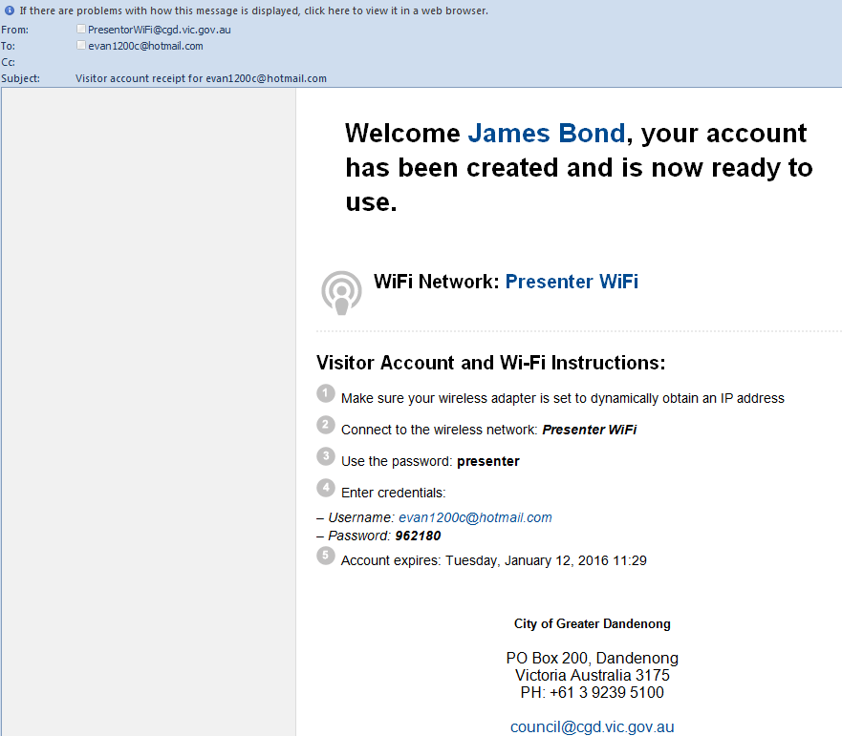
You will receive a copy of the email sent to the Presenter’s email account.
Keep this email just in case your presenter doesn’t have the details at your meeting.

The important details

The Presenter procedures.
1. At the Council office, the Presenter uses his device to connect to the Presenter WiFi network.
2. Type in the Network security key (Use the password displayed in step 3 on your email)
3. Open a browser (start to browse if required) where you will be asked for the Username (the email address) and the password that was sent to you.
You now have the amount of time that your Council Sponsor set for you.

