TechnologyOne Property & Rating
Introduction to Property Training Manual

Release 10.04
Participant Guide
QUALITY ENDORSEMENT - ISO9001:2000 Quality Management Systems - Requirements
COPYRIGHT
All rights reserved. No part of this publication may be reproduced, stored in a retrieval system or transmitted in any form or by any means electronic, mechanical, photocopying, recording or otherwise, without the prior permission of Technology One Limited.
SUPERSESSION CLAUSE
Upon receipt of this document please ensure any earlier versions are destroyed. No earlier versions may be retained without the written permission of Technology One Limited
DOCUMENTATION INFORMATION
Publication Ref: Rel10.4_Prop_Intro_to_Property_Participants_Guide.doc
Version Number: 1
Version Date: 7 May 2008

1 Workshop Overview 4
1.1 Purpose 4
1.2 Audience 4
1.3 Prerequisites 4
1.4 Outcomes 4
1.5 Screen shots 4
1.6 Privacy 5
2 Introduction to Property and Rating 6
2.1 Overview 6
2.2 Modules 6
2.3 Module-specific training 6
2.4 Journals 6
3 Record Types 7
3.1 Overview 7
3.2 Property 7
3.3 Name 7
3.4 Land 7
3.5 Address 8
3.6 Application 8
4 Related Data 9
4.1 Overview 9
4.2 Associations 9
4.3 Attributes 10
4.4 Memos 10
4.5 Aliases 10
4.6 Theme Associations 11
5 Roles and Workplaces 12
5.1 Overview 12
5.2 What is a role? 12
5.3 One user can have multiple roles 12
5.4 Many users – one role 13
5.5 Workplaces 13
5.6 Elements of a Workplace 13
5.7 Menu Bar 14
5.8 My Icon Panel 14
5.9 Role name 14
5.10 Tabs 14
5.11 Button Bar 14
5.12 Workplace area 14
5.13 Workplace footer 15
5.14 Participant activity 15
5.15 Learning check 15
6 Changing Your Workplace 16
6.1 Overview 16
6.2 Procedure 16
6.3 Participant activity 18
7 Navigating an Enquiry Window 19
7.1 Overview 19
7.2 Enquiry window 19
7.3 Elements of an Enquiry window 20
7.4 Entering search criteria in an enquiry window 22
7.5 Participant activity 23
8 Performing a Name Enquiry 24
8.1 Overview 24
8.2 Procedure 24
8.3 Participant activity 28
8.4 Learning check 28
9 Performing an Address Enquiry 29
9.1 Overview 29
9.2 Address formats 29
9.3 Procedure 29
9.4 Participant activity 34
9.5 Learning check 34
10 Performing a Property Enquiry 35
10.1 Overview 35
10.2 Procedure 35
10.3 Learning check 39
11 Performing a Land Enquiry 40
11.1 Overview 40
11.2 Procedure 40
11.3 Participant activity 43
12 Performing an Application Process Enquiry 44
12.1 Overview 44
12.2 Procedure 44
12.3 Participant activity 48
12.4 Learning check 48
13 Performing an Advanced Search 49
13.1 Overview 49
13.2 Procedure 49
13.3 Participant activity 53
14 Running a Report 54
14.1 Overview 54
14.2 Procedure 54
14.3 Participant activity 58
15 Searching and Making a Favorite 59
15.1 Overview 59
15.2 Searching for a task 59
15.3 Making a Favorite 61
15.4 Participant activity 64
16 Skills Practice 65
16.1 Self-assessment 65
16.2 Activity 66
16.3 Purpose 66
16.4 Details 66
17 Workshop Completion 67
17.1 Sand pit 67
Appendix A - Glossary 68
Appendix B - Revision History 69

Workshop Overview

Purpose
The purpose of this Participant Guide is to provide a support tool for course participants during and after the Introduction to Property & Rating workshop.

Audience
This training is aimed at any one who uses or does enquires within the Property and Rating system
Contractors who have a need to use the TechnologyOne Property & Rating system will also be required to complete this module.

Prerequisites
All participants in this course should have Completed the “Intro to Ci” course.

Outcomes
On completion of this workshop, participants will be able to:
- Explain the purpose and function of the Property & Rating system
- Briefly explain the following key concepts:
- Record types
- Related Data
- Roles and Workplaces
- Log on and off the system
- Select a Task
- Change Workplaces (optional)
- Perform the following types of enquiries:
- Name enquiry
- Address enquiry
- Property enquiry
- Land enquiry
- Application enquiry
- Perform an advanced search
- Run queries and reports from enquiry results
- Navigate between records in Property & Rating and GIS
- Use Search to locate menus and tasks (optional)
- Make a Search into a Favourite (optional)

Screen shots
The screen shots provided in this Participant Guide are intended to provide visual confirmation that you are in the correct screen when working with the system.
They are not intended to act as a detailed reference because of formatting restrictions.

Privacy
The training database contains an exact copy of the data contained in the real database, for example, ratepayer names and addresses. It is, therefore, essential that you ensure that the Council’s normal confidentiality and data management rules are followed when working with this information.

Introduction to Property and Rating

Overview
The TechnologyOne Property & Rating system provides extensive functionality for managing processes.

Modules
Property & Rating contains the following modules:
- Nucleus (Land, Property, Name, and Address record management)
- Regulatory (Applications)
- Customer Service
- Request Management
- Debtors
- Waste Management
- Property Data Management
- Property Lease Management
- Rates
- Debt Recovery
Property & Rating is integrated with TechnologyOne Financials, TechnologyOne Works, TechnologyOne ECM and GIS.

Module-specific training
In addition to this Introduction to Property training, you will be required to attend training in the modules which are relevant to your role.

Journals
All Technology One Property & Rating financial transactions must be assigned to a Journal. A Journal is bucket for holding like transactions as a group so that they can be processed together.
Different modules have different types of journals. For example, transactions generated by cashiers may be posted to a Receipting journal. Journals are posted to the General Ledger on a daily basis.
Information regarding journals will be included in module-specific training sessions.

Record Types

Overview
Information in the Property & Rating system is held in a variety of record types. These are:
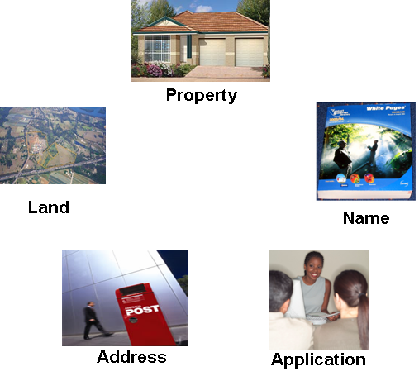
You can search for information in the system using property, name, land, address or application details.

Property
Properties are usually based on physical and legal land parcels.
A Property may:
- Consist of many land parcels, for example: large rural properties, or industrial estates
- Exist independently of the Land, Address and Name records.
Individual properties may have associations (i.e. relationships with other properties, for example:
- Units within a strata plan
- Shops within a shopping centre.
The Property record is the main record type in the Property & Rating system.

Name
A Name record exists for each person, business or other type of organisation that is recorded within the system.
One Name can be associated with one or many properties. One Name can have separate service (i.e. postal) and residential addresses.

Land
The Land record contains physical information relating to the:
- Legal description (e.g. lot and plan)
- Dimensions
- Area and controls of a parcel of land (e.g. zoning codes).
Information related to a land parcel e.g. planning and zone codes can be connected to the Land record.

Address
The Property & Rating system contains a record of all known addresses within and outside the Council boundaries.
Addresses can be property address, i.e. addresses associated with a Property record.
Addresses can also be postal addresses. These can be associated with a Name record.

Application
The Property & Rating system contains a record of all applications that have been entered into the system. There are various types of applications, for example:
- Development applications
Applications can be associated with a name and/or property record. For example, a development application would typically be associated with the owner of the property and the property to be developed.

Related Data

Overview
All records in the Property & Rating system can have related data, for example:
- Associations
- Attributes
- Memos
- Aliases
- Theme Associations
Related data is displayed in the left-hand side (i.e. Task Pane) of a record window, as shown in the example below:
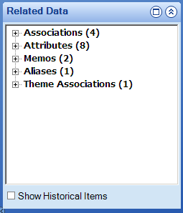
Related data can be added to any type of record.

Associations
Associations contain information regarding the connections between modules, in particular, Land, Address, Property, Name and Application records.
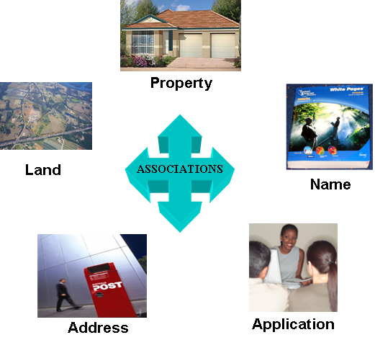
For example:
- A person’s Name record may have an association with the Property record of the property they own
- A Property record may have an association with a related land parcel
- An Address record may have an association with a person who resides at that address
Associations provide two-way links between records.

Attributes
Attributes are used to capture further information or characteristics of a record. Attributes will vary depending on the type of record.
Examples of Attributes for a Property record are:
- Bins
- Residential Rate
- VG Valuation
Examples of Attributes for a Land record are:
- House restriction
- LPS Locality
- Zoning
- Contaminated Land

Memos
Memos allow the recording of comments against records in the system.
Examples of Memos for a Property record are:
- Rates conversion memo
- Valuation change memo
- Pensioner Living in a Nursing Home memo

Aliases
The purpose of an Alias is to record additional information about a particular record. Examples of Aliases are:
- Valuation number of a property
- Former name of a person (e.g. a woman’s maiden name)
Aliases provide another method of searching for records.
Aliases are being used to record information from legacy systems.

Theme Associations
Theme Associations are used to link related data into a common concept.
Examples of Theme Associations are:
- Easements which affect multiple land parcels
- Waste zones for a property
- By-laws which affect a particular area

Roles and Workplaces

Overview
Understanding the concepts of Roles and Workplaces is central to using Property & Rating. This topic provides a definition of the concept of ‘Role’, and a description of the Workplace.

What is a role?
A Role groups together the business functions that are performed by a particular group of people within the organisation.
For example, Customer Service Officers perform a number of business functions, including:
- Handling customer enquiries
- Creating and maintaining applications
- Receipting
Customer Service
Handling customer enquiries

Creating & Maintaining Applications

Receipting

Therefore, these functions (and others) will comprise the Customer Service Role.

One user can have multiple roles
Users are given access to a Role, or series of Roles, depending on the business functions that they perform. For example, if they are a Customer Services Officer, they will have access to the Customer Service Role.
However, a Customer Services Officer may also perform waste management functions. In this case, they will have access to the Customer Service and the Waste Management Roles.
Customer Service Role

Waste Management Role
Joe Bloggs

Many users – one role
Many users can have the same Role.
Customer Service Officer
Pete

Sally

Joe

Workplaces
The Workplace is the window that is displayed when you log on. It is the gateway through which you can access all the tasks and functions that make up your Role.

Elements of a Workplace
A Workplace is made up of various elements, as shown in the example below:
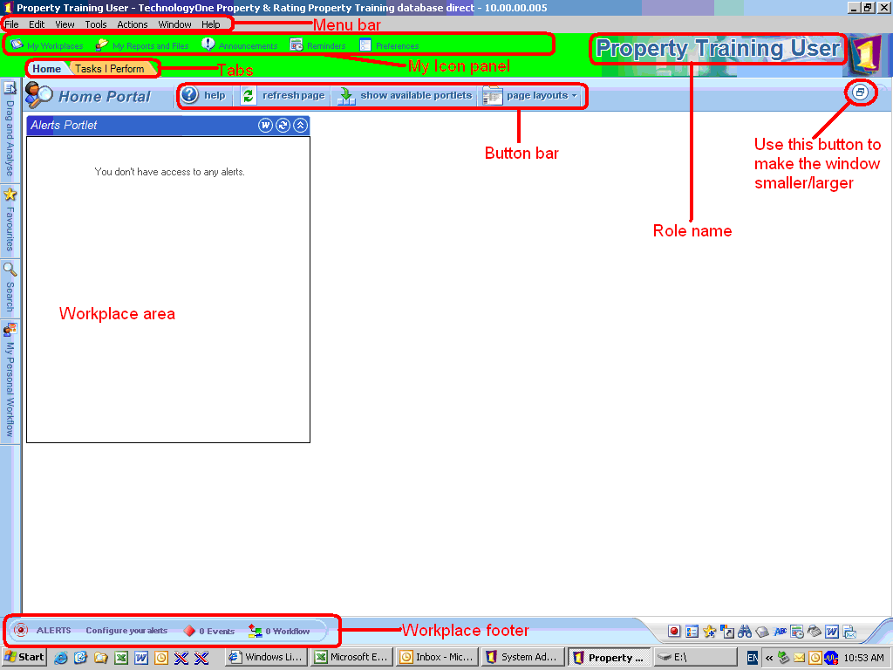

Menu Bar
The Menu Bar is made up of many Menus. Each Menu contains a group of commands sometimes referred to as items. Some items open a fly-out menu where further selections can be made. Other items complete an action immediately. If a Menu item is greyed out, the command is unavailable.
Many of the Menu item functions (e.g. opening or closing a Workplace) can also be activated by the buttons and links displayed in the Workplace.

My Icon Panel
The My Icon Panel allows access to:
- My Workplaces – displays available Roles
If the user only has one Role, this link will not be displayed.
- My Reports and Files – displays reports and files you have generated
- Announcements – displays latest announcements
- Reminders – displays reminder notices
- Preferences – enables users to change settings, e.g. the way windows are displayed.
You should not change any of the Preference settings.

Role name
The Role Name may vary if you have more than one role. If this is the case, it will change depending on which Role you have selected.
In the previous example on, ‘Property Training User’ is displayed as the Role Name.

Tabs
The Tabs allow you to access the following windows:
- Home Portal – the window displayed when you log in
- Workplace Tab – displays all the common tasks for the selected or default Role

Button Bar
The Button Bar displays buttons which you can use to perform specific functions.
The buttons which are displayed on the Button Bar will change depending on which tab or window you are in.
For example, in the Home tab, the ‘refresh page’ button is displayed; in the Tasks I Perform tab, the ‘back’ and ‘retrieve’ buttons are displayed.

Workplace area
What is displayed in the Workplace area will vary depending on which tab you have selected
The Home Portal will typically display alerts in separate Portlet, i.e. a separate frame which displays content.
The Tasks I Perform window will display a list of tasks that are relevant to your Role. This is an important window to help you navigate to the functions for your role.

Workplace footer
The Workplace footer displays system messages, such as alerts, or error and warning messages.

Participant activity
When asked by your trainer:
- Log on to Property & Rating again.
- Place your cursor over each of the menus in the Menu Bar to display the menu items.
- Place your cursor over each of the buttons on the Button Bar to display the pop-up text for the button.
- Click on the Tasks I Perform tab.
- Click on the Home tab to return to the Home Portal.

Learning check
To check your understanding of what you’ve learned, answer the following questions:
1. True or False? Each user can have only one role.

2. True or False? When you log in, your default Role and Workplace are displayed.

3. True or False? The Workplace is the window through which you can access all the tasks and functions that make up your Role.

Changing Your Workplace

Overview
As a user of the Property & Rating system you may have access to more than one role. If this is the case, you can easily change roles by changing your Workplace. You do not have to log out of and back in to the system.

Procedure
To change your Workplace, follow these steps:
Step 1.
In the Property & Rating Home Portal, click on the My Workplaces link in the My Icon Panel.
Result: The Open Workplace window displays a list of available roles as shown in the example below:
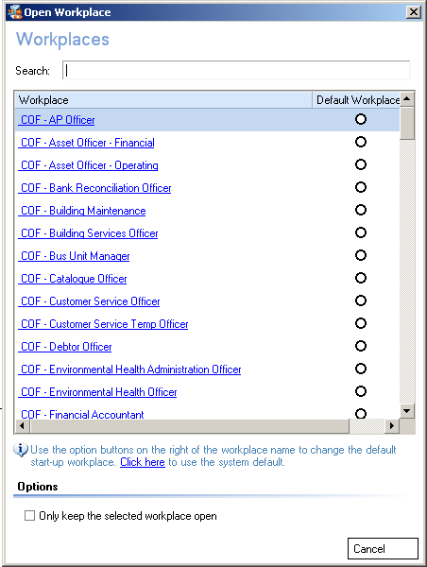
Step 2.
Click on the required role in the list.
Result: The Property & Rating Home Portal for the selected role will display. The original Workplace is not closed. You can access it again by clicking on the icon for that Workplace in the Windows task bar at the bottom of the screen, as shown below:
Access your role-specific system tasks by clicking on the Tasks I Perform tab.
Result: A list of role-specific system tasks will display, as shown in the example below:

Step 4.
Click on the relevant task button to access the required task.
Information on performing role-specific system tasks is provided in the relevant Participant Guide for each job role.
Step 5.
To close the Workplace, click in the top right-hand corner of the window.
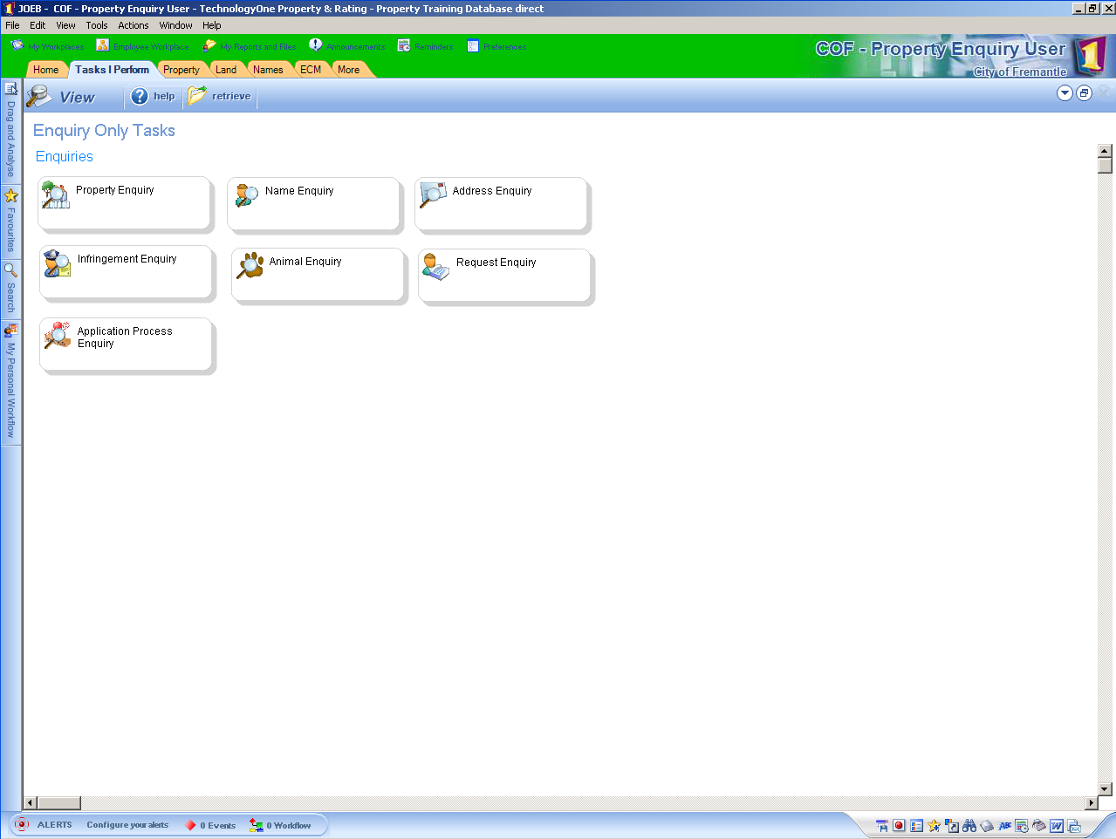
End of Procedure.

Participant activity
When asked by your trainer:
- Click on the My Workplaces link and select another role from the Open Workplace window.
- Click on the Tasks I Perform tab. What tasks are displayed?
- Close the Workplace you just opened.
- Restore your original Workplace by clicking on the Workplace icon in the Windows taskbar.
Not all users will have access to more than one Workplace when they log into the Property & Rating system with their own logins.

Navigating an Enquiry Window

Overview
Property & Rating allows you to enquire on a wide range of customer, property and rating information using Enquiry windows.

Enquiry window
The screen below displays the Enquiry - Property window. The elements in this window are typical of all Enquiry windows.
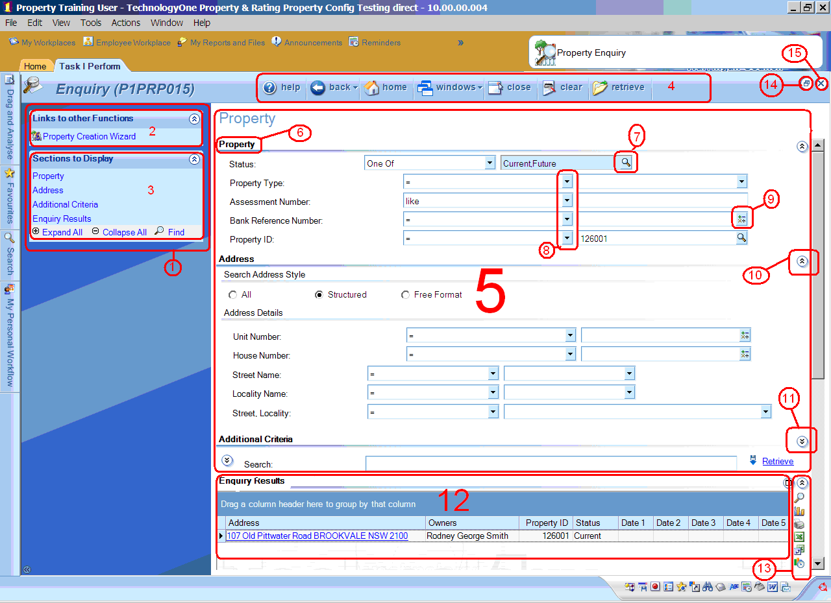
The Enquiry – Property window is accessed by clicking on the Property Enquiry task button in Tasks I Perform.

Elements of an Enquiry window
Following is a description of the main elements of an Enquiry window.

1. Task Pane
Contains sections such as Links to other Functions and Sections to Display.

2. Links to other Functions
Contains links to related functions.
When you click on a link in this section a new window for the related function is displayed. The window you were in remains open but hidden in the background.
If you want to return to the original window, click the button at the top right-hand corner of the current window.

3. Sections to Display
Lists the names of all the sections in the currently displayed form.
When you click on a link in this section the selected section will be displayed in the form on the right.
The Expand All button is used to expand all sections in the form.
The Collapse All button is used to hide the detail of all sections in the form, leaving only the section headings displayed.
The Find button is used to search for an item in the form.

4. Button Bar
The buttons displayed in an Enquiry window typically include:
- Help: Opens online help. This is not currently available.
- Back: Returns to the previously displayed window.
- Home: Returns to the Home Portal.
- Windows: Displays a list of currently open windows and allows you to navigate to them.
- Close: Closes the currently displayed window.
- Clear: Clears the search criteria and search results currently displayed.
- Retrieve: Displays search results based on the search criteria you have entered. Also refreshed the page.

5. Form
Contains a number of sections and fields for entering your search criteria.
For instructions on how to enter search criteria, refer to Entering search criteria on Page 31.
The sections and fields displayed will depend on your role and the particular enquiry window you have accessed.
Also contains a grid which displays the search results.

6. Section Heading
Each section in a form has a section heading.
You can expand a section by clicking on the section heading.

7. Picklist
Opens a separate window that displays a list of possible entries for that field. Select an item from the list and it will be displayed in the field.

8. Dropdown list
Used to select an entry from a list of possible entries for the field. Select an item from the list and it will be displayed in the field.

9. Calculator
Displays a calculator which you can use to make numeric calculations and enter these into the field.

10. Rollup button
Used to collapse the section so that only the heading is visible.

11. Expand button
Used to expand the section so that all the contents are visible.

12. Enquiry Results
Displays the results of your enquiry in a grid when you click on the Retrieve button or link.
You can click on a link in the Enquiry Results grid to display the window for that record.
You can perform a number of actions on the grid e.g. sort columns and adjust column width.

13. Grid Toolbar
The buttons in this toolbar allow you to perform a series of actions on the data in the grid:
Searches for text within the grid
Displays the contents of the grid in graph form
Prints the contents of the grid
Exports the contents of the grid to an Excel spreadsheet
Exports the contents of the grid to an Excel Pivot table
Publishes the contents of the grid (Not currently in use)
Exports the contents of the grid to a Word document for mail merge
Displays the Options menu for customising the appearance of the grid, with the Customise Columns options allowing you to add or remove columns from the grid.
Saves changes that you have made to the grid

14. Contract window button
Makes the current window smaller, to expand the window, click on the button again.

15. Close button
Closes the current window

Entering search criteria in an enquiry window
The screen below is of a section of the Enquiry - Property window. The fields displayed are for entering search criteria.
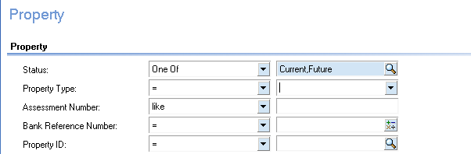
When entering search criteria, keep the following principles in mind:
- Each search item, e.g. Status or Property Type, has two fields.
- The field on the left allows you to select a search operator such as ‘=’ or ‘like’, etc. You can leave this field as default, or you can select a different search operator by clicking on the button, and selecting one from the drop-down list.
- If you use the search operator ‘=’, only records which match your search criteria exactly will be retrieved.
- The field on the right is for entering or selecting your search criteria. If the field has a drop-down list button, you can either click on this to display the drop-down list, and then select an entry. Alternatively, you can type the search criteria directly in the field. This is useful for avoiding scrolling when the list is a long one.
- Search entry fields are not case sensitive.
Example: Search Entry Fields
If you want to search on the Property Type ‘Resident’, you can select:
- ‘=’ in the field on the left, and
- ‘Resident’ in the field on the right.

Participant activity
When asked by your trainer:
- Click on the Tasks I Perform tab, and then click on the Property Enquiry button. What is displayed in the Links to other Functions section?

- Click on the links in Sections to Display. What happens in the form?

- Click on the Windows button. How many windows do you currently have open?

- Navigate to another open window.

- Navigate back to the Enquiry - Property window, using the Windows button.

- Click on the button in the second Property Type field on the right-hand side. How many property types are displayed?

- What window is displayed when you click on the button in the Property ID field?

- If Additional Criteria fields are not already displayed, click on the button next to the Search field to display them. How many new fields are displayed?

- Click on the button next to the Search field to hide the Additional Criteria fields.

- Roll your cursor over the buttons in the grid toolbar to view a description of each.

- Close the current window.

Performing a Name Enquiry

Overview
Use this procedure to perform an enquiry using a customer’s name.
A customer can be an individual, business or other type of organization.
Important information
This enquiry task is available to all Property & Rating users. If this task does not display in your Tasks I Perform tab, change your Workplace to ‘ COF - Property Enquiry User’.

Procedure
To perform a name enquiry, follow these steps:
Step 1.
From your workplace Menu Tab go to the Name Menu and select the Name Enquiry. option
Result: The Enquiry - Name window displays, as shown below

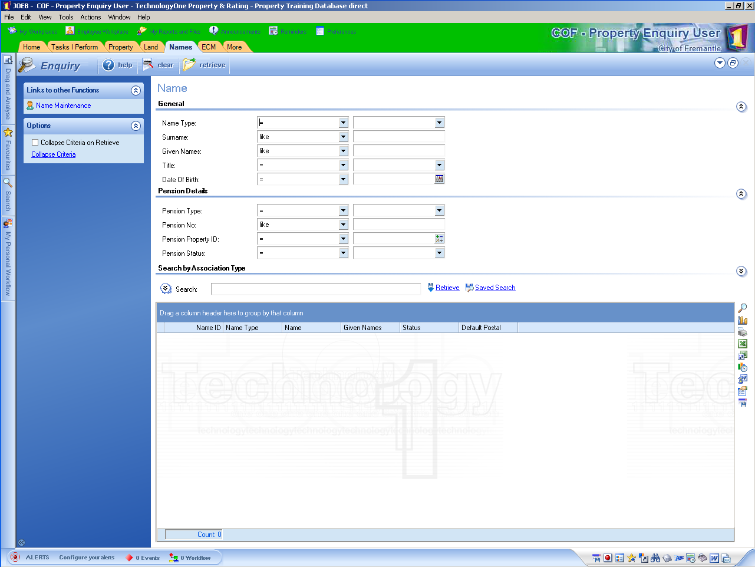
Step 2.
Complete the Surname and Given Names fields.
If searching for a business name, complete the Surname field only.
Tips:
- You can enter the first and middle names in the Given Names field. If you do not know the person’s middle name, ensure you leave ‘like’ selected in the field on the right. This will retrieve all name records that have the person’s first name.
- If you want to search for a name of which you are not exactly sure of the spelling, leave ‘like’ selected in the field on the left, then type the name or part of the name in the field on the right as you think it is spelt.
- Alternatively, if you are unsure of the spelling of a name, you can also use the ‘%’ symbol in the middle of a name, for example: ‘Jam%son’ or ‘K%ting’.

Step 3.
When you have finished entering your search criteria, click the Retrieve button or link.
Result: A list of names matching your search criteria displays in the grid at bottom of window, as shown below.
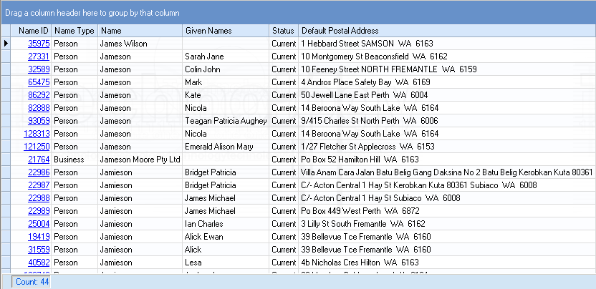
The number of records retrieved by your enquiry is displayed at the bottom of the grid. In the example above, 44 records have been retrieved.
If there are no records in the database which match your search criteria, the following message will display in the footer:
Step 4.
In the Name ID column in the grid, click on the link of the customer whose details you wish to view.
Result: The Maintain - Name window displays, as shown below:
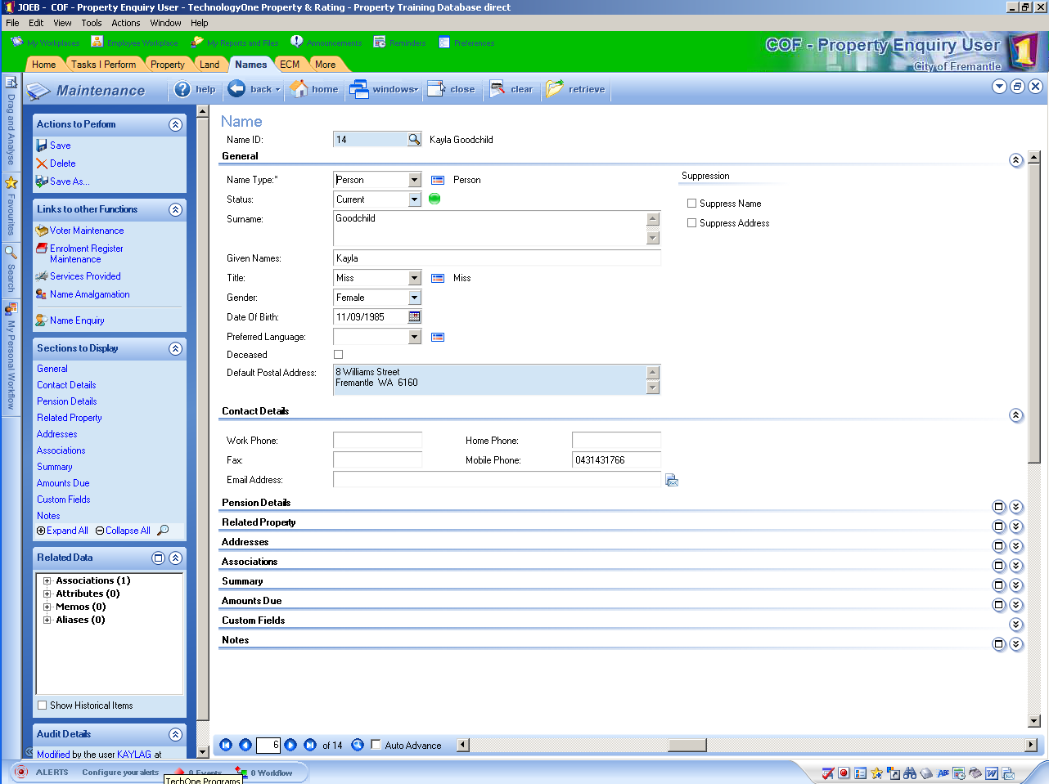
This window is an example of a ‘Maintain’ window. Here you can view the details of the person’s Name record.
The Task Pane on the left displays the following sections:
- Actions to Perform: This contains actions that can be performed in the current window, e.g. Save or Delete.
- Links to other Functions: See Navigating an Enquiry Window for an explanation of this section.
- Sections to Display: See Navigating an Enquiry Window for an explanation of this section.
- Related Data: This contains links to related data. See for an explanation of related data items.
- Show Historical Items: When checked, any items in the Related Data pane which have Past status or an end date, will also be displayed
- Audit Details: This contains audit information for the form, e.g. when the form was last modified and by who.
- If more than one record was retrieved in your enquiry an arrow bar will display at the bottom of the window. 
- Use this to navigate between records if required.
Fields that cannot be edited will have a blue background.
The sections and fields that are displayed in the Maintain windows are dependent on your user permissions, so may vary from the example on the previous page.
Step 5.
To access related information (i.e. associations, attributes, aliases or memos); click on the relevant link in the Related Data section in the Task pane.
For example, to view the property owned by the customer click:
- the symbol next to Associations, then
- the symbol next to Owned Property, then
- The property address link.
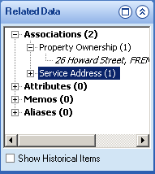
Result: The associated record is displayed in a separate window, for example, the View - Property window below displays the record of the property owned by the customer:
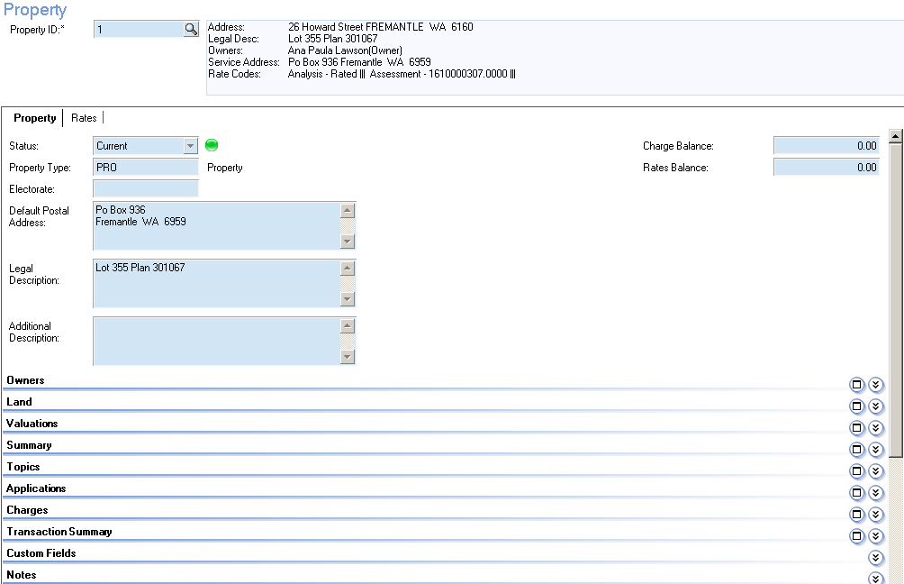
Step 6.
Click to close the current window.
Result: You will be returned to the Maintain – Name window.
End of Procedure.

Participant activity
When asked by your trainer:
- Conduct a Name Enquiry on the customer Ana Paula Lawson.
Hint: First, try a search entering just ‘Ana’ in the Given Names field, then try a search entering ‘Ana Paula’ in the Given names field. What results are retrieved for each search?
- Access Ana’s Name record.
- Write down Ana’s default postal address:

- Write down the Property number of the property owned by Ana.
Hint: Check the Related Property section.

Learning check
To check your understanding of what you’ve learned, answer the following questions:
- How would you conduct a Name Enquiry when unsure of the spelling of a surname ‘Smith’ or ‘Smyth’? What symbol could you type to represent both the letters ‘y’ and ‘i’?

- In the Enquiry - Name window, what are two methods of displaying information contained under a collapsed section heading?

- From the Enquiry - Name window, how can you navigate to associated records?

Performing an Address Enquiry

Overview
Using the Address Enquiry task, you can enquire on both postal and property addresses.
Address Enquiry will also retrieve addresses from within and outside Council boundaries.
Important information
This enquiry task is available to all Property & Rating users. If this task does not display in your Tasks I Perform tab, change your Workplace to ‘ COF - Property Enquiry User’.

Address formats
There are two address formats used when entering addresses into Property & Rating:
- Structured Address: This is used for physical street addresses within Council boundaries.
- Free Format: This is used for addresses outside Council boundaries, or for PO BOX numbers.

Procedure
To perform an address enquiry, follow these steps:
Step 1.
From your workspace Menu tab select the Address Menu and Address Enquiry option.
Result: The Enquiry - Address window displays, as shown below:

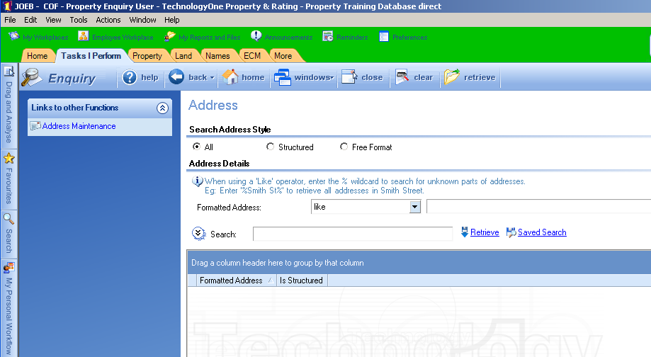
Step 2.
Do you want to search for a physical street address within Council boundaries? If:
- Yes: Go to step 3.
- No: Go to step 4.
Step 3.
Select Structured as the Search Address Style, then go to step 5.
Result: A new set of Address Details fields will display.
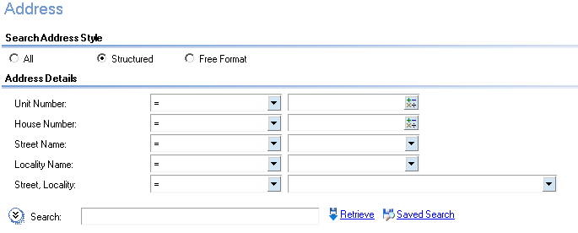
Step 4.
Select Free Format as the Search Address Style.
Result: A new set of Address Details fields will display.
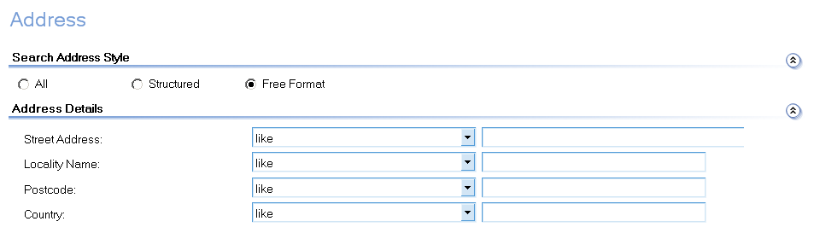
Step 5.
Enter your search criteria in the Address Details fields, and then click on the Retrieve button or link.
Result: A list of matching addresses displays in the grid at bottom of window, as shown below.
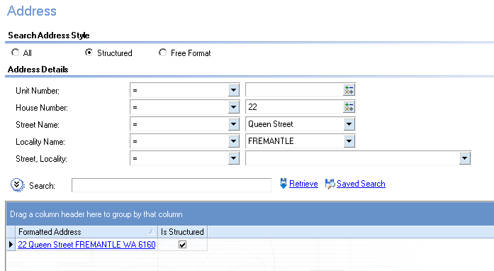
The more information you enter into the search fields, the fewer search results will be displayed. For example, entering ‘Ocean Street’ will retrieve fewer search results than entering just ‘Ocean’.
Step 6.
In the Formatted Address column in the grid, click on the link of the address you wish to view.
Result: The Maintain - Address window of the selected address displays, as shown below:
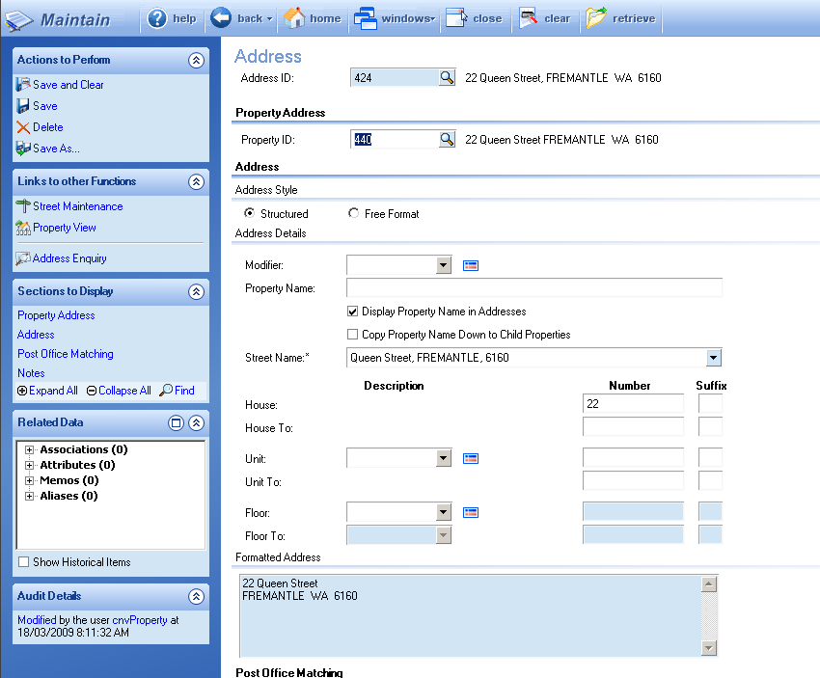
Step 7.
If you wish to view property or rating information related to this address, click the Property View link in the Links to other Functions pane.
Result: The View - Property window of the selected property displays, as shown below:
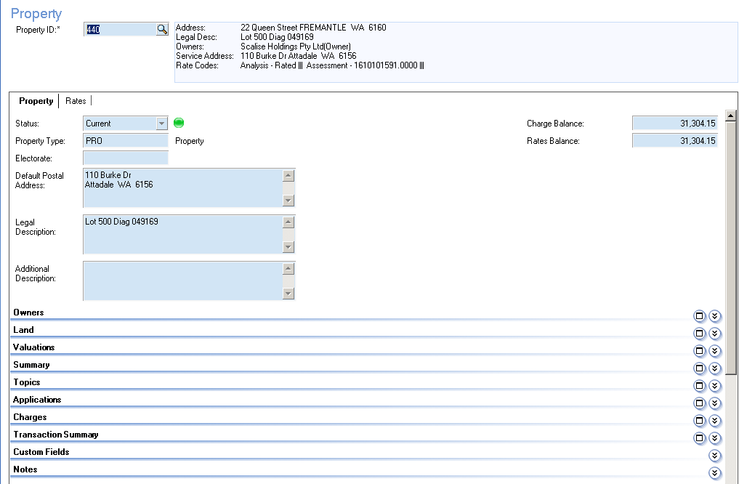
Step 8.
In the Sections to Display pane, click on the relevant section heading to display that section.
Step 9.
Click to close the current window.
Result: You will be returned to the Maintain – Name window.
End of Procedure.

Participant activity
When asked by your trainer:
- Enquire on the Postal Address you identified for Ada Paula Lawson in the previous Participant Activity.

- Enquire on the address: 8/4 Flindell Street, O`CONNOR. Who are the owners of this property?

Learning check
To check your understanding of this topic, answer the following questions:
- True or False? The Address Enquiry task will call up all matching addresses in the system, e.g. both property and postal addresses.

- True or False? The Address Enquiry only allows you to retrieve addresses which are within Council boundaries.

Performing a Property Enquiry

Overview
Using the Property Enquiry task, you can call up a property record by searching on a variety of property details, such as property ID, or address details.
Important information
Before you begin this procedure, please note these points:
- Only properties located within Council boundaries can have a Property record. Therefore, if you search using address details in the Enquiry – Property window, you will only get results for addresses of properties within Council boundaries. You cannot use this window to search for PO Box numbers, or addresses outside Council boundaries.

Procedure
To enquire on property details, follow these steps:
Step 1.
From your workplace menu tab, click on the Property Enquiry option under the Property Menu.
Result: The Enquiry - Property window displays, as shown below:
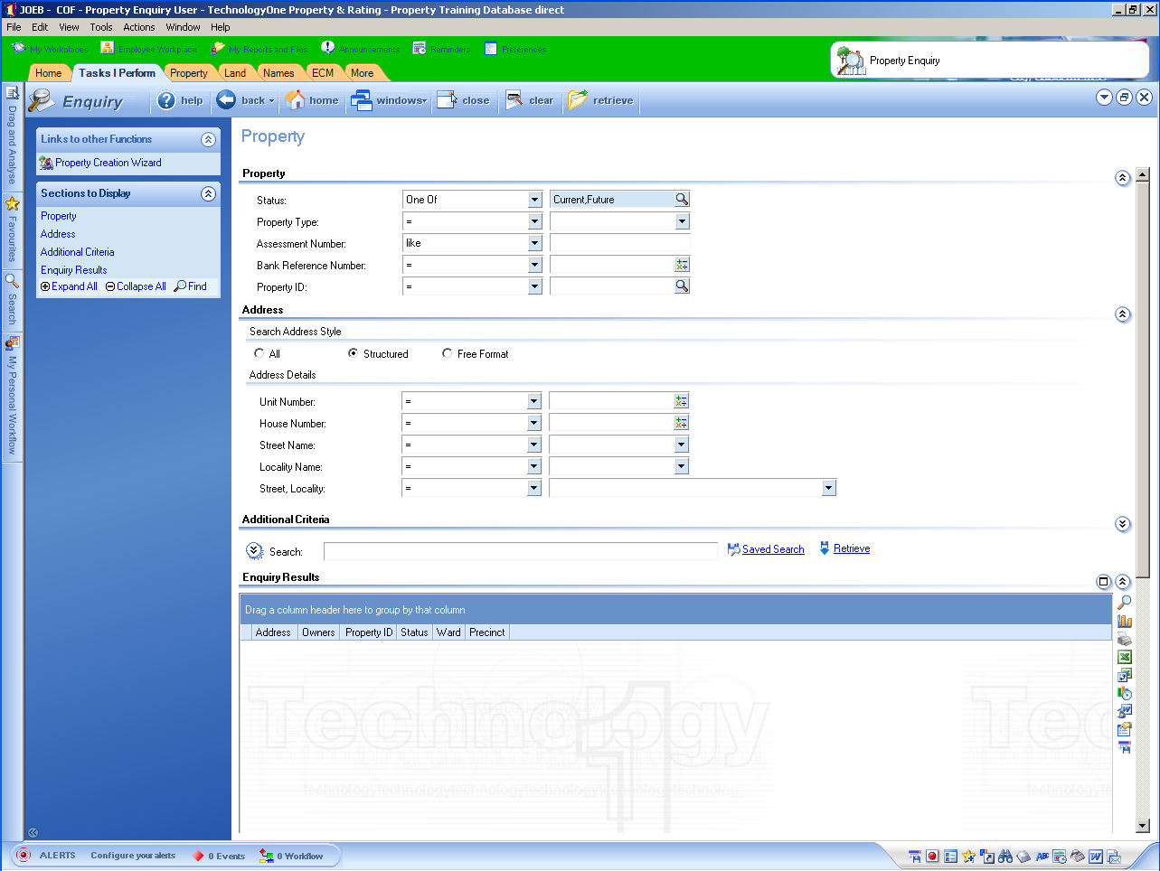
Step 2.
Leave the Structured Address option selected, and enter the property or address details you wish to enquire on, such as a Property ID, and then click on the Retrieve button or link.
Result: A list of matching properties displays in the Enquiry Results grid at bottom of window, as shown below.
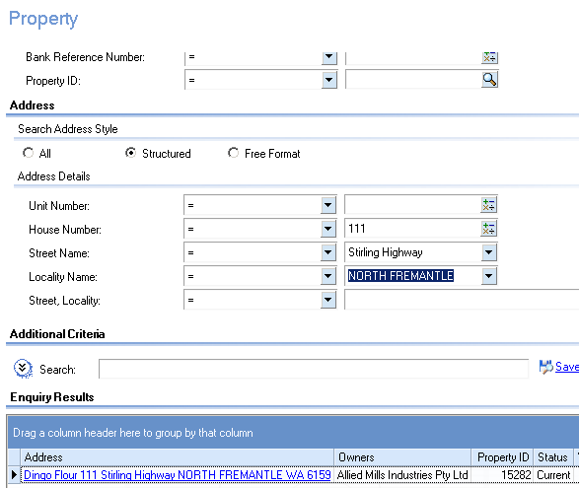
Step 3.
In the Address column of the Enquiry Results grid, click on the link of the Property record you wish to view.
Result: The View - Property window for the selected property displays, as shown below:
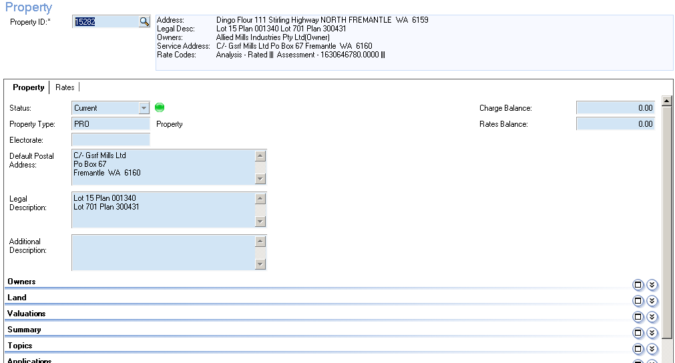
Step 4.
To access related information (i.e. associations, attributes, aliases or memos); click on the relevant link in the Related Data section in the Task pane.
For example, to view the owner of the property click:
- the symbol next to Associations, then
- the symbol next to Owner, then
- The link of the Owner whose record you wish to display.
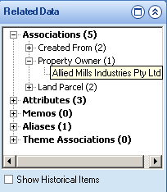
Result: A window displaying details of the selected item displays. For example, the Maintain - Name window for the selected name displays, as shown below:
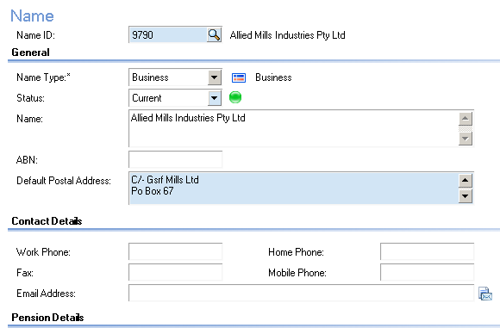
Step 5.
Click to close the current window.
Result: You will be returned to the View – Property window.
End of Procedure.
Participant activity
When asked by your trainer:
- Using the Property number you noted down in the Participant Activity in Performing a Name Enquiry, enquire on the property owned by Ada Paula Lawson, then answer the following question:

  - What is the Legal Description of the property?

  - Note down the Land ID. Hint: Check the Land section.

- Enquire on a property using the following address: 133 Carrington Street, WHITE GUM VALLEY
  - Who are the owners of the property?

Learning check
To check your understanding of this topic, answer the following questions:
- True or False? If you search on address information using the Property Enquiry task, the results will list property addresses only.

- From the Property record, how can you navigate to view the Name record of the owner/s of a property?

Performing a Land Enquiry

Overview
Using the Land Enquiry task in Property & Rating, you can conduct a search using the details of the land parcel e.g. plan type, plan number and lot number.
Important information
This enquiry task is available to all Property & Rating users. If this task does not display in your workplace Menu Tab then locate it using the Function Search method.

Procedure
To perform a land enquiry, follow these steps:
Step 1.
Click on the task Land Enquiry under the Land Menu.
Result: The Enquiry - Land window displays, as shown below:
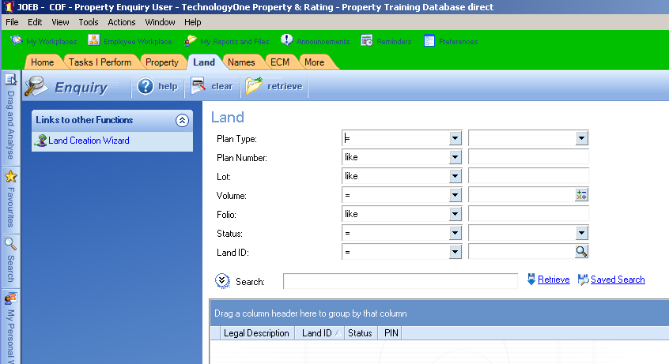
Step 2.
Enter the details you wish to enquire on, and then click on the Retrieve button or link.
For example: In the following example, the legal description “Lot 246 Plan 139059” has been inserted into the relevant search fields:
- Plan Type: Plan
- Plan Number: 139059
- Lot: 246
Result: The land parcel enquired on displays in the grid at bottom of window, as shown below.
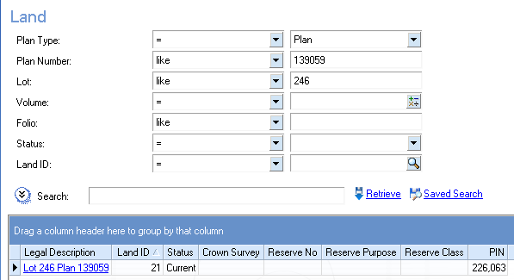
Step 3.
In the Legal Description column in the grid, click on the link to display the land record.
Result: The Maintain – Land window of the selected record displays, as shown below:
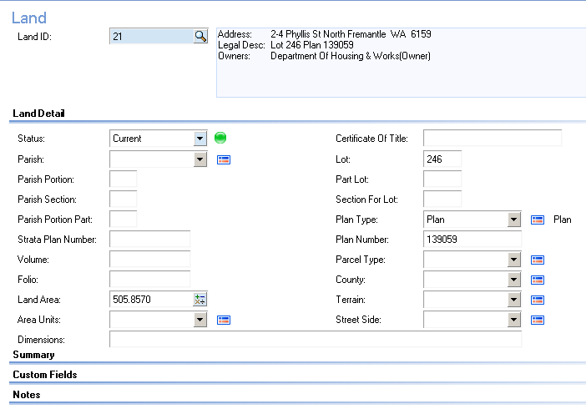
Step 4.
To access related information (i.e. associations, attributes, aliases or memos); click on the relevant link in the Related Data section in the Task pane.
For example, to view the property related to the land parcel click:
- the symbol next to Associations, then
- the symbol next to Related Property, then
- The address link of the related property.
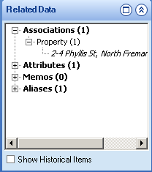
Result: The details are displayed in a separate window, such as the View - Property window below which shows the details of the property related to the land parcel:
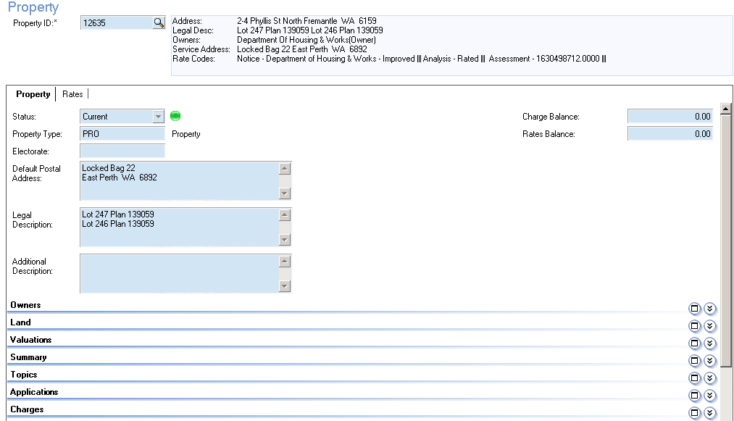
Step 5.
Click to close the current window.
Result: You will be returned to the Maintain – Land window.
End of Procedure.

Participant activity
When asked by your trainer:
- Using the Land ID you noted down in the Participant Activity in Performing a Property Enquiry, enquire on the land record, then answer the following question:
  - What attributes are attached to this land parcel?

Performing an Application Process Enquiry

Overview
Using the Application Process Enquiry task, you can search for any type of application, for example:
- Development application
- Parking permit application
Important information
This enquiry task is available to all Property & Rating users. If this task does not display in your Tasks Not all Application Processes are available to all users.

Procedure
To enquire on an application, follow these steps:
Step 1.
From your workplace tab go to the Regulatory Menu, click on the task Application Process Enquiry.
Result: The Enquiry - Application Process window displays, as shown below:
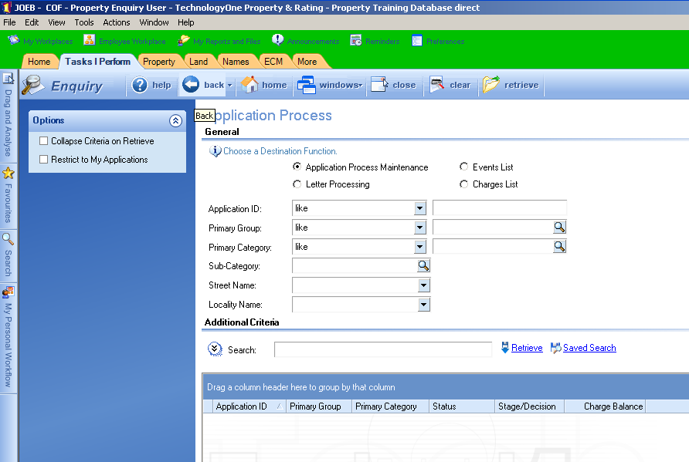
Step 2.
Enter your search criteria, e.g. Application ID or Primary Group, then click on the Retrieve button or link.
Result: The results of your enquiry are displayed in the grid at the bottom of window, as shown below.
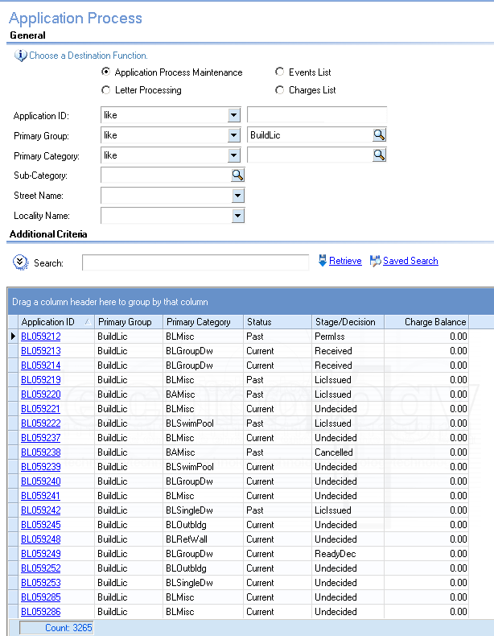
The grid displays information about the application such as its Primary Group (e.g. BuildLic for Building Licence Applications), Primary Category (e.g. BLOffice for Office applications), and the Status and Stage/Decision the application is at.
You can also search using other criteria. This will be covered in detail in the relevant role-specific training.
Step 3.
In the Application ID column in the grid, click on the relevant link to view the details of the application.
Result: The Maintain Applications - Application Process window displays, as shown below:
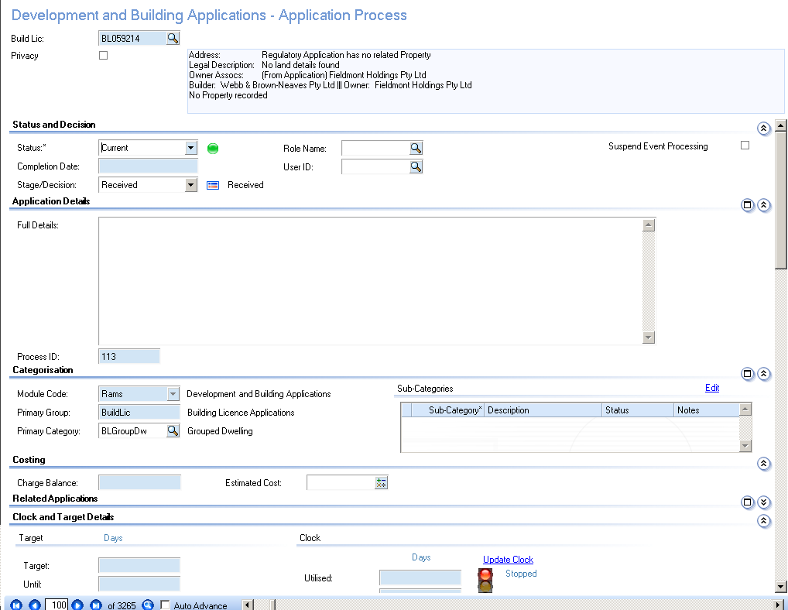
You will need to scroll down to view all the fields and sections in this window. The details of this screen will be covered in the relevant role-specific training.
Step 4.
To access related information (i.e. associations, attributes, aliases or memos); click on the relevant link in the Related Data section in the Task pane.
For example, to view the applicant’s name record, click:
- the symbol next to Associations, then
- the symbol next to Owner, then
- The applicant’s name.
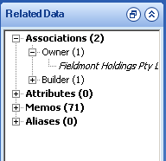
You may need to scroll down in the Task Pane to view the Related Data section.
Result: The selected record is displayed in a new window, as shown below:
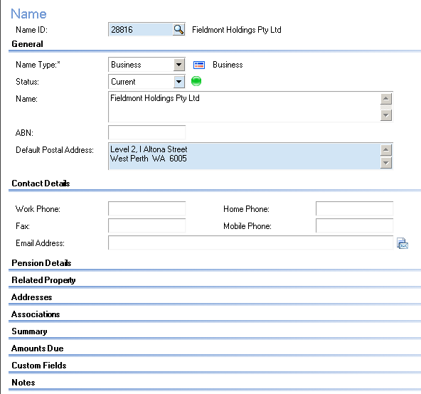
Step 5.
Click to close the current window.
Result: You will be returned to the Maintain Applications - Application Process window.
End of Procedure.

Participant activity
When asked by your trainer:
- Click on next to the Primary Group field, and check the types of applications contained in the list.
- Close the Regulatory Groups window.
- Enquire on the Application ID: BL060838, then answer the following question:
  - What is the application for?

  - What is the status of the application?

- Access the Maintain Applications – Application Process window of the application BL060838.
  - Who is the Owner for the Application?

Hint: Check the Related Data > Associations.

  - What is the primary property associated with the application?

Hint: Check Related Data > Associations.

- Close the Maintain Applications – Application Process window, and go back to the Enquiry - Application Process window.
- Perform an enquiry to display all Request Management applications regarding Animal Control.

Hint: Select ‘Animals’ in the Primary Group field.

Learning check
To check your understanding of this topic, answer the following questions:
- True or False? You can access the Name record of the applicant from the Maintain Applications - Application Process window.

- Which section on the Maintain Applications - Application Process window displays the date and time at which events associated with the application (e.g. Application Received) occurred?

Performing an Advanced Search

Overview
The Property & Rating system allows you to perform advanced searches using search criteria not displayed in the search fields at the top of the Enquiry windows.
For example, you may wish to search for construction certificates received during a particular time period, or you may wish to search for building applications of a particular status.
In such cases, you will need to use the advanced search fields to search by date or status.
This function also allows you to save and reuse searches you have already run.

Procedure
To perform an advanced search, follow these steps:
Step 1.
From your workplace tab go to the Regulatory Menu, click on the task Application Process Enquiry.
Result: The Enquiry window for the selected task displays, as shown in the example below:
Step 2.
Click on the button next to Search.
Result: Advanced search fields are displayed, as shown below:
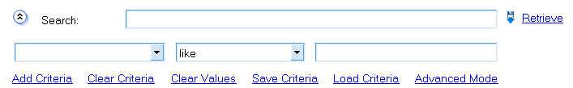
Step 3.
Click on the button in the first field under Search, and select an entry from the drop-down list, e.g. ‘Stage/Decision’:
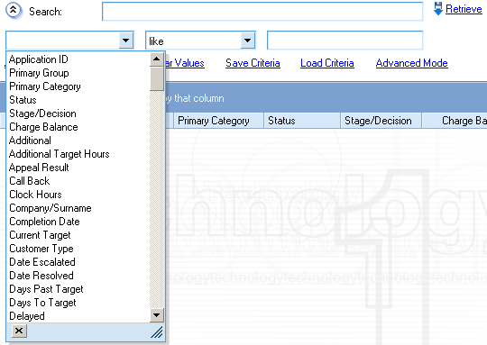
Step 4.
Click on the button in the second field under Search, and select a search operator from the drop-down list, e.g. ‘=’:
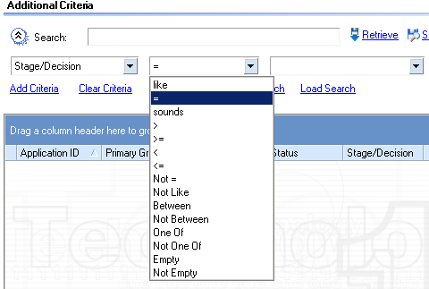
Step 5.
Using the button in the third field, select your search criteria, e.g. ‘LicIssued ’:
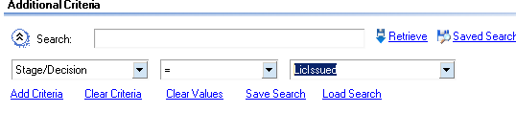
Step 6.
If you wish to add another set of fields for entering search criteria, click on the Add Criteria link, and then enter your search criteria. For example:
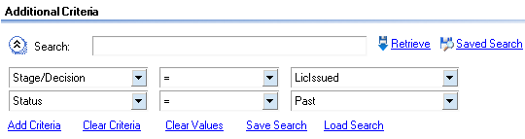
Step 7.
If you wish to clear all sets of fields that you have added and as well as the entered criteria, click on the Clear Criteria link.
This will clear all criteria fields.
Step 8.
If you wish to clear any values that you have entered into the third field in a set, click on the Clear Values link.
Step 9.
If you wish to save your search criteria for reuse, click on the Save Criteria link, complete the fields in the pop-up window, and then click OK.
Result: The results of your search are displayed in the grid, as shown below:
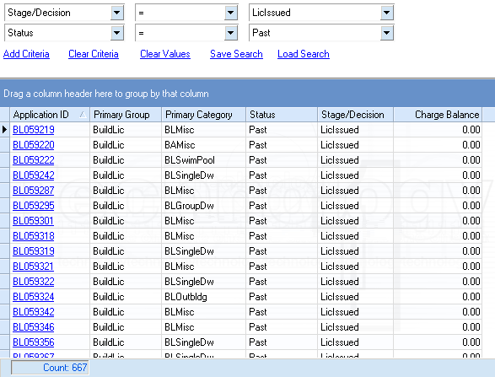
Step 10.
If you wish to use saved search criteria, click on the Load Criteria link then click on the required search template in the pop-up window.
Result: The results of your search are displayed in the grid.
Step 11.
When you have finished entering your search criteria, click on the Retrieve link.
Result: The results of your search are displayed in the grid.
Step 12.
To toggle between Advanced and Easy mode, click on the Advanced Mode or Easy Mode link as required.
Advanced Mode is the default option. By clicking on Advanced Mode you can display the Easy Mode, and a Saved Criteria field which allows you to easily select and run saved searches.
End of procedure

Participant activity
When asked by your trainer:
- Access the Enquiry - Application Process window.
- Enquire on all Animal Control applications that are current.

Hint:
- Select Primary Group: DemoLic.
- Add another set of criteria fields.
- Select Status: Current.
- How many current = applications are there?

- Enquire on all building applications which have a status of ‘Current’, and a Stage/Decision of ‘Received’.

- How many past Planning Applications at the Stage ‘Approved’ are there?

Hint:
- Select Primary Group: PlanApp
- Add another set of criteria fields.

Running a Report

Overview
Use this procedure to run a report using any Enquiry window.
When you perform an enquiry, you can export the results of the enquiry into an Excel spreadsheet.

Procedure
To run a report, follow these steps:
Step 1.
From your workplace tab go to the Regulatory Menu, click on the task Application Process Enquiry.
Result: The Enquiry window for the selected task displays, as shown in the example below:
Step 2.
Perform a simple enquiry or an advanced search, as required.
For information on how to perform enquiries and advanced searches, refer to the relevant procedure:
- Performing a Name Enquiry
- Performing an Address Enquiry
- Performing a Property Enquiry
- Performing a Land Enquiry
- Performing an Application Process Enquiry
- Performing an Advanced Search
Result: The results of your enquiry or search are displayed in the grid, as shown below:
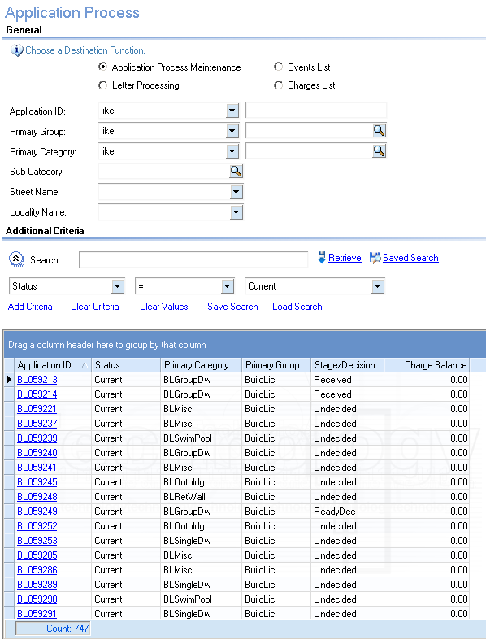
Step 3.
Group by Primary Category.
Result: The results of your enquiry or search are displayed in the grid, as shown below:
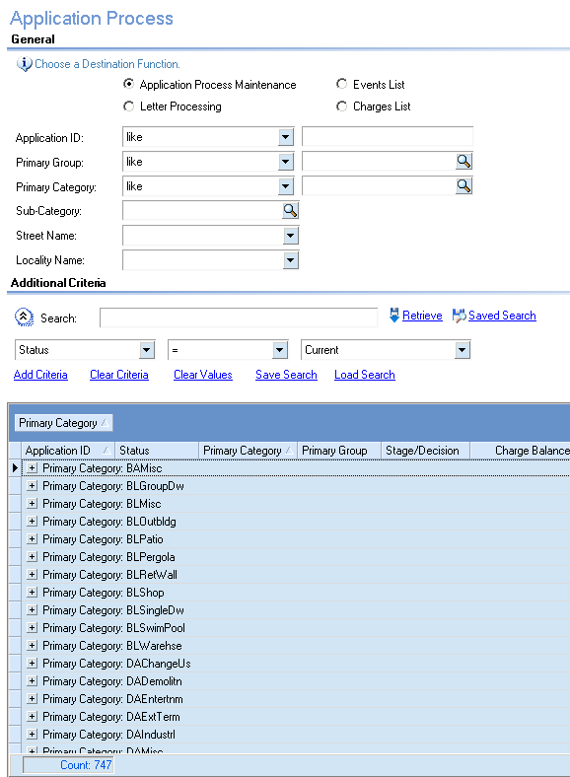

Step 4.
Click the Send to Excel icon on the grid toolbar.
Result: The data in the grid is displayed in an Excel spreadsheet, as shown below.
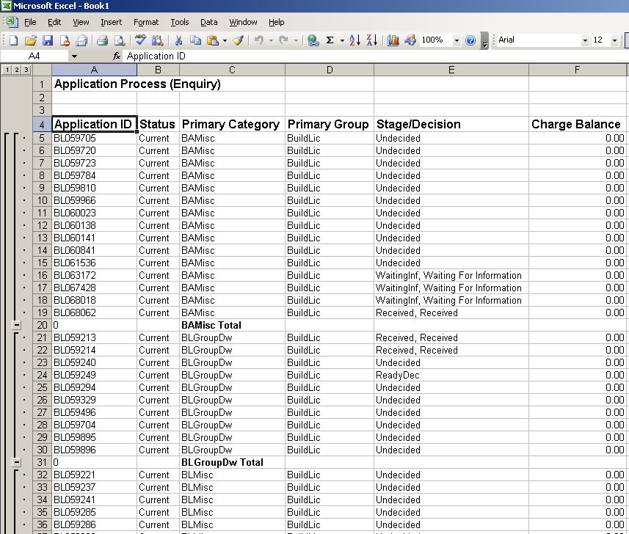
Step 4.
Save or print the spreadsheet, if required.
End of Procedure.

Participant activity
When asked by your trainer:
- Access the Enquiry - Property window, and run a report which displays all the properties in Booth Court, SAMSON.

- Access the Enquiry – Application Process window, and run a report which displays all the current Building applications.

Hint: You will need to perform an advanced search for this exercise

Searching and Making a Favorite

Overview
As you become comfortable with navigating around Property & Rating, you may want to take advantage of some of the more powerful features. In this topic, you’ll learn two of these.
First, you’ll learn how to use Search. This is an alternative way of initiating tasks without having to use the Tasks I Perform tab and without having to change your Workplace (if you have more than one role).
Secondly, you’ll learn how to save your Search results as Favourites, so you will not have to search for that task again.
Important information
Before you begin this procedure, please note these points:
- You can use Search to call up any task you have user authority to perform without having to change Workplace.
- The same is true of Favourites. You have one list of Favourites that displays across all your Workplaces. Using your Favourites, you can launch any task from any Workplace.

Searching for a task
To search for a task, follow these steps:

Step 1.
Click on the Search tab located at left of the window.
Result: The Search pane displays, as shown below:
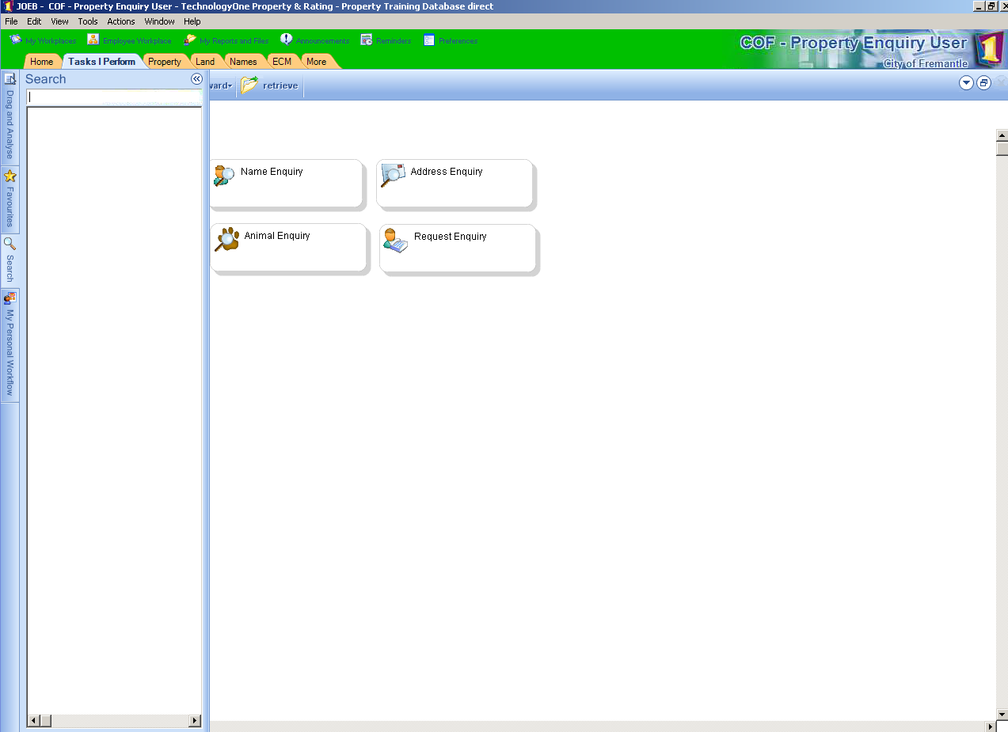
Step 2.
Enter a keyword into the Search field. Eg Memo
Result: A list of matching tasks displays in the Search pane, as shown below:
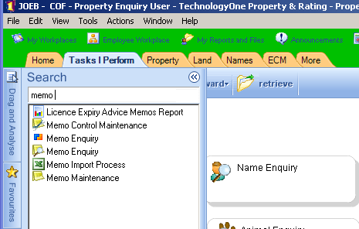

Step 3.
Double-click on the task you wish to display, e.g. Memo Enquiry.
Result: The task displays in a separate window, as shown below:
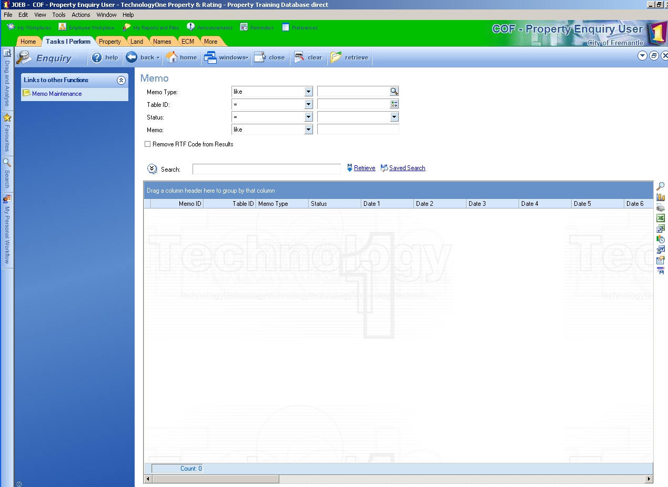
End of Procedure.

Making a Favorite
To make a Favourite from your search results, follow these steps:
Step 1.
Search for a task, as described in Searching for a task.
Results: Your search results display in the Search pane.
Step 2.
Right-click on the required task, then select Add to Favourites from the shortcut menu, as shown below:
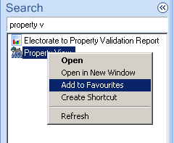
Result: The Add Favourite window displays, as shown below:
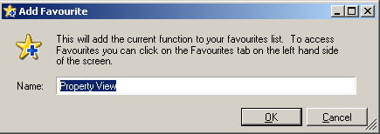
Step 3.
Change the Name if required, and then click OK.
Result: The search is added to your Favourites.
Step 4.
To view your Favourites, click on the Favourites tab, located at left of window.
Result: Your list of Favourites displays, as shown below:
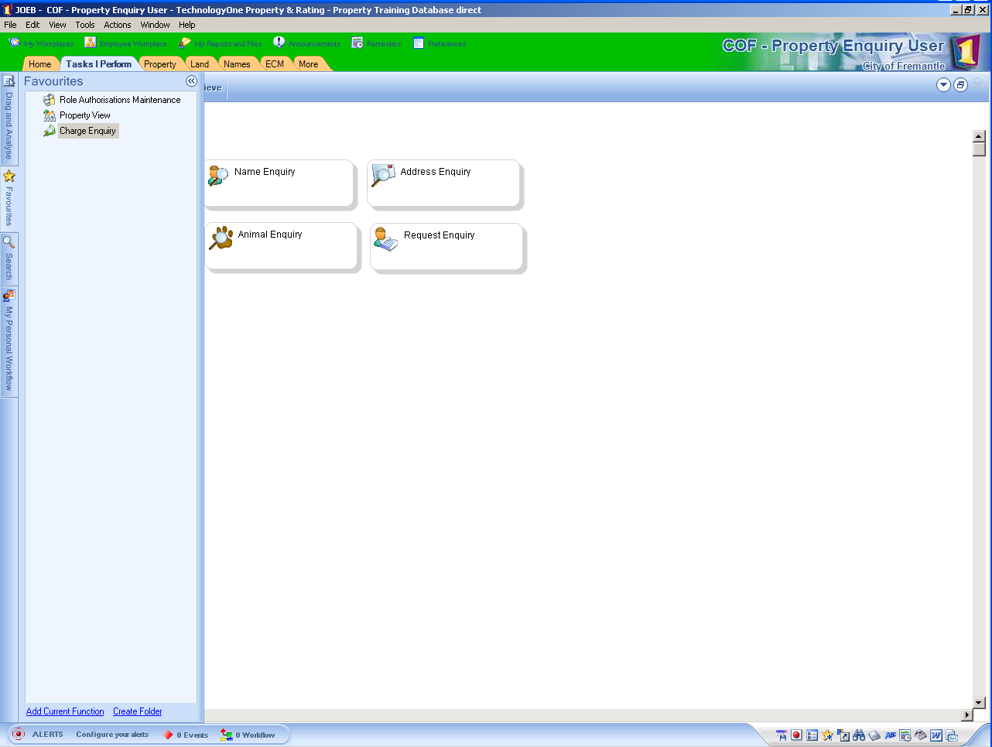
Step 5.
To commence any task appearing in your Favourites, double-click on it.
Result: The task displays in a separate window, as shown below:
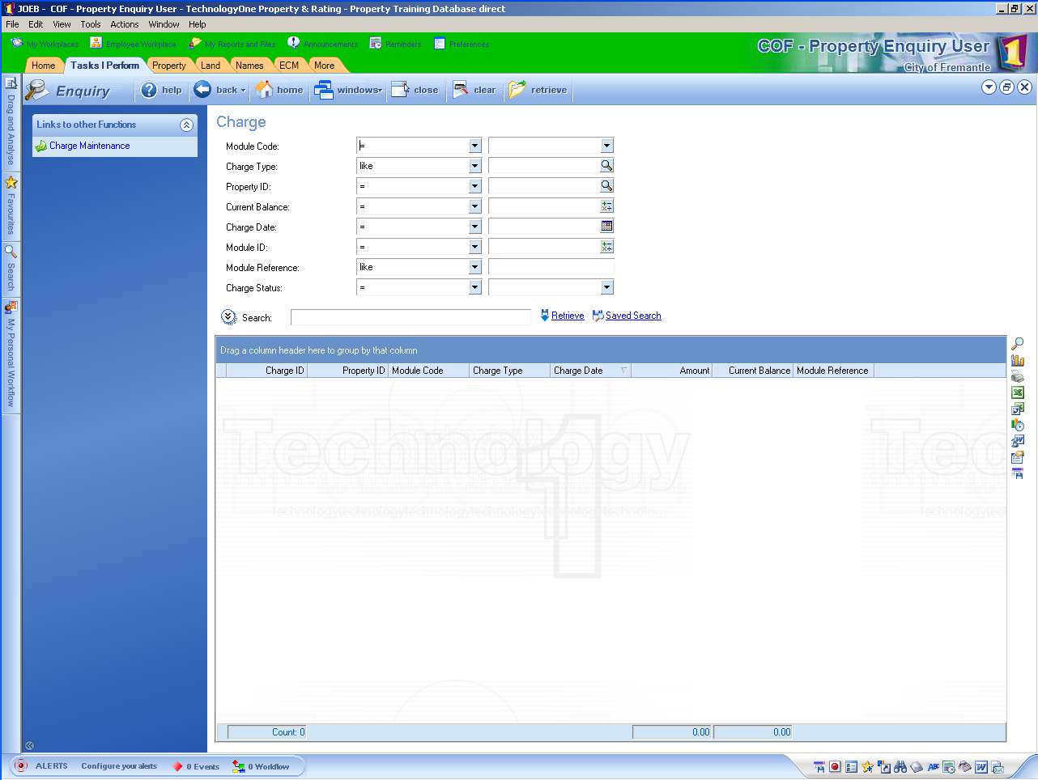
Step 6.
Alternatively you can add a screen to you favourites by press the button on the bottom right of the screen.

End of Procedure.

Participant activity
When asked by your trainer:
- Access the Search pane.
- Search for the Property Enquiry task.
- Add the Property Enquiry task to your list of Favourites.
- Launch the Property Enquiry task from your Favourites.

Skills Practice

Self-assessment
This self-assessment is designed to help you reflect on your learning experience and to rate your ability to perform each of the procedures detailed in this training.
It will assist you to focus your energies during the Skills Practice.
It will also help identify any ongoing training needs; use it to initiate a personal training discussion with your manager when you return to the workplace.
The self-assessment requires you to rate your competence using the following scale:

Rating | Description
1. | No competence; unable to perform this task; further training is required in this area.
2 | Low competence; able to perform this task but with supervision.
3 | Full competence; able to perform this task unsupervised.
4 | High competence; able to coach and support others to perform this task.

Activity
Self-assess your competence using the checklist below:
Topic | Will you do this in your job? | 1 | 2 | 3 | 4
Topic 4 – Logging On and Off
Topic 7 – Changing Your Workplace
Topic 8 – Navigating an Enquiry Window
Topic 9 – Performing a Name Enquiry
Topic 10 – Performing an Address Enquiry
Topic 11 – Performing a Property Enquiry
Topic 12 – Performing a Land Enquiry
Topic 13 – Performing an Application Process Enquiry
Topic 14 – Performing an Advanced Search
Topic 15 – Running a Report
Topic 16 – Searching and Making a Favourite

Purpose
The purpose of this activity is to provide further practice in the key functions we have covered in this training.
Important information
Remember - your facilitator is there to help you with any queries you may have. Please do not hesitate to ask for help if you need it.

Details
Perform the following tasks:
- Perform a name enquiry.
- Perform an address enquiry.
- Perform a property enquiry.
- Perform a land enquiry.
- Perform an application enquiry.
- Perform an advanced search from an Enquiry window of your choice.
- Export the results of the advanced search to an Excel spreadsheet.
- Display the Property record in the Property & Rating system.

Workshop Completion

Sand pit
The test environment is a copy of the “live” system that you will be working with on the job. Use the test environment to practice what you’ve learned during the training in readiness for “go live”.
- Glossary

Alias | An alternative name. For example, a Name record can contain a person’s maiden name as well as their married name, or a Property record can contain the valuation number of a property as well as the Property ID. This alternative information can be used when performing enquiries.
Association | An association contains information regarding the connections between records, in particular, Land, Address, Property, Name and Application records. For example, a Property record is associated to the Name record of the person who owns the property.
Attribute | Attributes are used to capture further information or characteristics of a record. Attributes will vary depending on the type of record. For example, a bin is an Attribute of a Property record.
Form | The form is the area of an Enquiry or Maintain window containing fields for entry or display of information.
Free Format Address | Allows you to enter address details freely without selecting streets and suburbs from a drop-down list. This is used to search for or enter addresses which are outside Council boundaries, or for PO BOX numbers.
Journal | A Journal is bucket for holding like transactions as a group so that they can be processed together. Different modules have different types of Journals.
Memo | Memos allow the recording of comments against records.
Record | Information about customers, properties, land parcels, addresses, applications etc. is held in separate records. These records can be retrieved by performing enquiries
Role | A Role groups together the business functions that are performed by a particular group of people within the organisation.
Structured Address | Allows you to enter or search for an address by selecting the street and suburb from a drop-down list. This is used for physical street addresses within Council boundaries.
Task | A function e.g. performing a property enquiry, or creating a new application. All the tasks that a Role will need to perform are displayed in the Tasks I Perform tab for that Role.
Workplace | The window that is displayed when you log on. It is the gateway through which you can access all the tasks that make up your Role.

- Revision History

DOCUMENT REVISION HISTORY
Version | Sections/All | Doc Date | Reason
1 | All | 18 March 2000 | This is the first version of the document.
 |  | 29 November 2011 | Updated for City of Greater Dandenong

