IntraMaps Help v.21B
Prepared by: Milind Joshi
Last Update: 19 August 2022

INDEX

To view answers please click on any question while holding Ctrl key
1. How to add and save annotations (text, symbols and lines)?
2. Can I quickly see property number or address in a map?
3. How to save favourite view?
4. How to delete favourite view?
5. How to select properties?
6. How to close property information window
7. How to find details of neighbours for fence enquiries?
8. How to change zoom of map?
9. How to find x and y coordinates of a location?
10. How to view aerial photos?
11. How to measure area?
12. How to measure distance?
13. How to export property data in excel?
14. How to save a map in a Microsoft Word document?
15. How to send IntraMaps link to another IntraMaps user?
16. I don’t see map in map window?
17. Can I select all properties within a buffer distance?
18. How I can see all selected properties in a map window?
19. Can I access this IntraMaps help document from IntraMaps module?
20. Can I access this help document from IntraMaps Application?
21. How to do I customise IntraMaps to open it in specific module every day?
22. How to change the order of Modules?
23. How to change the order of Searches in a module?
24. How to change the arrow annotations
25. How to change direction of an arrow annotation?
26. How to rotate symbols in annotations?
27. How to export a map image?
28. How user can load external maps in IntraMaps?
29. How to extract owner and owner/ occupiers information?
30. How to select properties using a buffer distance?
31. How to know Common Property (CM) of a subdivision?
32. Where is the information about all maps in all modules?
33. IntraMaps and Assetic Asset Management System

1. How to add and save annotations (text, symbols and lines)?

Following tools will open when user clicks on Annotation toolbar as shown below
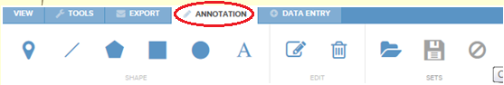

- To write text on the map click on  symbol on tool bar, which will open
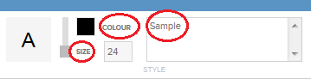
additional tools such as size and colour of text as shown above. User can write the text in window where work ‘Sample’ written above. The text in that window will appear on map wherever user clicks mouse.
User can delete the text using 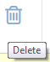 tool or edit it using edit 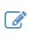 tool.
- Symbol tool 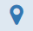 will give option to select one of the symbols as shown below by clicking on symbol tool. User can change colour of the symbol as well as size of the symbol by clicking on tools shown below.
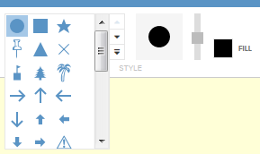
- Similarly user can draw lines by clicking on line tool 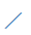 as shown here.
- User can draw circles, rectangles as well as odd shape polygons. Options of colours as shown below allows user to fill colours in circle, rectangle or make it transparent or semitransparent. Sliding bar control in red circle below allows user to control transparency. 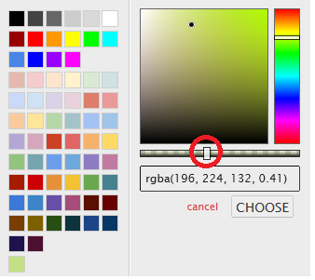

- Annotation can be saved by clicking on  save symbol. It saves annotations and the map as an image. User can name the annotation and load it next time using the open symbol. All saved annotations will be available in the drop dawn list. User can delete any saved annotation by clicking X in front of saved annotation name.
- User can edit text, line, polygons by clicking edit 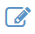 tool
- Delete tool will delete selected annotation and “clear annotations set” tool will clear all annotations on the page.

- How Can I quickly see property number or property address in a map window?

2. Can I quickly see property number or address in a map?

User can see property number and property address as mouse is hovered over any property. To get this function please add tick mark as shown below in front of show tool tip. Show feature outline will show boundary of the property in blue outline.

This tool is available in top right hand corner.

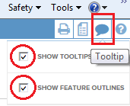

3. How to save favourite view?

User can click on save tool under View Tab in IntraMaps. It will prompt user to give a name for the view and that name will appear in the list as shown below as Dandenong Office, Estate1 etc.

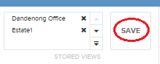
User can click on the name to open that view or click on x to delete the saved view.

4. How to delete favourite view?

You can save many views in the favourite views but when you don’t want any view in your list, click on x in front of view name and it will be deleted.
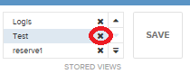

5. How to select properties ?
Under tools menu there are 4 selection tools.

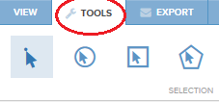
Single select tool 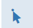 can be used to select an asset or a property. Click on circle select tool and then create circle on the map to select all properties touching or within that circle. Polygon select tool 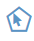 allows user to draw odd shape polygon. Please note- to end the drawing of a polygon double click on the last point.

Information about selected properties will be displayed in the right hand side of the map window.

6. How to close property information window
Whenever user selects one or more properties or assets, information about the properties gets displayed in right hand side information panel.

If user wants to unselect selection or close information panel click on x as shown in red circle below.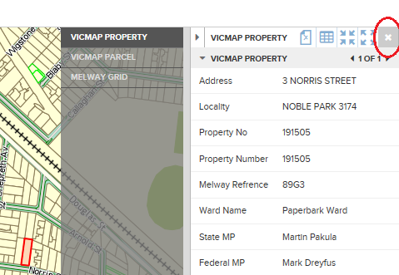

7. How to find details of neighbours for fence enquiries?
Customer service staff get requests to provide owner information of neighbouring properties for fence purposes. To get that information click on share boundary selection tool  and then click on the property in question. It will highlight all neighbouring properties in the map as shown below and provide information in right hand side panel how many properties selected.
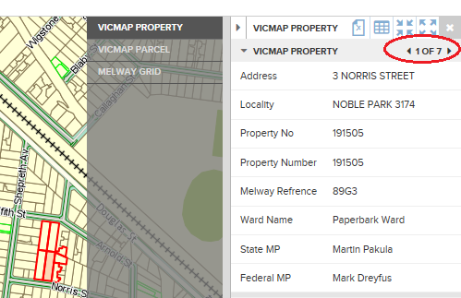
To transfer the information of selected properties in Excel, click on Export tab and click on Excel tool shown below in red circle, select owner mail merge and click on export button.

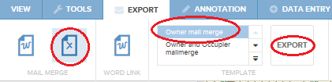
It will open a dialogue box as shown below to open the data in Excel or save the data.

8. How to change zoom of map?
To change the zoom level of the map window click on View tab. It will display current zoom level of the map window.

In the image below 2471 indicates real length of the area shown in the map from left edge to right edge of the map window. User can change the number in front of the Zoom to view map of desired zoom level.

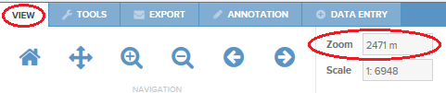

9. How to find x and y coordinates of a location?
In View tab x and y coordinates of centre point of the map window is displayed as shown below. As there are number of coordinate systems are used, it also highlights coordinate system used along with x and y value.

User can type x and y coordinate values and selecte coordinate system to find out a location in City of Greater Dandenong.

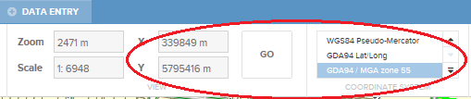

10. How to view aerial photos?
There are two ways user can view aerial photos of City of Greater Dandenong. You can use any module or Aerial Photos module.

1. Use slider bar in top left corner of the map window as shown below. As the handle of slider bar shown in image below is moved from left to right transparency of aerial photo layer will change. The aerial photo shown here is the latest aerial photo available in the IntraMaps.
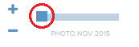
2. Another way to view aerial photo is to add tick mark in front of aerial photo name as shown below in layers tab - left side of map window.
User can see aerial photos of City of Greater Dandenong from June 1999 to November 2014 in Aerial Photos module of IntraMaps.

If IntraMaps user wants to compare 2 aerial photographs of a same area, they can follow 3 steps as shown below.

1. Go to desired location of City of Greater Dandenong in the map window
2. Add tick mark in front of an earlier aerial photo as shown below.
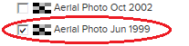
It will show aerial photo of the area in June 1999
3. Now select handle of the slider bar in top right hand side of the map window as shown below inside red circle and move towards right slowly.
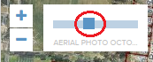
It will superimpose latest aerial photo over June 1999 photo.

11. How to measure an area?
To measure an area select Area tool  under Tools tab. Then start from one corner and click all corners of the area ending with double click at the last point of the area. It will open Results Area window as shown below. User can change unit of the area if required.

Please note that user will get option to snap property or parcel layer before they start measuring area.
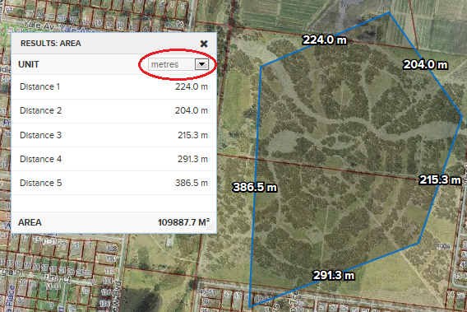

12. How to measure distance?
To measure distance click on distance tool 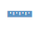 under Tools tab and then click on map with double click at the end. It will open up Results Distance window as shown below. User can change unit of the distance as well.

User will see the screen below before they measure the distance. Also cursor will snap the corner point of property approved layer if it is selected as shown below.
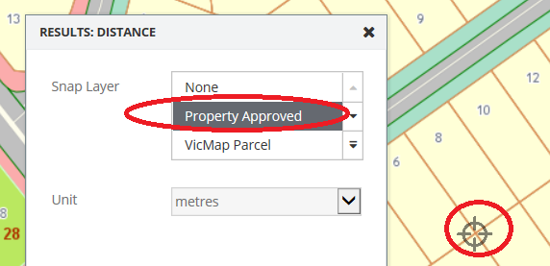
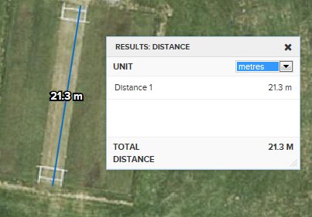

13. How to export property data in Excel?
Select the properties by using search tools or using 4 selection tools

Single select tool can be used to select a property. Click on circle select tool and then draw circle on the map to select all properties touching or within that circle. Polygon select tool allows user to draw odd shape polygon. Please note- to end the drawing of a polygon double click on the last point.

Information about selected properties will be displayed in the right hand side of the map window.

To transfer the information of selected properties in Excel, click on Export tab and click on Excel tool shown below in red circle, select owner mail merge and click on export button.

It will open a dialogue box as shown below to open the data in Excel or save the data.

14. How to save a map in a Microsoft Word document?

1. Click on Export tab, then click on Word link and then click on Export tab as shown below.

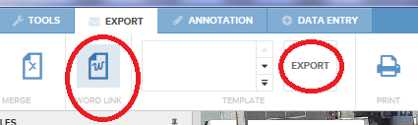

2. It will transfer map onto a word document.

3. You can save the word document with map or email the word document.

15. How to send IntraMaps link to another IntraMaps user?
Click on export link tool  in Export tab. It will open Export Current View as Link window as shown below. Copy the link and email the link to another CGD staff.
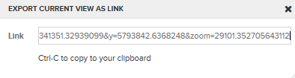
When user clicks on the link, it will open IntraMaps with the screen setting of the original user who sent the link.

16. I don’t see map in map window?
While working in map window suddenly you don’t see any map in the map window then click on home tool  under View tab which will bring home screen of the selected module.

17. Can I select all properties within a buffer distance?

In Tools tab user can
1. Type the buffer distance as shown below and then
2. Click on the tool Butter around next to buffer distance
3. Click on the property from where 100 m buffer will apply
All properties within 100m buffer will be selected in map window.

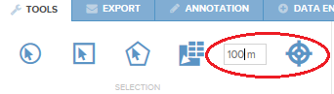

18. How I can see all selected properties in a map window?

To see all selected properties click on Zoom to Entire Selection tool as shown below in red circle. You will see this tool near top right hand corner of the IntraMaps window.

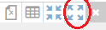

19. Can I access this IntraMaps help document from IntraMaps module?

To view this help document from any module of IntraMaps, from top right hand corner of IntraMaps click on the icon in red circle below.
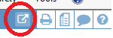
It will prompt user to open or save the document. Click open and this document will be opened from Objective document management system.

21. How I can customise IntraMaps to open it in a specific module and view for me every day?

- Click on Settings tool in top right hand corner as shown below
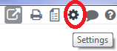
- It will open User settings window. Please select Start Option and fill your requirements and click save.
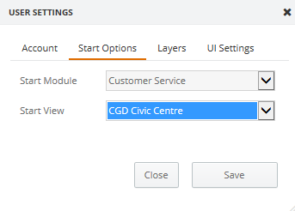
- When user will opens IntraMaps next time it will remember the settings and will open in Customer Service module with selected start view. Repeat it for Layers tab and click Save and then close the user setting window.
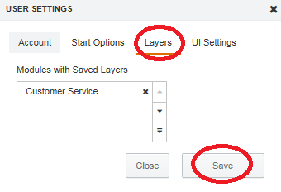

22. How to change the order of Modules:

User have control to select which modules should be on the top of the modules list.
Please use following steps to get the desired result:

- Click on setting button 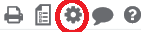in top right-hand corner
- Select Modules tab as below
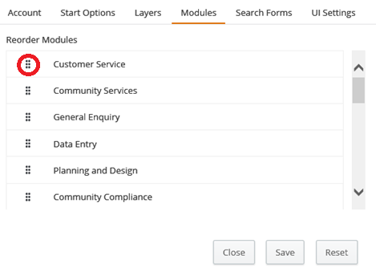
- Click on six dots highlighted in red circle above and change the order of Modules by dragging and dropping.
- Click Save tab.
- IntraMaps will show the new order of Modules when refreshed.

23. How to change the order of Searches in a Module:

- Click on setting button in top right-hand corner
- Select Search Forms tab as shown in image below
- 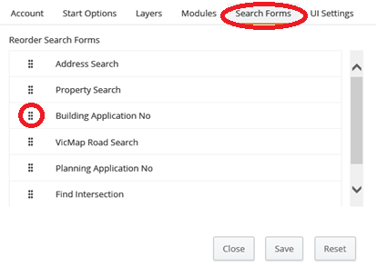
- Click on six dots highlighted in red circle above and change the order of Search Forms by dragging and dropping.
- Click Save tab.
- IntraMaps will show the new order of Search Forms when refreshed.

24. How to change the arrow annotations:

  - Arrow is a new annotation tool available to IntraMaps users. Click on arrow tool as shown below in red circle.

  - Select line type, arrow head and colour for the arrow and click on the map to draw arrow. It can be a single line or a line with nodes.

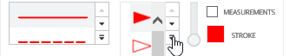
  - Double click to stop drawing the arrow.

25. How to change direction of an arrow annotation:

  - It is possible to rotate an arrow annotation
  - In annotation menu click on  edit tool and then click on the arrow you want to rotate. You will notice following change.
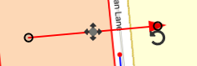
  - Click on semi-circle and it will act as handle to rotate the arrow as shown below.

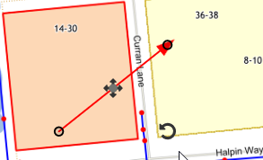

26. How to rotate symbols in annotations:

- Rotate Symbols

  - It is possible to rotate symbols drawn using annotation menu
  - In annotation click on edit tool and then click on the symbol you want to rotate.
  - A semicircle will appear as shown below. Use that to rotate the symbol.

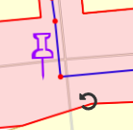
  - Click on semi-circle and it will act as a handle to rotate the symbol as shown below.

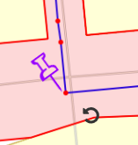

27. How to export a map image?

- Export Map Image:

  - User can control size and resolution of an image using Map Image under Export menu as shown below.
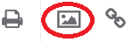
  - It will open following window
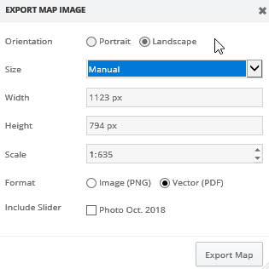
  - User can select specific width and height under Manual or select A3, A4
  - Clicking Export Map tab will export it pdf or .png format.
  - Right click on the image and select save as to save the pdf or the image in desired location.

28. How user can upload external maps in IntraMaps?

- User can open external map in IntraMaps for the current session.
- Under tools menu select Upload Data tool as shown below 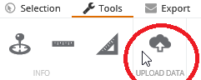
- It will open a window shown on next page that informs which GIS file formats can be dragged and dropped to open in IntraMaps map window.

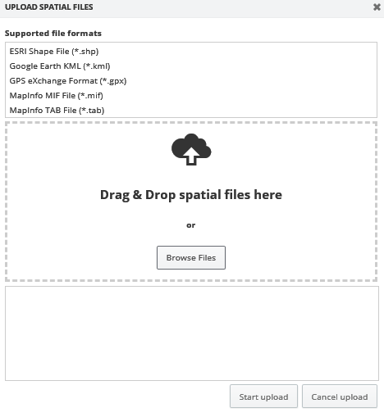

- Click on Start upload button at the bottom of the page.
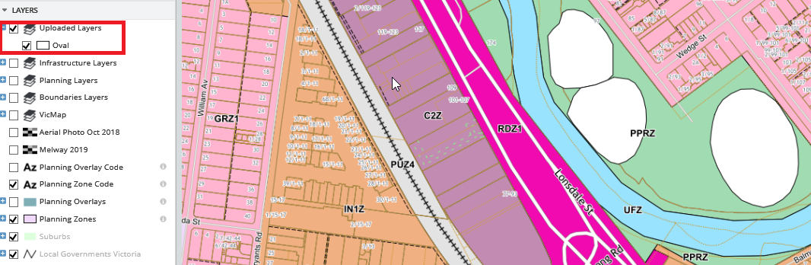

- The temporary layer will be listed in layers tab as shown in red rectangle above.
- The map layer will disappear once IntraMaps is closed.

29. How to extract owner / owner & occupiers information?

- Please use one of the selection tools to select properties you are interested in
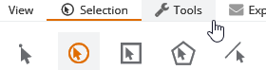
Mostly you will use this  tool to select the area. Double click at the last point to close the selection polygon.

- Change the module you are in to Planning and Design module. Your selected properties will remain selected even after you change the module.

- Click on Excel symbol highlighted in red circle below from Export menu

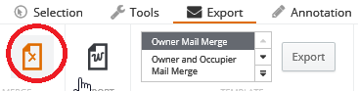

- Then select either owners mail merge list or Owner and Occupier list.
- Click Export button
- Export the list as an excel spreadsheet which will place the information in columns which can be used for mail-merge.

Note: We don’t store occupiers names, so property address is the address of all occupiers – whether they are owners or renting the place.

30. How to select properties using a buffer distance?

Following example shows how to select all properties in 25m buffer.

- In selection Menu type buffer distance (25) as shown below.
- Click on the buffer around tool as shown below in red oval

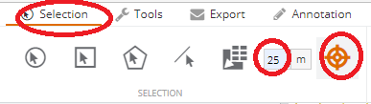

- Click on the property around which buffer is required (shaded property below)
- All properties in 25 m buffer will be selected.

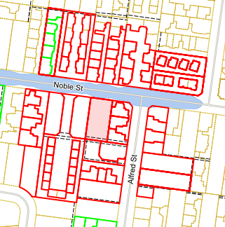

31. How to know common property of a subdivision?

- When user select a selection tool  and click on any property in a map window. Right hand side information panel shows owner of the property as below.

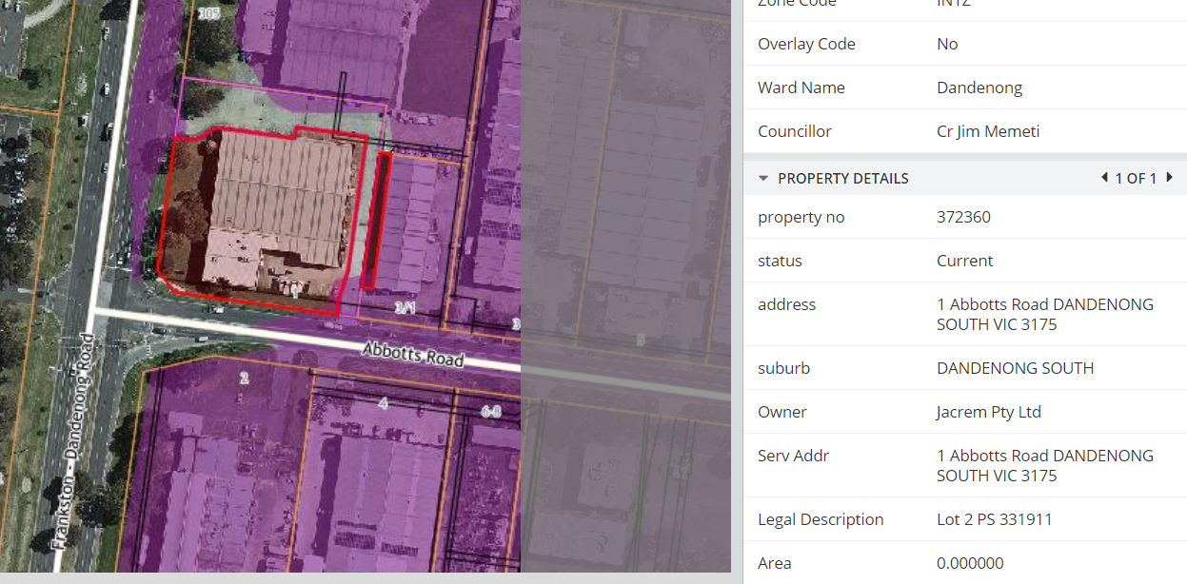

- However, when user select a land parcel which is a common property then owner is not displayed.
- To confirm the land is common property (CM), go to Property Revenue module of the IntraMaps and click on the same land parcel. Then select VicMap Parcel as shown below.
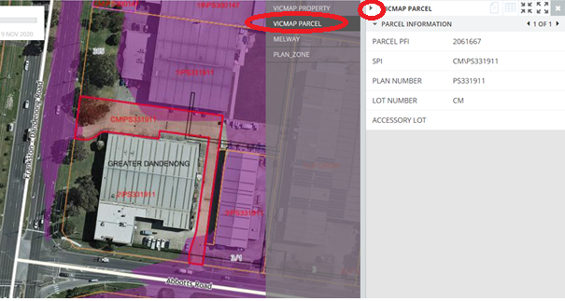
- It displays parcel description or SPI as CM|PS331911. Which is common property of Plan of Subdivision PS331911.
- The land used and owned by all lot holders of that subdivision. For this subdivision the Common property is owned by lot1,2, 3 of that subdivision.

32. Where is information about the maps in all modules?

- All maps in all modules are listed in an Excel spreadsheet in Objective document management system.
- User can access it here or use following url https://objective.cgd.vic.gov.au:8443/documents/A2302989

33. IntraMaps and Assetic Asset Management System

Infrastructure Assets information is stored in Assetic Asset Management System.
There is Drainage module, Roads and Footpaths module as well as Parks and Open Space module where Infrastructure assets map layers are available.
User can select asset using one of the selection tools 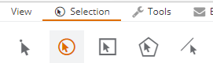

, 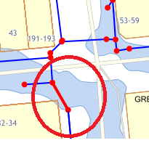
Once an asset is selected, then associated information of that asset is displayed in information panel in right hand side as shown below. If more than one asset is selected, then it will indicate by 1 or 2 as shown below, and user can click small arrow to find out information of 2 of 2
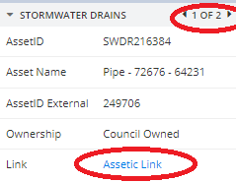
More information about the asset can be found by clicking on Assetic Link as shown above.

If you have any questions about the any features of IntraMaps please contact Milind Joshi on 8571 5338 or email mjoshi@cgd.vic.gov.au

