Overview  A new version of a document is created whenever it is edited. The new version can be released as either draft or published. Older versions of the document can be opened, printed, emailed or restored.  To display document versions  - Right click the document and select Properties to open the Properties window.  - Select the Versions tab.  - Select the checkbox Display Draft Versions.  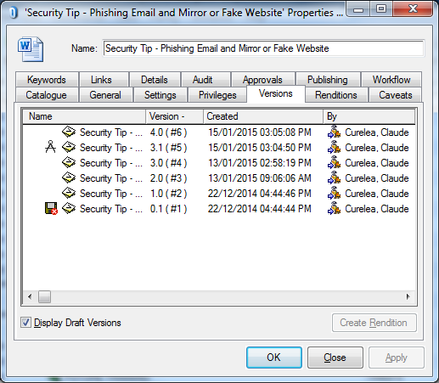 | To restore a version  - Display the Versions tab of a document (draft or published).  - Right click the required version.  - Select Restore Version to open the Restore Version window.  - Press the Restore button to restore the version.  - Save, close, publish and Release the document.  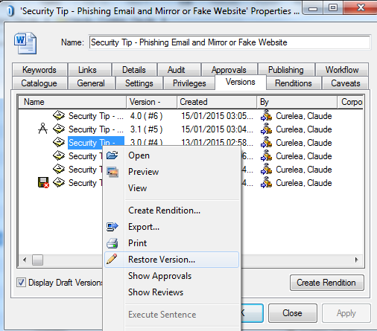  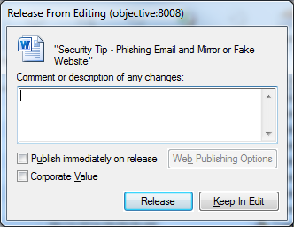      Note: If the document is in edit state use the Revert function.

