Overview  A rendition is a replica of a document in another format such as PDF. Renditions are useful when you do not have access to the native application of the document, or you want to email a PDF rendition rather than the actual document.  Renditions are not separate objects in Objective, but part of the source document and can be created for any version of a document.  To create a PDF rendition  - Right click the document and select Properties to open the Properties window.  - Select the Versions tab and display all draft versions.  - Select the document version you want a rendition of  - Click the Create Rendition button to open the Create Rendition window.  - Select the PDF File check box and the Onscreen checkbox.  - Click OK to create the PDF rendition.  Note: This may take a few moments to create        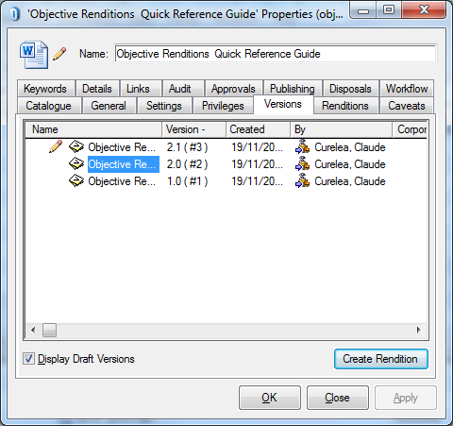 |     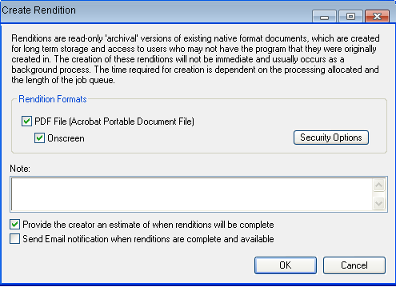  To email a copy of a PDF rendition  Once you have created a PDF rendition you can email it using preferred method below:  - Double-click on PDF inside Renditions tab and use File>Send File.. from Adobe.  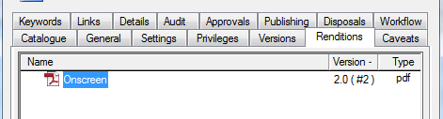  - Right-click on the Objective document and use the Send > Send Copy To.. command. Select the “Onscreen” PDF and press the OK button.  