Overview  Use Easy Search when you want to search for specified words or phrases in the content of published documents, or in selected search fields of any object.  The Available Categories pane which displays in an Easy Search enables you to quickly refine the search results.  Easy Search results will default to search by relevance to the specified text. Results can also be sorted in ascending or descending order by the date the object was last updated or by the size of the document.  To run a text search using Easy Search  - Select Windows > Find Objects.  - Provide the text to search.  - Click Search.      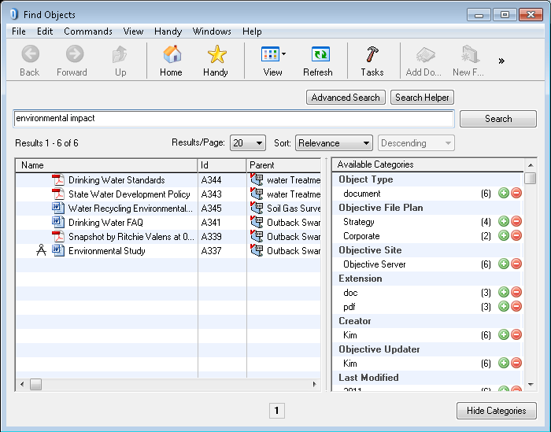 | To refine an easy search with the Categories pane  From the search results in a Find Objects window:  - Click next to an item to indicate search results must use that category.  - Click next to an item to indicate search results must not use that category.  - Click to remove categories from the Selected Categories section.  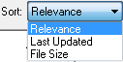  To sort results of an Easy search  From the search results in a Find Objects window:  - Select the sort parameter from the Sort list.  - Select the sort order from Ascending/Descending.  - Click the Search button to action the sort.  To use the Search Helper  Use the Search Helper if you want help to construct advanced search criteria in your text search.  From the Find Objects window:  - Click the Search Helper button to open the Search Helper window.  - Provide the text to be searched or excluded in the available fields.  - If you also want to search specific fields, do the following:  - Select the checkbox Search the following fields.  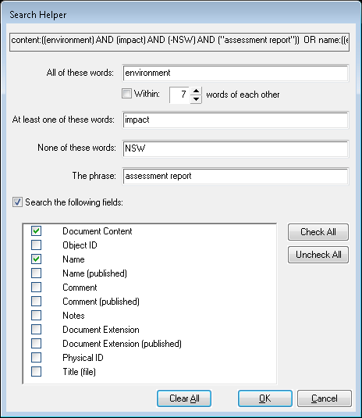  - Select boxes for each field you want to search.    - Click OK to close the Search Helper window and have the search criteria written into the text field.

