Actioning Correspondence as CORRESPONDENCE OFFICERS

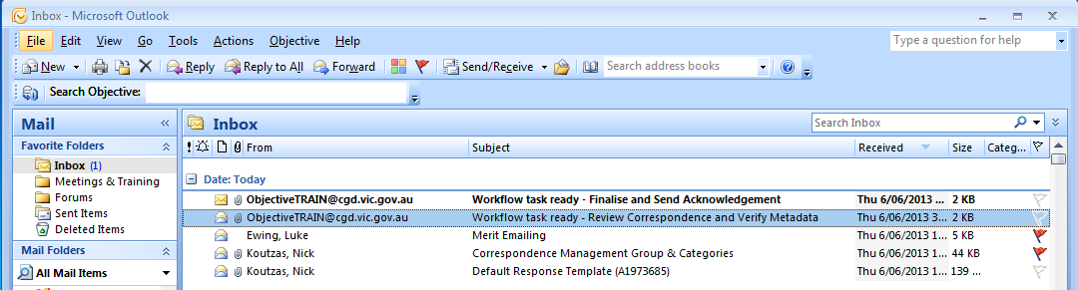
- Open the “Action Correspondence” email from your Inbox. This email will contain “Finalise and Send Acknowledgement” in the subject.



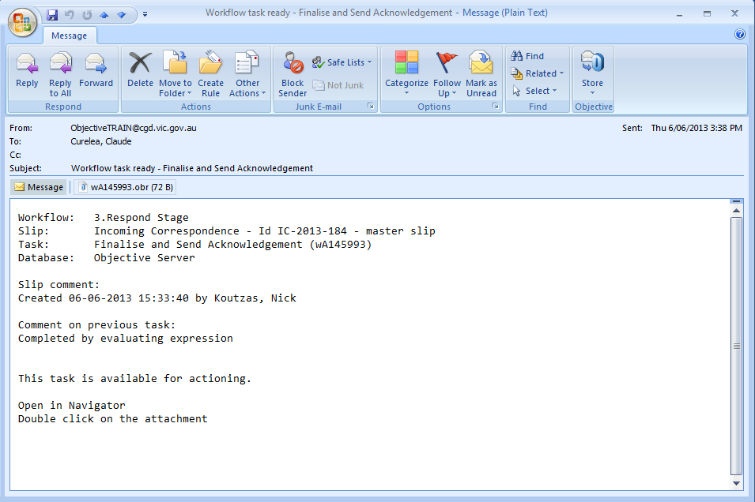

- Double-click on the Objective reference (.obr) attachment and click the Open button.

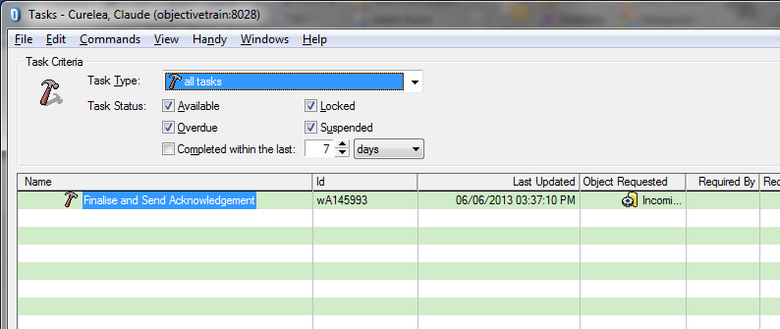
- Double-click on the Action Correspondence item in your task list.

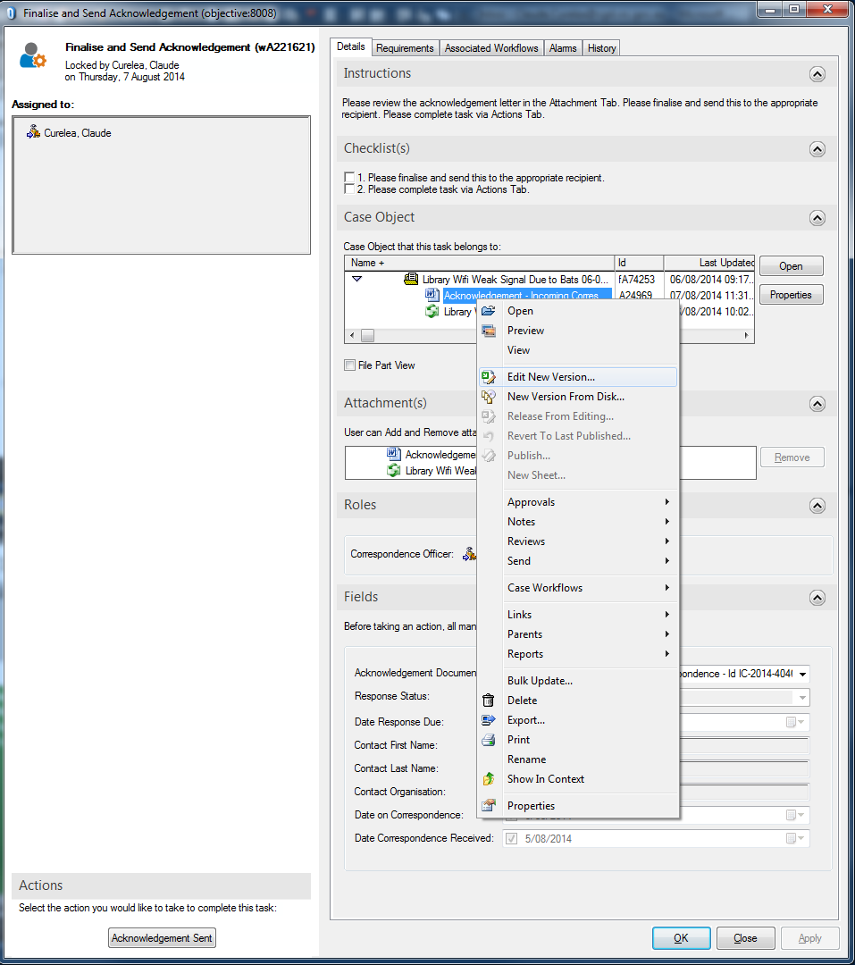
- To respond using the CGD Acknowledgement (Word template) right-click the Acknowledgement document and select Edit New Version... and skip to step 6.

To respond via email go to step 5.

Note: You may need to click on the reveal triangle to expand the file divider to access the documents.

Correspondence document ()is the original correspondence from the Resident. You can double-click on this document or email to read it at this time.

Acknowledgement document is generated by system and needs to be edited by Officer.

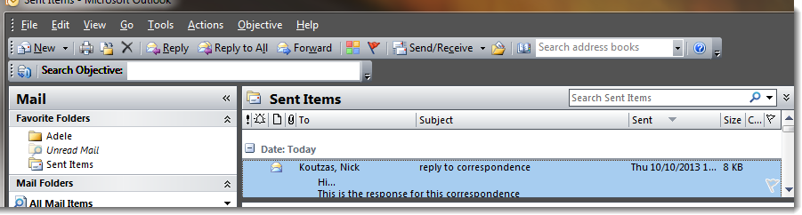
- If you have responded via email you can drag and drop your email (from your sent items) and place it ON TOP OF the Acknowledgement document in the above screen.

Press OK at the “Add as new version” screen.



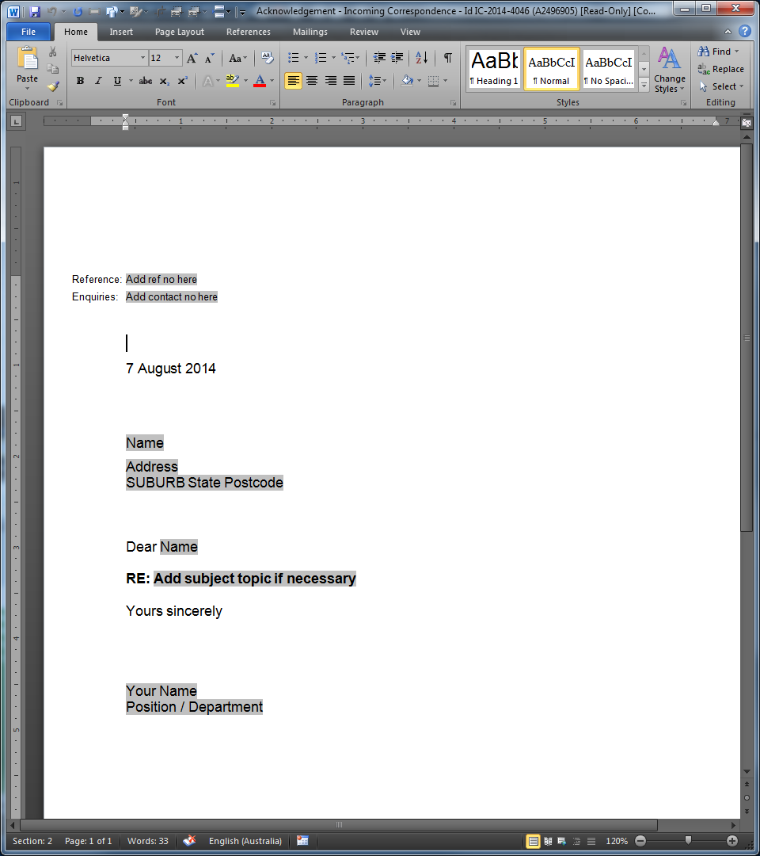
- Press Create button to continue responding using the Acknowledgement document.

Write your response to the Resident.

When finished click Save icon and Close the document.

- Publish with Corporate Value and press Release button.
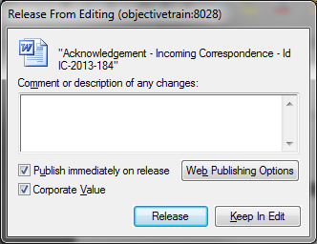
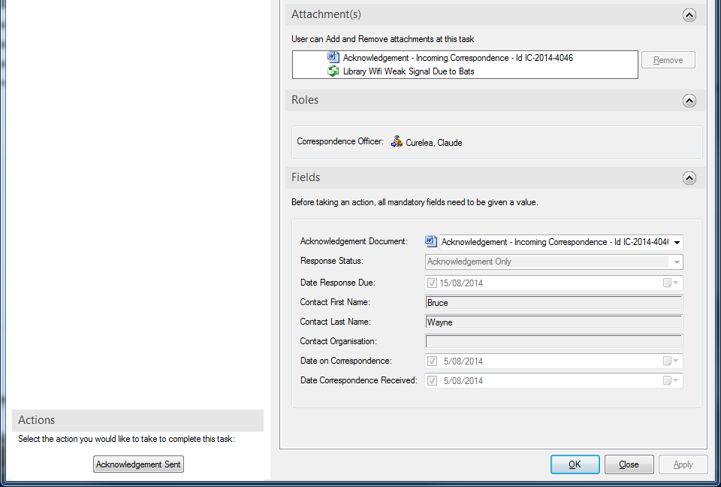
- To complete the task press the Acknowledgement Sent button.

