Actioning Correspondence as CORRESPONDENCE COORDINATORS

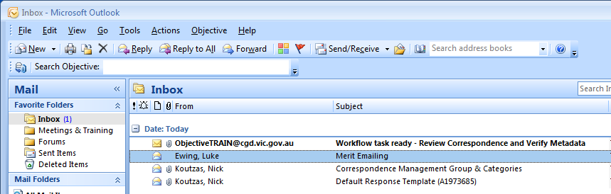

- Open the “Action Correspondence” email from your Inbox. This email will contain “Review Correspondence and Verify Metadata” in the subject.

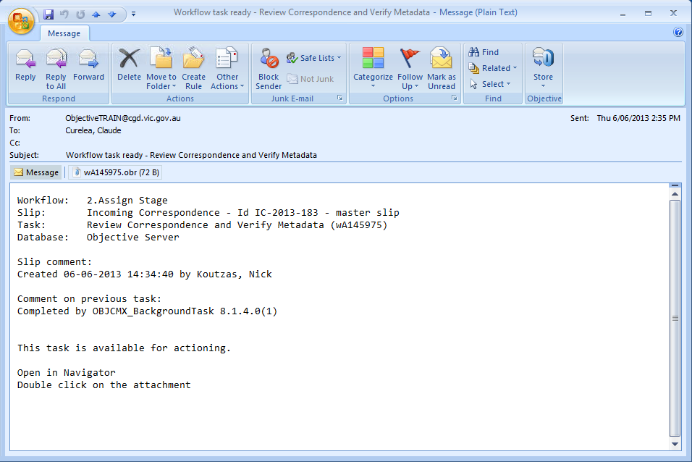
- Double-click on the Objective reference (.obr) attachment and click the Open button.

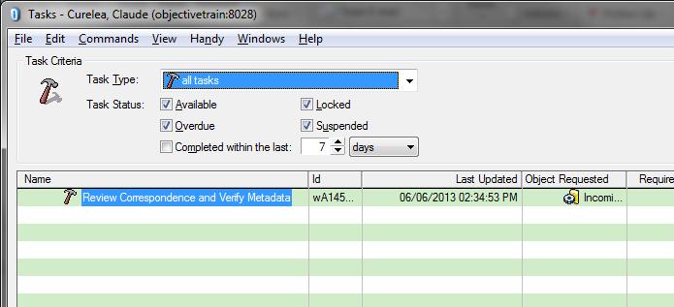
- Double-click on the Action Correspondence item in your task list.

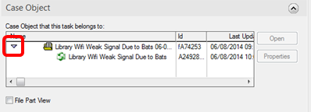
- Double-click on the correspondence document to open it. You may need to expand the file-divider. Correspondence Coordinator is to decide if task is to be handled by their department. Close the document and continue with procedure.
SCENARIO 1: TASK SENT TO CORRECT DEPARTMENT

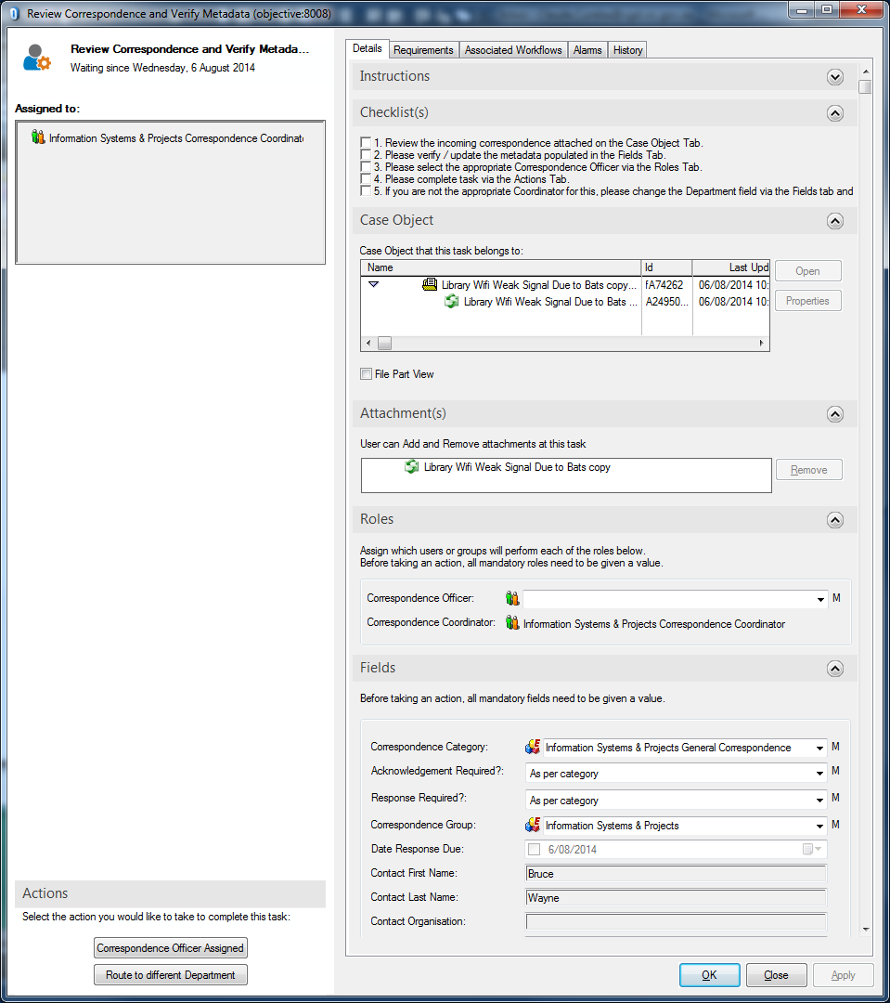
- Do not change any entries in Fields section.

- In the Correspondence Officer field enter the name of the officer in your department who will be carrying out the work.

Note: You can type in type the first few letters of a surname and press TAB key to make a section.

- Press the Correspondence Officer Assigned button.

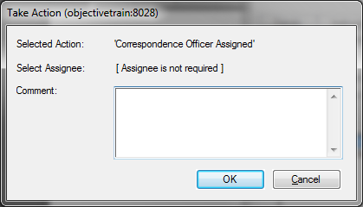
- Press the OK button at the Task Action screen.

SCENARIO 2: TASK SENT TO WRONG DEPARTMENT

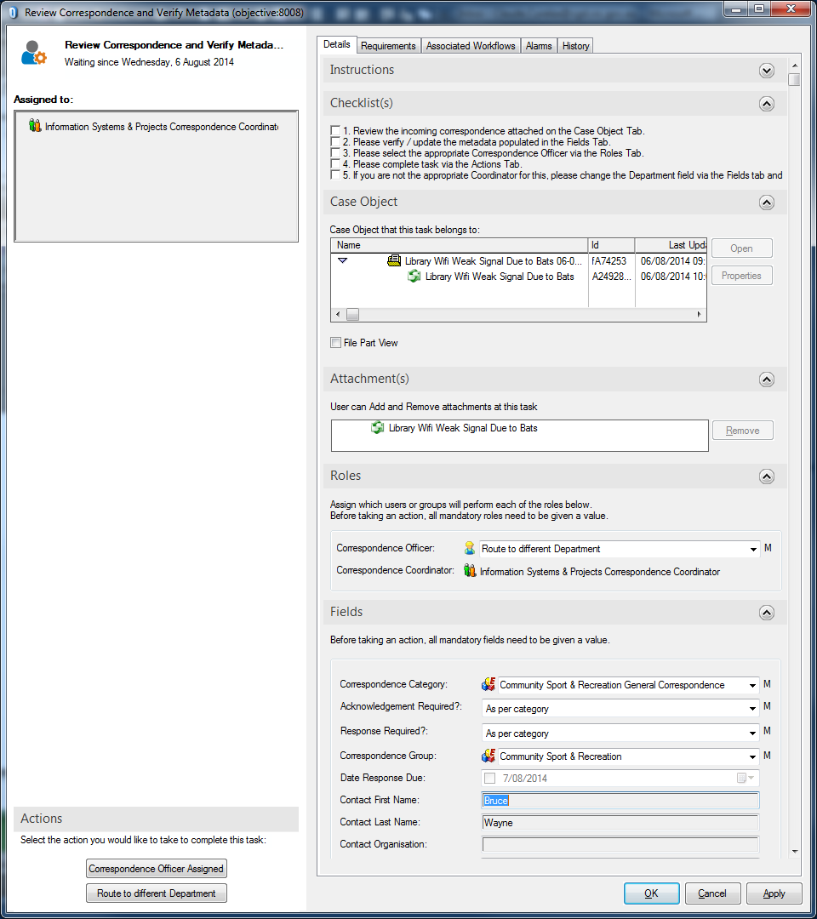
- Change the Correspondence Category and Correspondence Group fields to the correct department.

Note: You can type in department name and press TAB key to make a section.

- Change the Correspondence Officer to “Route to different Department”.

Note: You can type “route” in the Correspondence Officer field and press TAB key.

- Press the Route to different Department button.

- Press the OK button at the Task Action screen.

