To Run Magiq reports for Month End Reporting

Make sure the time series is referencing the correct month.

Please be aware that your data browser will be different from the example shown below as it will show access that it unique to you.

As the system is live, Magiq will automatically reference the month (eg September).

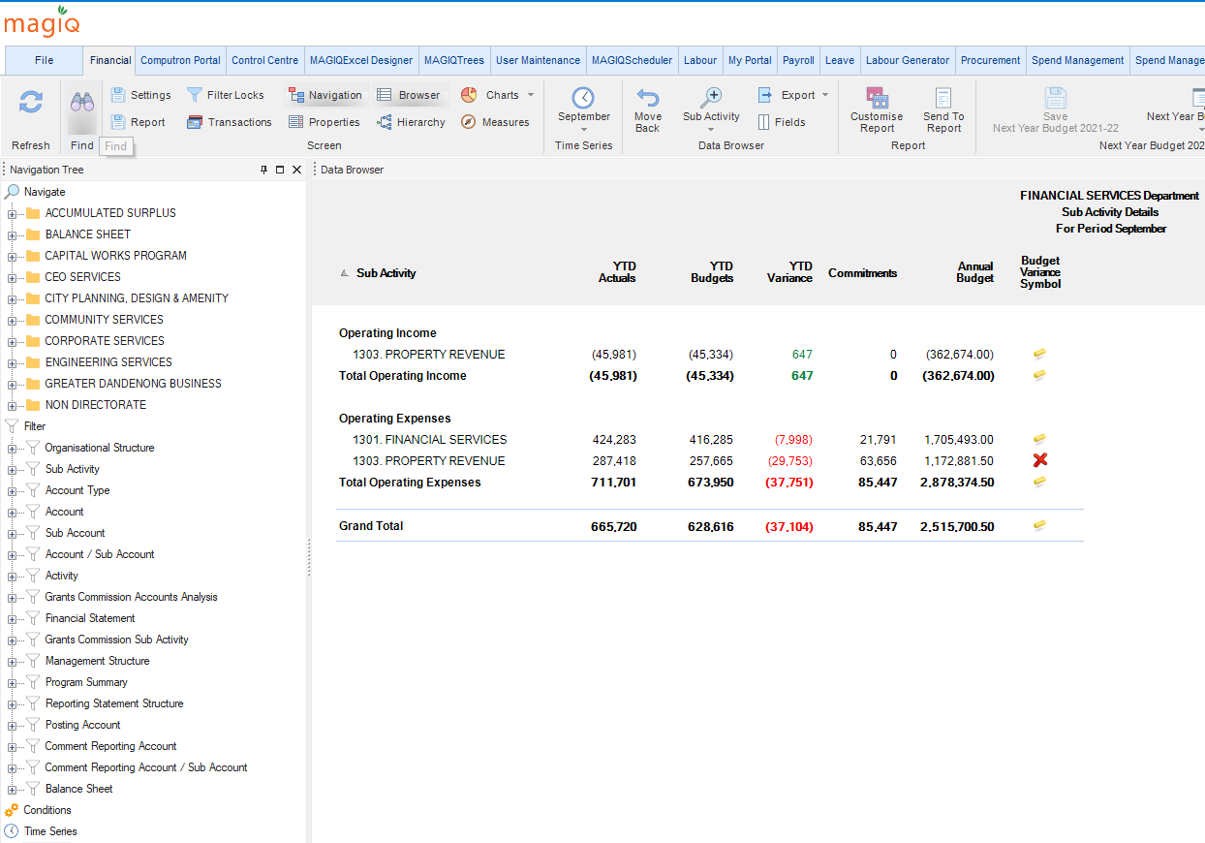

Month end cut off is now the end of the month so the reporting month will have to be selected (eg August).

To change the month
Click on the time series tab

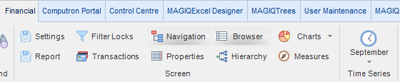

Select the reporting month - eg August

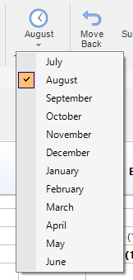

Report will now show the reporting month

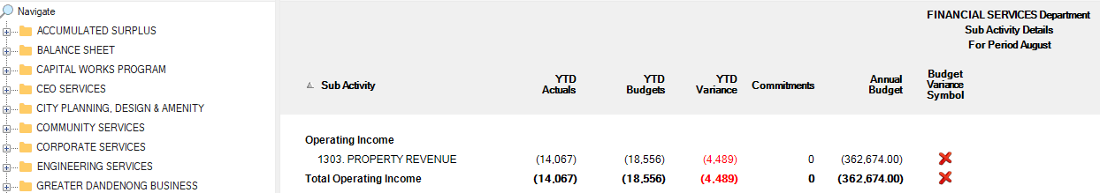

Printing the Report

A standard monthly report has been set up for month end reporting. This report has been saved in the Reporting directory in the Shared with Everyone file.

Double click on Reporting in the Navigation panel, this will expand and show options available.

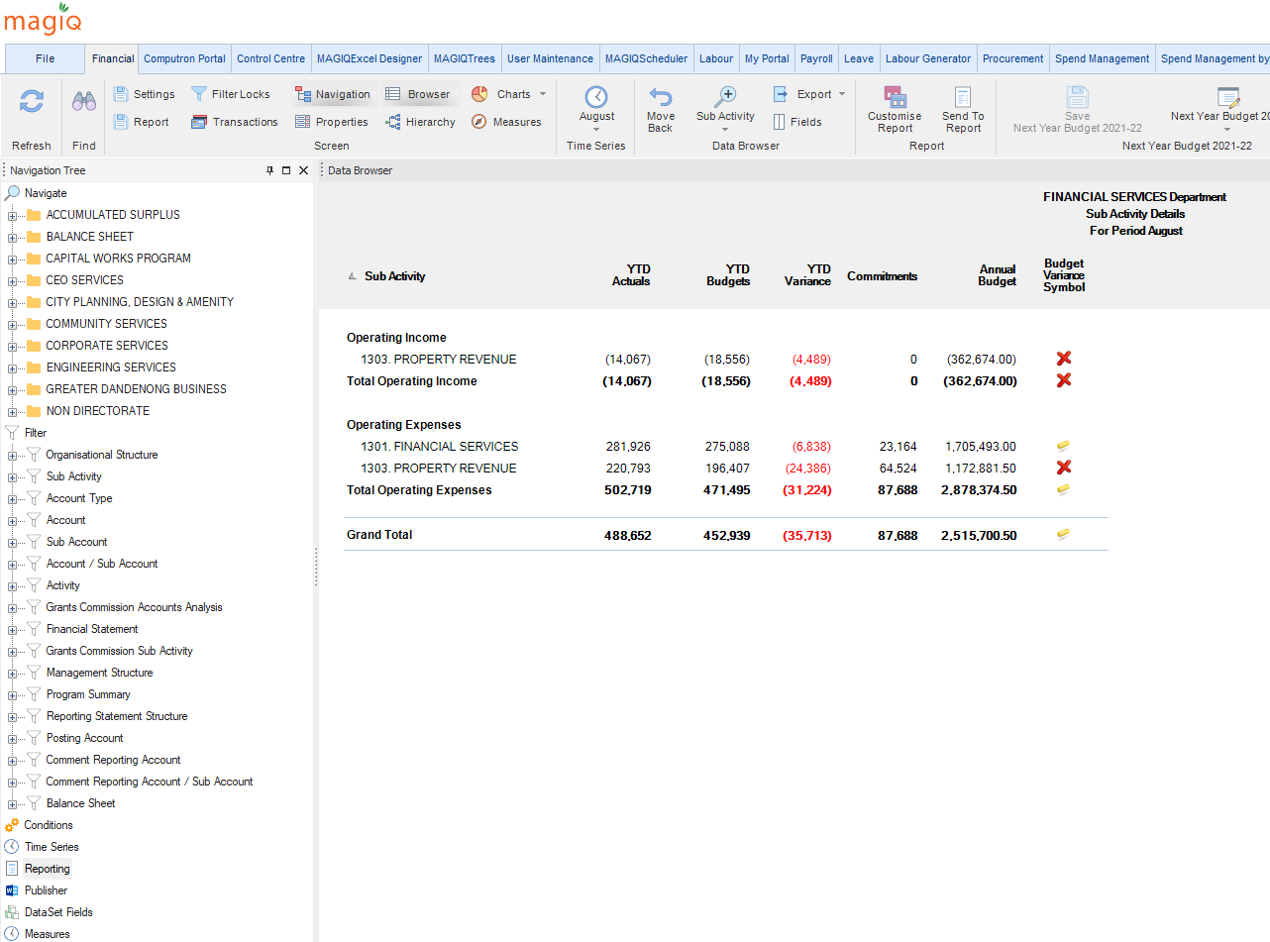

Double click Shared With Everyone

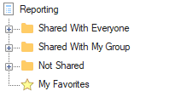

Double click Monthly Operating Income/Expenses Report

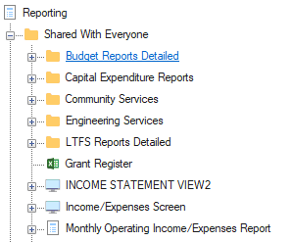

The report is ready to print or it can be downloaded to Excel or PDF to be saved if you wish.

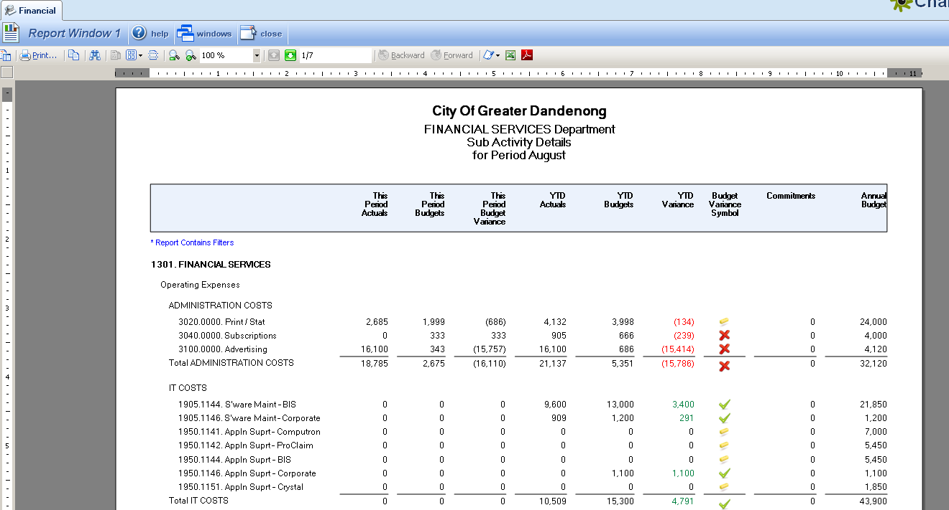

The procedure for reporting variances has also changed; please refer to the Magiq Template for Variance comments for instructions

Income, expenditure and Net result that exceed the criteria of $10,000 and 5% require a comment.

Please remember to state the reason for the variance and the action that will be taken to correct it and send comments to zzFinancial Planning.

