



Approver Guide
City of Greater Dandenong



Table of Contents

Approver Guide 1
1. Introduction 3
1.1. Approver Responsibilities: 3
2. Logging in 4
3. Approval Process 5
5. Overview of Reporting in FlexiPurchase: 7
6. Employee Analysis Report: 7

Introduction

Welcome to the Approvals User Guide. This guide will take you through the process of approving your employee’s transactions.

If you have any questions or issues regarding Flexipurchase, please contact your Administrator within City of Greater Dandenong.

Approver Responsibilities:

Supervisor Responsibilities

- Comply with the Corporate Purchasing Card Policy –
https://objective.cgd.vic.gov.au/id:A1963568/document/versions/latest
- Monitor and satisfy themselves of the appropriateness of all expenditures incurred by purchasing cardholders under their supervision prior to approving all transactions (failure to adequately review and monitor transactions of subordinates may result in disciplinary action being taken with respect to the supervisor).
- An approver must not approve transactions that relate specifically to themselves or subordinate transactions to another cardholder in order to circumvent normal approval channels.
- Ensure timeliness of all approvals (prior to end of month).
- Provide the Purchasing Card Administrator with details of any suspected inappropriate card transaction activity.
- Only delegate approvals to a recognised employee within the same financial delegation band as themselves.
- Business Unit Managers are to conduct spot checks on purchases by subordinates to ensure validity and compliance with procedures

Responsibilities of Purchasing Cardholder's Manager/Director

Managers and/or Directors of officers holding a Council Purchasing Card are responsible for the following:

- Approval of cardholder applications;
- Setting of monthly credit limits;
- Ensuring their department cardholder delegations are current and are to advise the Purchasing Card Administrator of any cards to be cancelled;
- Analysing monthly transactions and pursue any irregular or unusual transactions with the respective cardholder to ensure compliance with all Council policies.
- Follow up cardholders delaying the coding/approval of their transactions

If you have any difficulties regarding FlexiPurchase please contact:

Subi Nathan
X 5129
Email: purchasingcards@cgd.vic.gov.au

Logging in

Step 1: Go to http://flexipurchase.cgd.vic.gov.au and login in with your Flexipurchase username & password. (If you don’t have a username and password please send an email to the contact persons listed above)

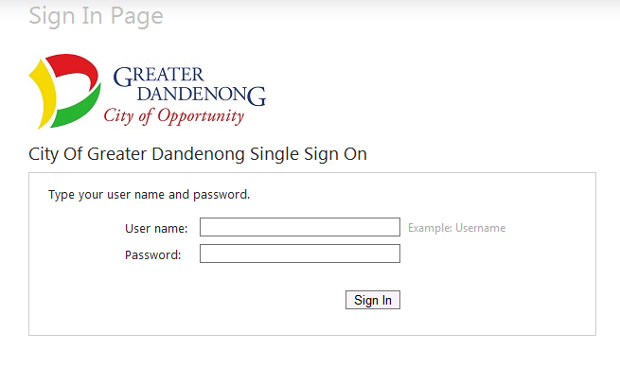

Step 2: Click on “Accept” if you agree to the Terms and Conditions.
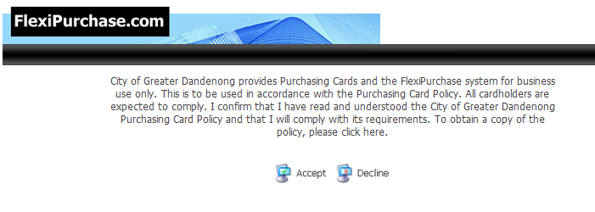

Approval Process

Step 1: Click the Approvals tab on the main menu – this will be flashing if a transaction has been triggered for your approval.

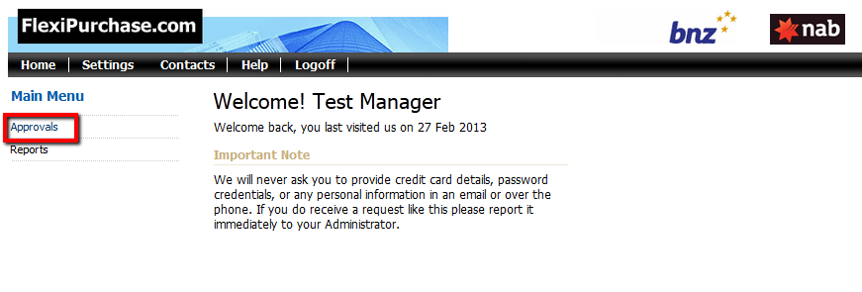

From the Items Requiring Attention screen, click:

- an employee's name to display all transactions that need approval across all periods and all account types, or
- a statement period beside an employee's name to display only the transactions for that period and that account type.

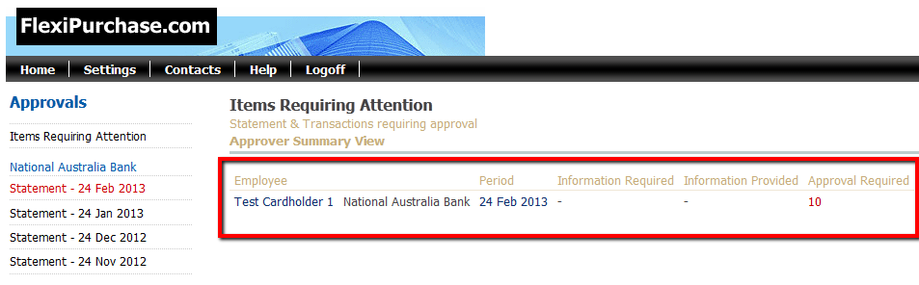

The Transaction Approval screen appears, allowing you to view the employee’s transactions that require approval.

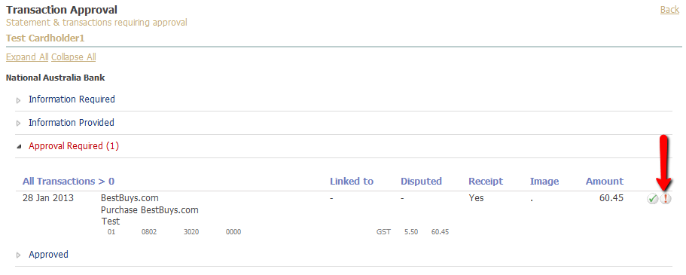

Step 2: You can approve transactions on an individual transaction basis by clicking the icon against each transaction and selecting an appropriate status: (see below)
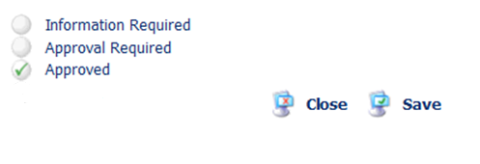

OR you can request further information about that transaction from the employee by selecting “Information required” and typing a question in the ‘Approver Comments’ field and clicking Save.

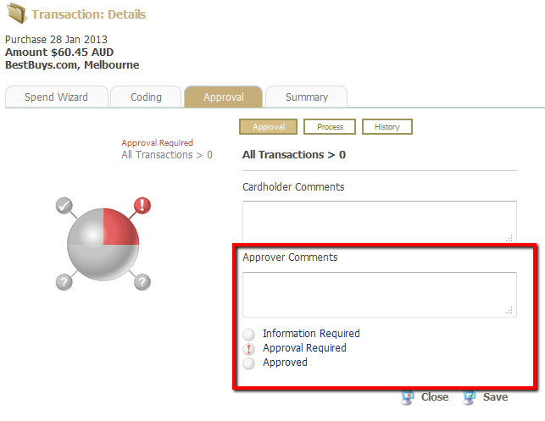

This will appear as a “?” for the cardholder –who can then narrate as required and you can view and add further comments etc or approve / decline if a Petty Cash expense. Remember to click Save.

When asking for more information an auto email is generated and sent to the cardholder’s inbox, telling them to login and check their transaction. When they post a cardholder comment in reply you will also be notified by automatic email.
As an approver it is your responsibility to ensure they are using their cards correctly.

FlexiPurchase will provide you with intuitive reporting over your employees spend. If you need help with these reports please contact your FlexiPurchase Administrator.

To get the most out of a successful expense management program you must also think about the policy surrounding the use of the cards. You need to ensure the cards are used in an appropriate manner.

Overview of Reporting in FlexiPurchase:
FlexiPurchase has a suite of powerful reports to support you monitor the expenditure of your employees.

Employee Analysis Report:

This report is a great dashboard-style view to monitor the coding compliance of all your employees throughout the month

Step 1: Click on [Reports] in your main menu

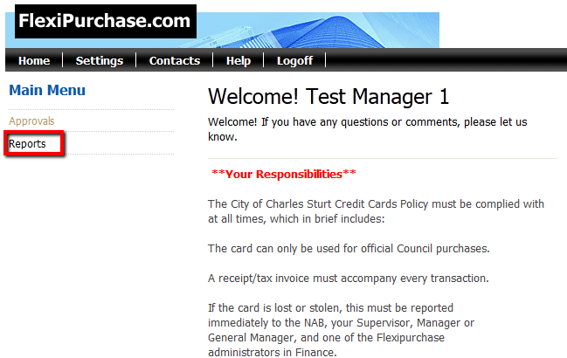

Step 2: Click on [Analysis – Employee] report:

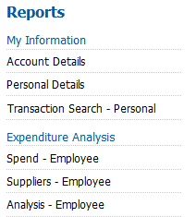

Step 3: Choose the relevant filters you are interested in (i.e. statement period or date range) and click [Search]

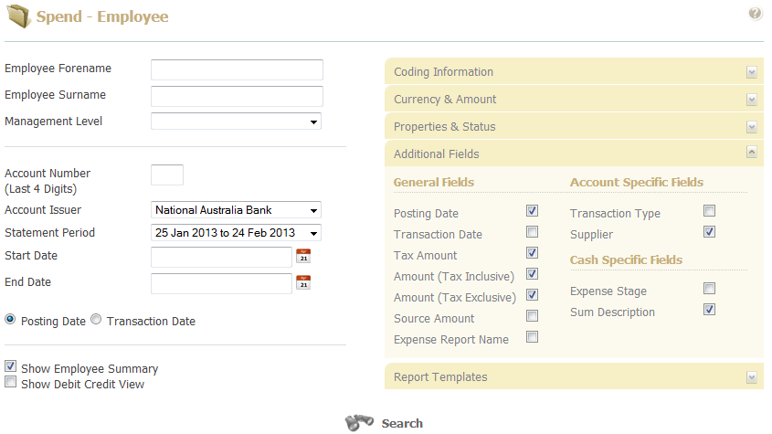

Note: If selecting a Statement period, you must delete the start & end date defaults

Step 4: The results display as a “Dashboard” style view with percentage stats against relevant coding and approval statuses.

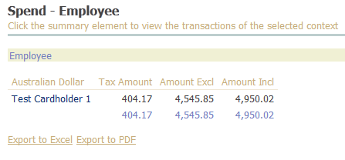

Useful Tip! Have a good play with all your reports as you can’t break anything by experimenting with reports and filters.

