Magiq – Variance comments and template
V 2.0
Version Date: 5 May 2021


Procedure Name: | Magiq – Variance comments and template
Version Number: | V 2.0
Owner/Author: | Assistant Management Accountant
Effective Date: | 5 May 2021
1. PURPOSE
Budget officers are required to complete variance comments and template if the year to date variance are over $10,000 and 5% of year to date budget.
The template for variance comments can be run from Magiq. This template will include the figures relating to your relevant department, the percentage calculation and an area for comments to be entered.
Following procedure is step by step on how to access variance comments and template from Magiq.
2. RESPONSIBILITY
This procedure applies to staff responsible for maintaining the Magiq system under the control of the Financial Services Department. Financial Services staff with administration responsibility of the Magiq system will be accountable for the following procedure.
3. PROCEDURE
Step 1 Log into Magiq as normal, change time series
Change the timeline to reflect the reporting month. In the example below the reporting month is November. The month showing is December as it is the current working month after close off.
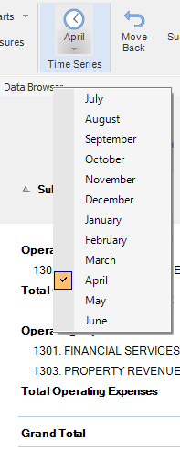

Step 2 Access variance comment template
In the Navigation Panel, double click on Reporting
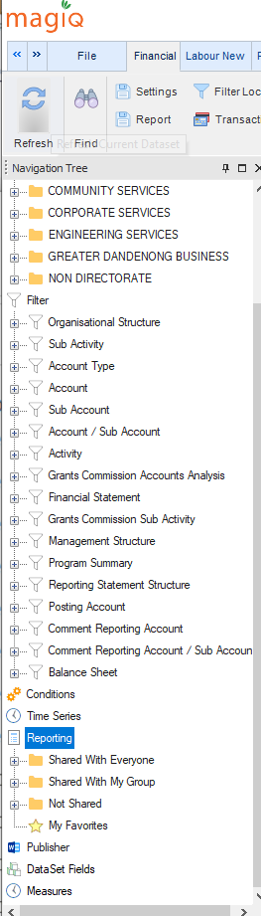
Double click on “Share With Everyone”
Double click on “Monthly Variance Report”
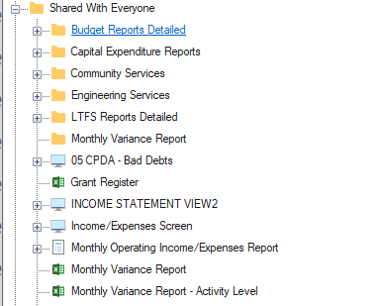

The message below will appear on screen while the report is loading. This is a very quick process.

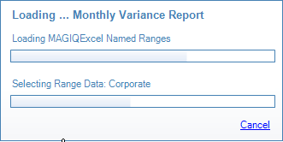

Note: For departments that require to print/view monthly variance report at Activity level – select and double click on “Monthly Variance Report – Activity Level”. Same process as running normal Monthly Variance Report .

Once the load has finished, your screen will show the downloaded screen in your data browser. This is the variance report template. This template needs to be exported to Excel –comments cannot be entered while still in Magiq.

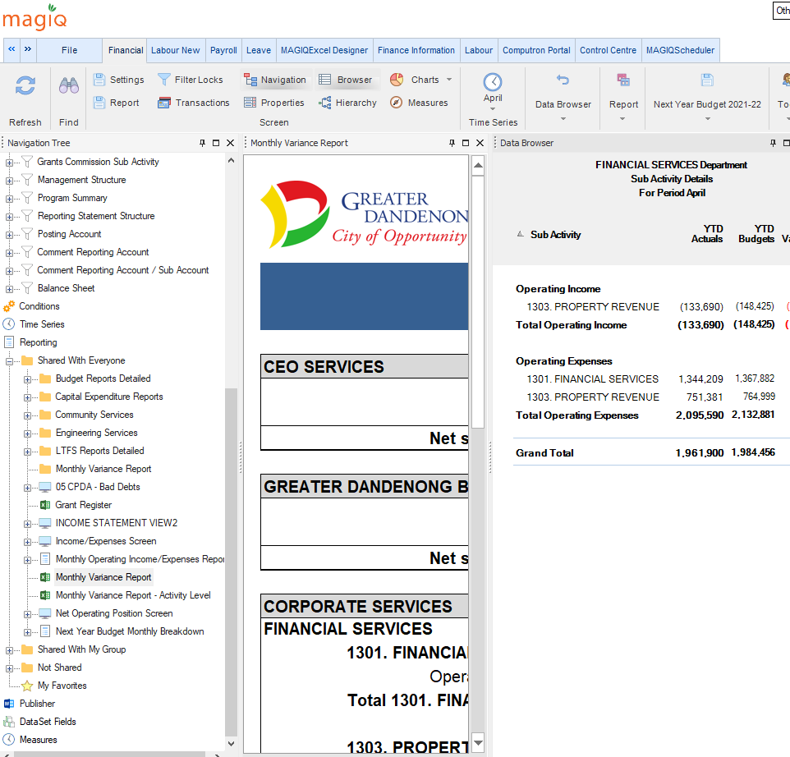

Step 3 Export to excel
To export - right mouse click in the body of the middle panel – the variance report. A menu will pop up, select Export. This will drop the variance report into an excel spreadsheet.
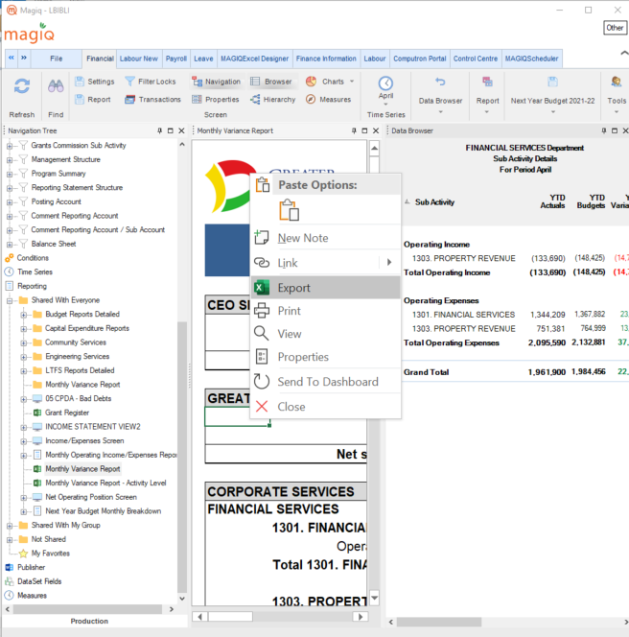

The template will be populated with only the area relevant to your user access. This is a global template and the other directorates will show but they will be blank.

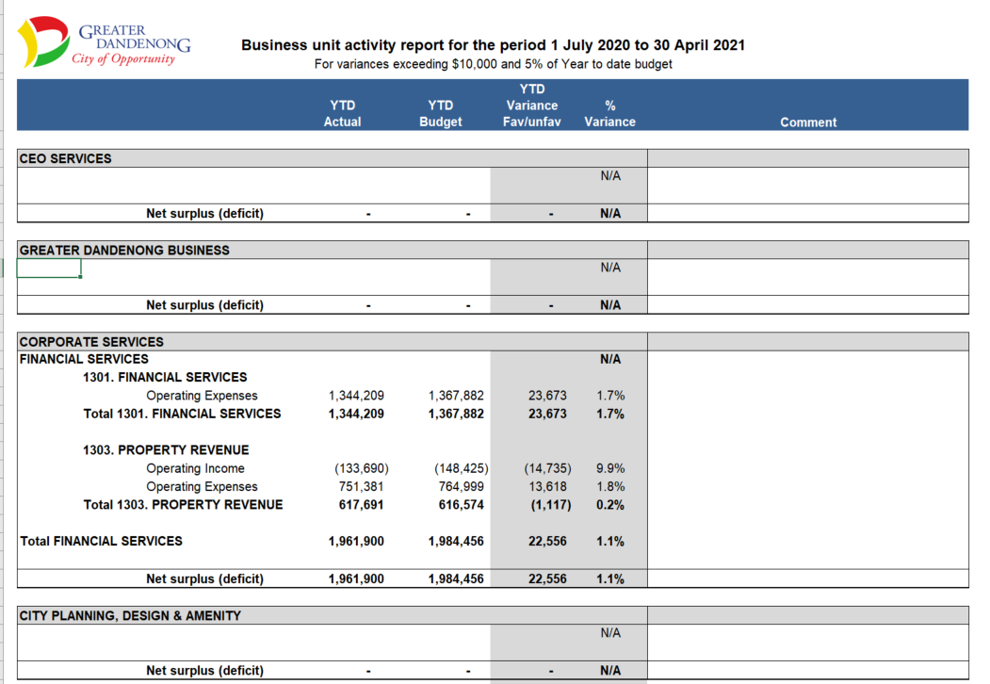

Once in Excel the other directorates can be deleted and your comments if applicable can be entered.
The text will wrap in the one cell and there is a limit as to how many characters will appear.
If you can’t see all the text expand the cell. To do this, go to the corresponding row and hover the mouse on the row until the cursor changes to a black cross and then double click and the row will expand.

Once comments are done, attach them to an email and send to zz Financial Planning.

To exit the excel template in Magiq, click on the x in the variance template panel.

