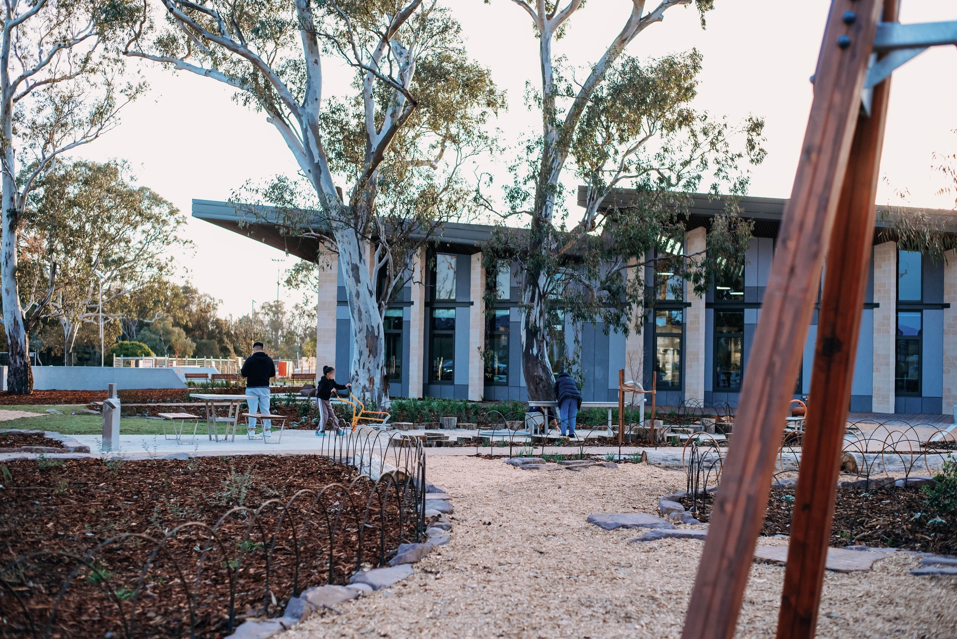


Sub-heading

Heading

Heading 1
Heading 2
Body Font

Table | Update

