Purpose
Greater Dandenong City Council (GDCC) is committed to providing a safe and healthy work environment. It is the responsibility of management to work co-operatively, and in consultation with employees, to attain a safe standard of office-based work to minimise injury in the workplace.

Scope
To provide a work environment and work practices which minimise risks from ergonomic, manual handling, and housekeeping hazards for office-based workers.

Definitions
Hazard: A source or a situation with a potential for harm in terms of injury or illness, damage to property, damage to the environment or a combination of these.
Health and Safety Representative (HSR): An employee elected by the DWG to represent them on matters relating to OHS.
Risk Assessment: the process of determining the likelihood and consequence of injury, disease or illness, or damage arising from exposure to a hazard. If there are existing Risk Controls already in place, an Assessment of Risk considers the reliability and robustness of these existing Risk Controls when determining the Inherent and Residual Risk Level/Score.

Responsibilities
For general OHS responsibilities refer to the GDCC OHS Responsibility Procedure.
Manager OHS is responsible for:
- ensuring the Procedure is implemented and reviewed, as required.
Managers are responsible for:

implementing the Procedure in their area of responsibility;
- monitoring work conditions and ensuring, as far as practicable, a safe working environment which may include ‘modification of the working environment’.

Employees are responsible for:
  - ensuring that the principles outlined in this Procedure is adopted and put into practice.

Procedure

Work Posture
Screen based tasks: (these principles also apply when working from home)

A good working posture will reduce fatigue and the risk of injury whilst improving efficiency.
You should adjust your workstation so as to provide a natural and relaxed position.
To achieve this, follow these fundamental principles:

Your feet must be firmly and comfortably supported, either on the floor or on a footrest.

To adjust your chair correctly –
Stand in front of the chair and adjust so
the highest point of the seat is just below your knees.
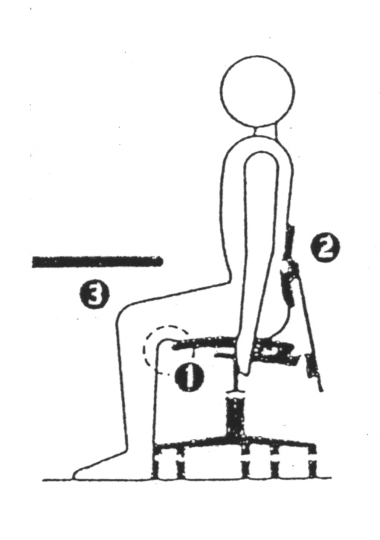

Sit so three fingers to a clenched fist fits between the
front edge of the seat and the lower
part of your legs.

Adjust the backrest so that it supports
the hollow in your lower back.

Armrests should height adjustable

The clearance between the top of your thigh and the underside of the desk should be approximately 1 to 2 cm, when the angle between your thighs and your upper body is 90° or greater.

When sitting correctly, the top of the computer should not exceed the
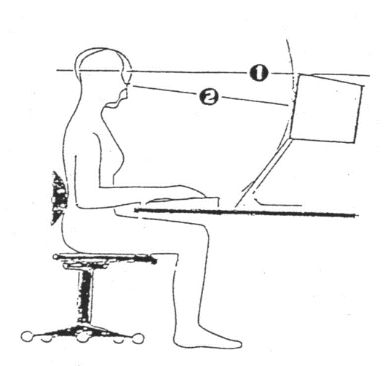
horizontal line of sight.

The viewing distance should be
approximately 600 to 750mm
from your eye to the centre of the
computer screen .

The principles above (5.1.4 and 5.1.5) also apply when standing at a sit / stand workstation.

Source documents should be placed on a document holder either next to, and level with, the computer screen or between the keyboard and screen.

You should avoid frequent or continuous bending and rotation of your neck.

To minimise eye strain, periodically focus on an object at least 6 metres away and move your eyes up, down, sideways and diagonally.

To minimise prolonged static postures, vary tasks at regular intervals and practice stretching exercises. Avoid prolonged keying tasks by varying activities every hour.

Maintain your natural posture and avoid excessive twisting and bending. You can
achieve this by correctly organising your workstation.

Your shoulders should be comfortable and relaxed and your elbows as close to your body as possible. Elbow angle should be as close to 90º as possible.

You must avoid frequent or continuous bending of your wrists in any direction.

Clerical tasks:

4.2.1 Your feet must be firmly and comfortably supported, either on the floor or a footrest.

4.2.2 Adjust your chair for maximum comfort. This position is typically 10 – 15 cm lower than for screen based tasks.

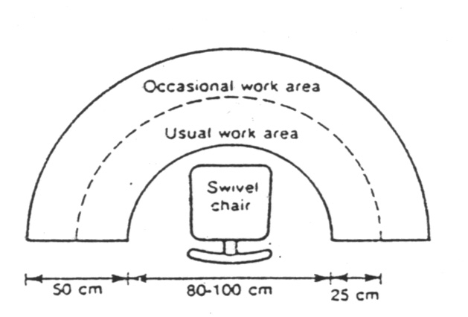
4.2.3 Organise your workstation with frequently used items within the reach range of
35 – 45 cm and less frequently used items within the maximum reach range of
55 – 65 cm.

Avoid twisting and bending to retrieve items

Purchase of Office Furniture and Equipment

4.3.1 Guidelines for the purchase of office furniture and equipment have been established in corporate document Selection and Layout of Office Furniture and Equipment. Advice on the purchase of equipment and furniture can be obtained from Council’s Purchasing Officer in the Contracts Unit or Council’s Health & Safety Consultant in the Risk & OHS Unit.
4.3.2 The purchase and use of polycarbonate chair mats (or similar) is not approved. Only approved equipment and furniture must be used. If in doubt, contact Council’s Purchasing Officer or Health & Safety Consultant

4.4 Housekeeping:

4.4.1 Keep access around your workstation and throughout the department free of
obstructions.

4.4.2 Always ensure that exits from your work area are accessible.
If access is restricted in any way, report it to your supervisor.

4.5 Manual Handling :

4.5.1 Store materials safely –
  - On shelving, store heaviest items on shelves between knee and elbow height.
  - Cartons / boxes must be securely stacked not more than three high.

Note: Do not over reach. Use a sound two step ladder to reach higher shelves.

4.5.2 Use filing cabinets safely
(1) Never open more than one draw at a time.
(2) Always close the draw when leaving the cabinet.

4.6 When lifting:

4.6.1 Prepare your muscles. Consider warmup exercises
4.6.2 Bend your knees.

4.6.3 Ensure the load is close to your body.

4.6.4 Position your feet properly.

4.6.5 Grip with the heel of your hand. Not your fingers

4.6.6 Test the load before lifting. If it’s too big or heavy get help

4.6.7 Keep your back correctly aligned. Tuck your chin in

4.6.8 Move your feet to turn, do not twist your back

4.6.9 Carry out the lift smoothly and gradually

4.7 Safety Tips:

4.7.1 Do not use faulty or unsafe equipment / furniture. Report it to your supervisor

4.7.2 Keep work areas and aisleways clear of obstructions and clutter.

4.7.3 Be aware of the emergency plan and wardens for your area. Plans are displayed
throughout the office, and emergency wardens are displayed on noticeboards.

4.7.4 Ensure that the location of first aid kits are known. First aid kits are maintained by
designated First Aid Officers. Know your Designated First Aid Officers of your area.
First Aid signs are clearly displayed throughout the office, and Designated First Aid
Officers are displayed on noticeboards.

4.7.5 Adjust your workstation and chair correctly to reduce the risk of injury and fatigue.

4.7.6 Use handrails when ascending and descending stairs. Ensure you sanitise before using handrails or lifts. In accordance with GDCC Infection Control procedures, hand sanitising stations have been made available for everyone’s use and are located throughout GDCC Buildings and Offices.

4.7.7 Store and handle materials safely. If it is too heavy or bulky get help

4.7.8 Mop up any spillages in the lunchroom kitchen / kitchenettes or bathrooms.

References
- Occupational Health and Safety Act 2004
- Occupational Health & Safety Regulations 2017

Related Documents
OHS Policy
OHS Consultation and Communication Procedure
OHS Electrical Safety Procedure
OHS Infection Control Procedure
OHS Issue Resolution Procedure
OHS Manual Handling Procedure
OHS Purchasing Goods Procedure
OHS Responsibility Procedure
OHS Risk and Change Management Procedure

Document History
Version Number | Issue Date | Description of Change
0.1 |  | 1st Draft from Risk & OHS Unit.  Previous version of Procedure was under old document control process:  COS0101 Version “G” Effective: February 2002, Last Review: June 2012
0.2 | 09.02.2021 | Accepted by the OHS Policy Sub-Committee
0.3 | 15.03.2021 | 14 Day Employee Consultation completed
1.0 | Apr 2021 | Approved by the OHS Oversight Team
1.1 | Jun 2025 | 2nd Draft from OHS Unit
1.2 | Jun 2025 | Accepted by the OHS Policy Sub-Committee
1.3 |  | 14 Day Employee Consultation completed
2.0 |  | Approved by the OHS Committee

