


Greater Dandenong City Council
Operations Centre
Emergency Management Plan

Content Page

Content Page 2
Introduction 5
Purpose 5
Aim of the Plan 5
Emergency Management Organisational Structure 5
What is a Major Incident and an Emergency 5
Emergency Planning Committee 6
Members 6
Responsibilities 6
Specific Duties of the EPC 7
FIRE FOUND 8
HAZMAT – GAS, CHEMICAL OR OTHER FUMES LEAK 9
HAZMAT – SPILLAGE FROM AN ITEM OF MAIL 10
HAZMAT – CONTACT WITH SPILLAGE FROM AN ITEM OF MAIL 10
BOMB THREAT RECEIVED 11
SUSPICIOUS ITEM OR VEHICLE IDENTIFIED 12
SERIOUS SECURITY INCIDENT – LOCKDOWN / SHELTER IN PLACE 13
MEDICAL INCIDENT REQUIRING FIRST AID OR MEDICAL ATTENDANCE 14
POWER FAILURE 15
PEOPLE WHO REQUIRE ASSISSTANCE 16
EXTERNAL EMERGENCY TELEPHONE NUMBERS 17
DANDENONG OPERATIONS CENTRE SITE MAP 18
BOMB THREAT CHECKLIST 19

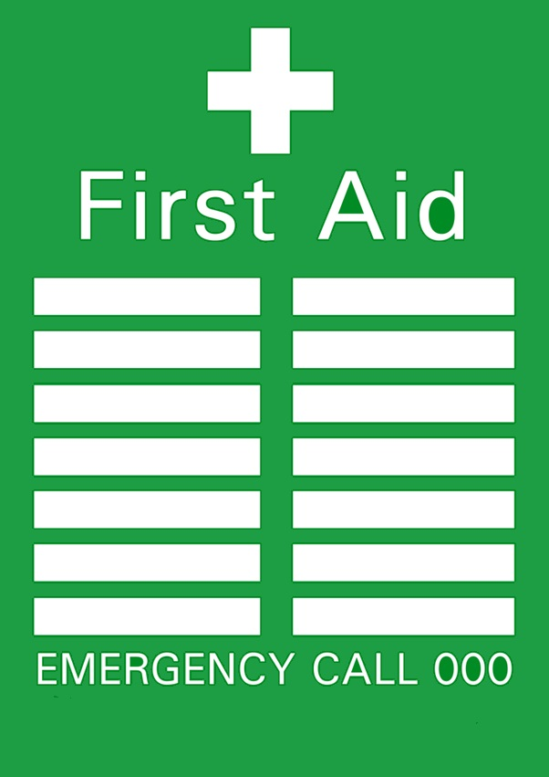
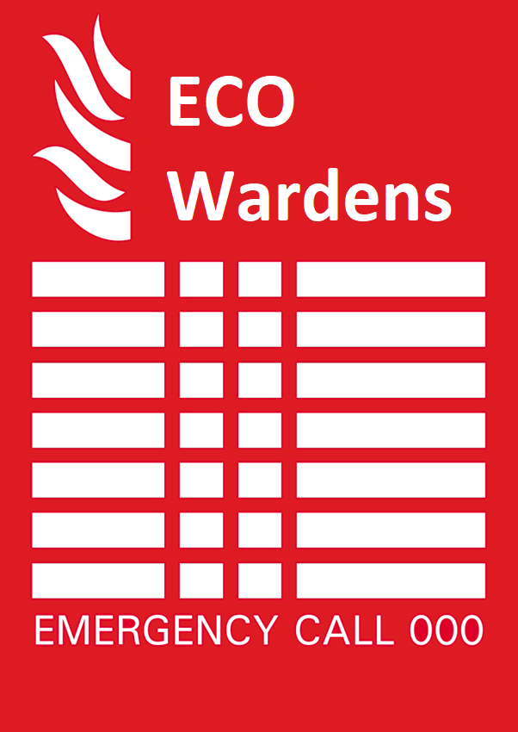

Introduction

Purpose
These procedures were formulated to meet the requirements of Australian Standard AS3745 Managing Emergencies in Facilities.
The principal function of the emergency procedures is to ensure the safety of personnel. To this end we seek your cooperation in observing the procedures and in the event of a major incident or emergency, the instructions given by the Wardens.

Aim of the Plan
The aim of the plan is to make available to all Greater Dandenong City Council – Operations Centre Management Team and relevant staff and contractors, as necessary and appropriate, information covering the initial procedures for the protection and safe movement of occupants of the Operations Centre during a major incident or emergency situation.
All Greater Dandenong City Council – Operations Centre staff are required to participate in Emergency Planning and Evacuation Exercises and acknowledge the authority of appointed Wardens in emergency situations. Instructions given by the ECO will overrule the normal management structure.

Emergency Management Organisational Structure
Two organisational structures are established for emergency management:
- The Emergency Planning Committee (EPC) responsible for putting preparations in place to meet emergency situations; and
- The Emergency Control Organisation (ECO) responsible for providing the initial assessment and response to emergencies.

What is a Major Incident and an Emergency
Major Incident is any occurrence that has occurred, or may occur, which whilst disruptive to normal operations, does not, nor is likely to threaten or endanger the safety or health of persons or property.
Emergency means an incident, due to an actual or imminent occurrence, which endangers or threatens to endanger, the safety or health of persons or property, resulting in the complete suspension of normal operational duties.

Emergency Planning Committee

Members
The EPC is responsible for deciding the members of the ECO, providing they are trained by an accredited facilitator and the development and approval of Operations Centre Emergency Management and Major Incident Plan.
The EPC for Operations Centre will consist of the following Personnel.
Permanent Members:
- Ray Tully
- Robert Maglicic
- Erland Cazeneuve
- Pathan Kanagasabathy
- Lisa Gnocato
- Greater Dandenong City Council OHS Advisor

Invited Guests to the EPC
- Emergency Management Consultant (Matt Smallwood – Mathew Smallwood Consulting)
- Emergency Services (Police, Fire, Ambulance)
- Service Contractors

Responsibilities

Appoint and maintain the ECO

Coordinate the establishment of, and maintenance of, an Emergency Operations Centre.
Engage the emergency management consultant to develop Emergency Evacuations Plans for all areas of Operations Centre including.
- Prepare and maintain emergency contact lists (Reference this):
  - The emergency contact lists should include, but not limited to.
    - Operations Centre Staff
    - Key Council Staff
    - Police and Emergency Services
    - Hospitals and Medical Centres
    - Major Contractors
    - Utility Suppliers
    - Relevant Neighbours / Stakeholders

- Prepare and maintain wallet sized laminated key staff contact lists
  - This list should include
    - Key Springvale Community Precinct Staff
    - Key Head of Office Staff
    - Media Relations
    - Trauma Councillor

- Ensure copies of the Emergency Management and Major Incident Plan is in the EOC and other nominated places.
- Maintain a register for Training (Refer location)
- The EPC will be responsible to ensure the following plans are placed in the appropriate sections of the appendices.
  - Evacuations Diagrams
  - Critical plant and service isolation / shutdown plans
- Developing, planning, and coordinating emergency responses with Emergency Services organisations.
- Evaluate evacuation exercises and rectify flaws in policies and procedures, develop remedial training and implement changes; and
- Consider the supply of, and training the in the use of, telephone recording equipment to be used to record bomb threat calls.

Specific Duties of the EPC

Integration of the Emergency and Major Incident Procedures
- The Plan shall form part of the routine management arrangements of Operations Centre.
- Incident and Emergency management shall be recognised at all Operations Centre meetings as an agenda item
- Incident and Emergency Management planning and responses shall be subject to regular audits by their nominated person as well as an external consultant.

Coordinate and Develop Public Address Scripts
- The EPC, in conjunction with the Emergency Plan consultant, shall be responsible to ensure appropriate scripts are developed and implemented for announcements covering.
  - Evacuation
  - False Alarms
- Scripts are to be printed and located adjacent to each Public Address System for quick reference during announcements.

Awareness of the Plan
- The EPC shall ensure all relevant information and procedures are disseminated to staff, contractors, and other relevant personnel.
- All members of the ECO are to read and understand the Emergency Management and Major Incident Plan.

Training
- The EPC shall ensure all members of the ECO are provided with relevant training to their appointment
- The EPC shall ensure other relevant training shall be provided to other staff as specified in the education and training section of the Emergency Management and Major Incident Plan.

FIRE FOUND
IMMEDIATE ACTION
If you discover a fire within Operations Centre, you should take the following action:
- Remain as calm as possible
- IF SAFE TO DO SO – alert all occupants within your immediate area, of the fire
- IS SAFE TO DO SO – direct occupants toward the safest exit
- IF SAFE TO DO SO – alert and inform the nearest ECO Warden of the situation
- IF SAFE TO DO SO – attempt to extinguish the fire with the correct fire extinguisher
- Evacuate the areas under direct threat from the Operations Centre via the safest exit, or exit as directed by the ECO Wardens
- Follow all further directions from ECO Wardens, and Emergency Service personnel.

Note: Operations Centre does not have a fire detection system and will not sound any audible alarm when a fire has started.

HAZMAT – GAS, CHEMICAL OR OTHER FUMES LEAK
IMMEDIATE ACTION
If you can clearly smell gas or other fumes evident within the Operations Centre, you should take the following action
- Remain as calm as possible
- IF SAFE TO DO SO – Inform the nearest ECO Warden of the evident fumes
- IF SAFE TO DO SO – Stop work – do not move around the grounds
- If you are exposed to chemical and able, make your way to the chemical wash station located near the HAZCHEM stores.
- IF SAFE TO DO SO – Secure your working environment
- Gather your basic personal possessions (Phone, Purse, Jackets etc);
- Exit the building you are occupying
- Make your way to the closest Emergency Assembly Area; and
- Follow all further directions from ECO Wardens.
Note: When exiting the centre due to Gas or Fumes please ensure you are upwind from the HAZMAT substance to avoid any possible inhalation concern from staff, and visitors.

HAZMAT – SPILLAGE FROM AN ITEM OF MAIL
IMMEDIATE ACTION
If you have opened an item of mail and an unidentified substance has been spilled from it, you should take the following action:
- Remain as calm as possible
- Slowly place the item of mail down
- Do not touch or move the item any further
- Do not touch any spilled substance
- Cover the spillage area, including the item of mail
- Alert the nearest ECO Warden, of the situation
- Minimise movement throughout the affected area of Operations Centre
- Follow all further instructions from ECO Wardens, and Emergency Service Personnel.
HAZMAT – CONTACT WITH SPILLAGE FROM AN ITEM OF MAIL
IMMEDIATE ACTION
If you believe you have been exposed to, or have come into contact with an unidentified substance that has spilled or leaked from an item of mail, you should immediately take the following actions
- Remain as calm as possible
- Slowly place the item of mail down
- Do Not move from the location within Operations Centre
- Remain in your current location and alert others in the immediate areas, of the spillage and contact with the substance
- Have the nearest ECO Warden informed of the spillage and that contact with the substance, has occurred
- Do Not brush any spilled substance of clothing
- Wait-in-place for directions from ECO Wardens; and
- Follow all further instructions from ECO Wardens, and Emergency Service personnel.
Note: If the Operations Centre is staffed it is important that those areas to either move into an open aired location, or if no risk of air contamination, remain in their office spaces and minimise the awareness of the situation which will reduce cause for alarm.
BOMB THREAT RECEIVED
IMMEIDATE ACTION
If you receive information threatening the placement and/or detonation of an explosive item, near at or within the Operations Centre, you should take the following action
- Remain as calm as possible
- Attempt to record as much of the received information as possible – the bomb threat checklist should be used, or anything close at hand to document threat information, such as:
  - Was the caller’s voice male, female, loud soft, fast, slow, clear, muffled, clam, emotional, have an accent, familiar with the area.
  - Was the caller well spoken, incoherent, irrational, taped, abusive, message read by caller.
  - Was there background noise such as street noise, aircraft, other voices, music, machinery, house noise, local or long-distance call.
- Without alerting others around you, immediately pass all threat information to the nearest ECO Warden; and
- Follow all further directions from ECO Wardens

SUSPICIOUS ITEM OR VEHICLE IDENTIFIED
IMMEIDATE ACTION
If you have identified an item, or a vehicle at or near the Operations Centre, that has raised suspicion as to its origin, owner, or purpose, you should take the following action
- Remain as calm as possible
- DO NOT TOUCH OR TAMPER WITH THE ITEM OR VEHICLE IN ANY WAY!
- Without alerting others in the area, inform the nearest ECO Warden and or Emergency Services of the situation; and
- Follow all further directions from ECO Wardens, and Emergency Services personnel.
- Restrict access to the area where the vehicle has been parked, either keep occupants inside and away from vehicle or if necessary, evacuate to the opposite side of the building from the vehicle.
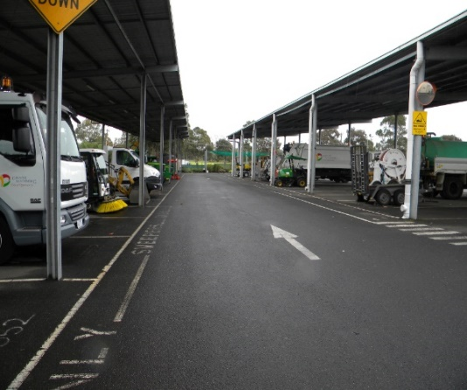
Note: The entry to the Operations Centre facility is through a card swipe or key fob system. The operations admin area can only be accessed by being invited however the rest of the compound is open to walk-ins if not questioned by staff.

SERIOUS SECURITY INCIDENT – LOCKDOWN / SHELTER IN PLACE
IMMEDIATE ACTION
Where a security incident arises that has been deemed to impose a safety risk to the Operations Centre occupants, direction may be given to lockdown and shelter in place.
IMMEDIATE ACTION
If you hear a code black shelter in place message communicated via the PA system or a member of staff located within the Operations Centre, you should take the following action
- Remain as calm as possible
- IS SAFE TO DO SO – Follow these four steps
  - Close window, blinds, and secure doors of all buildings within Operations Centre
  - Stay out of sight and minimise movement. HIDE!
    - Exit the Operations Centre in a safe manner taking others with you, ensure you utilise the exits furthest from the incident
  - Hide within one of the offices, or first aid room of the Operations Centre
  - Stay silent, turn mobile phones to silent
  - Endure - you may be in LOCKDOWN for some time.
- Wait in place and follow further directions from your nearest ECO Wardens, and Emergency Services personnel.

Note: The entry to the Operations Centre facility is through a card swipe or key fob system. The operations admin area can only be accessed by being invited however the rest of the compound is open to walk-ins if not questioned by staff

MEDICAL INCIDENT REQUIRING FIRST AID OR MEDICAL ATTENDANCE
IMMEDIATE ACTION
If you witness an incident resulting in a person requiring medical assistance near, at or within the Operations Centre, you should take the following action
- Remain calm as possible
- IF SAFE TO DO SO – provide comfort to the injured person and have the nearest First-Aid officer informed of the situation
- DO NOT MOVE THE INJURED PERSON – Remain in the area until the arrival of the nearest First-Aid officer and or Emergency Services personnel
- Have the nearest ECO Warden informed of the situation; and
- Follow all further directions from the First-Aid officer, ECO Wardens, and Emergency Services personnel.
While waiting for Emergency Services to arrive:
- Send a staff member to the main entrance to wait for Emergency Services to arrive.
- Ensure you know the location of all First Aid equipment including first aid kits, defibrillators, personal medical devices (EpiPen, Ventolin, Other Medicines) and mobility devices.

POWER FAILURE
IMMEIDATE ACTION
If all power completely ceases within the Operations Centre, you should take the following action
- Remain as calm as possible
- Stop Work – do not move around the workplace
  - Use the light on your mobile device to initially find your way
- Secure your designated working area
- Collect any flashlights, megaphones or other personal protective equipment to assist you with communicating the power failure to staff and visitors of the Operations Centre
- Wait in place for directions from ECO Wardens; and
- Follow all further directions from ECO Wardens.
The Operations Centre ECO Warden will dispatch a staff member to walk through building and inform all occupants of what has occurred and the planned response by the organisation. Depending on the source of the power failure, decisions must be made for a temporary and permanent response for each occurrence of a power failure.

PEOPLE WHO REQUIRE ASSISSTANCE
Circumstance that requires a specific emergency response procedure for a person requiring assistance during emergency situations may include; a person with a restrictive physical mobility issue; a person with a hearing, sight, or psychological condition or a person with a temporary physical or psychological limitation.
Certain people may require some form of assistance (minimal or significant), during an evacuation from the workplace. A specific local emergency response procedure called Personal Emergency Evacuation Plan (PEEP) will either be developed as required or will already exist within the Operations Centre. Typically, this specific procedure will include several pre-determined response steps and may include the allocation of a ‘buddy’ to assist and accompany the person requiring assistance during the emergency.
If you believe you will require assistance during an evacuation from the workplace, please inform your ECO Warden of your requirements ASAP, so that an appropriate emergency response procedure can be arranged. Alternatively, your ECO Warden will inform you of the previously developed and formalised emergency response procedure that will be activated to assist you during emergency situations.
IMMEDIATE ACTION
If you are made aware of a fire, or are verbally informed of an emergency occurring, or that an immediate evacuation is required, you should take the following actions:
- Remain as calm as possible;
- Stop work and minimise movement around the building;
- Secure you working environment;
- Gather your basic personal possessions (phone, purse/wallet, jacket etc) and any required medication and specific physical aids;
- Activate your individual ‘specific’ emergency response procedure, then follow all further directions from ECO Wardens, and Emergency Services personnel; or
- Wait in place and follow all further ‘specific’ directions from your allocated buddy or ECO Wardens, and Emergency Services personnel.
EXTERNAL EMERGENCY TELEPHONE NUMBERS

Fire Brigade | 000
Police | 000
Ambulance | 000
Police Non – Emergency | 131 444
State Emergency Service (Storms, etc.) | 13 25 00
Environment Protection Agency (EPA) | 1300 372 842
Electrical Faults & Emergencies: Energy Safe Victoria – United Energy | 000 or 13 20 99
Sonic Health Plus Dandenong | 03 9213 2800 or 03 9793 0243
WorkSafe Victoria – Advisory Service | 1800 136 089
Gas Leaks / Emergencies | 13 27 71
South East Water and Sewerage Emergencies | 13 28 12
Poisons Information Centre | 13 11 26
Interpreter Service (24 Hours) | 13 14 50
Coronavirus Hotline (DHHS) | 1800 675 398
Child Protection Crisis Line | 13 12 78
Crime Stoppers | 1800 333 000
Dial Before You Dig | 1100
Monash Health – Dandenong Hospital | 03 9554 1000
Roads, Traffic and Hazardous Road Condition | 13 11 70
City of Kingston | 1300 653 356
City of Casey | 03 9705 5200
Employee Assistance Program (EAP) | 1300 687 327

OPERATIONS CENTRE SITE MAP
Site Evacuation Diagrams are posted throughout the Operations Centre in the main office, fleet workshop, and stores facility.

Bomb Threat Checklist
BOMB THREAT CHECKLIST – KEEP CALM – DON’T HANG UP
When is the bomb going to explode?
Where did you put the bomb?
When did you put it there?
What does the bomb look like?
What kind of bomb is it?
What will make the bomb explode?
Did you place the bomb?
Why did you place the bomb?
What is your name?
Where are you?
What is your address?
EXACT WORDING OF THE THREAT
ACTION
Report Call Immediately to:
Phone Number:
RECIPIENT
Name (Print):
Phone Number:
Signature:
CALLERS VOICE
Accent (specify): | Any impediment (specify):
Voice (loud / soft): | Speech (fast / slow):
Diction (clear / muffled): | Manner (calm / emotional):
Did you recognise the voice? | If so, who do you think it was?
Was the caller familiar with the area?
THREAT LANGUAGE
Well Spoken? | Message read by Caller?
Incoherent? | Abusive?
Irrational? | Other?
Taped?
BACKGROUND NOISE
Street Noise? | House Noise?
Aircraft? | Local Call:
Voices? | Long Distance:
Music? | STD:
Machinery
Other:
OTHER INFORMATION | CALL TAKEN
Sex of Caller: | Date:
Estimated Age: | Duration of Call:
 | Number Called:

