Value for Money

Quick Reference Guide No. |  | QRG-01
Quick Reference Guide Name |  | Value for Money
Quick Reference Guide Owner |  | Procurement Manager
Version No. | Status |  | Issue Date
0.2 | Current |  | October 2024

Definition
"Value for money" (VFM) is a concept we use in procurement of goods, services and works which assesses the "value" of our prospective purchase rather than just the price. "Value" is the combination of price and other aspects of the procurement that are important in achieving the objective of the procurement and that are important to the City of Greater Dandenong.
It can be defined as follows:
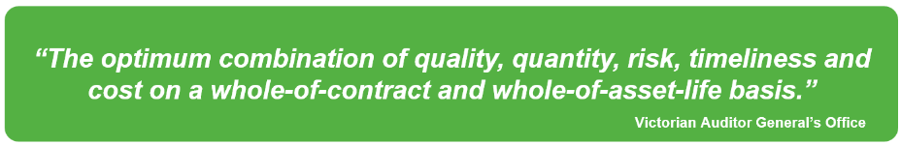
When we assess the value for money of our procurement, we may find that the lowest price does not necessarily represent the best value.

Objective of Value for Money
Council is committed to maximising the benefits to Council and the community from our expenditure on goods, works and services, whilst achieving positive economic, social, environmental, and economic outcomes through procurement. We use value for money to ensure that a balanced assessment of the impact of the procurement in these areas is considered.

The Imperative for Value for Money
Value for money is specified in the Victorian Local Government Act and in the Victorian Local Government Best Practice Procurement Guidelines.
The Victorian Local Government Act requires Councils' procurement policies and practices to support value for money.
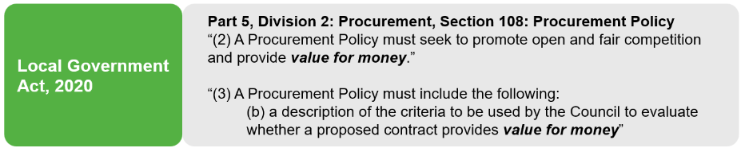
The Victorian Local Government Best Practice Procurement Guidelines 2024, require value for money to be a fundamental principle of procurement. The Guidelines point out that the Victorian Auditor-General’s Office and the Victorian Ombudsman may assess Council's practices against the Guidelines.
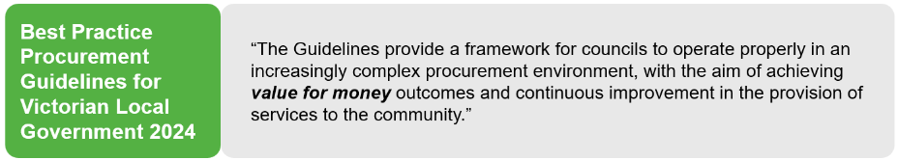

Value for Money in Council's Procurement Policy
The City of Greater Dandenong Procurement Policy is the key document governing procurement within Council. Value for money is a key principle of the Procurement Policy. The Policy states that "achieving value for money shall be the basis of all procurement decisions within Council".
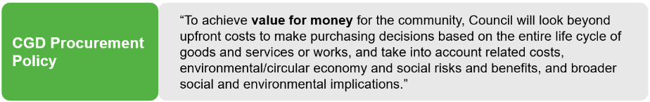

How Value for Money is Used in Council
Value for money during the procurement process
Value for money is utilised at the three different stages of the procurement process, "Plan", "Source" and "Manage", as described below.
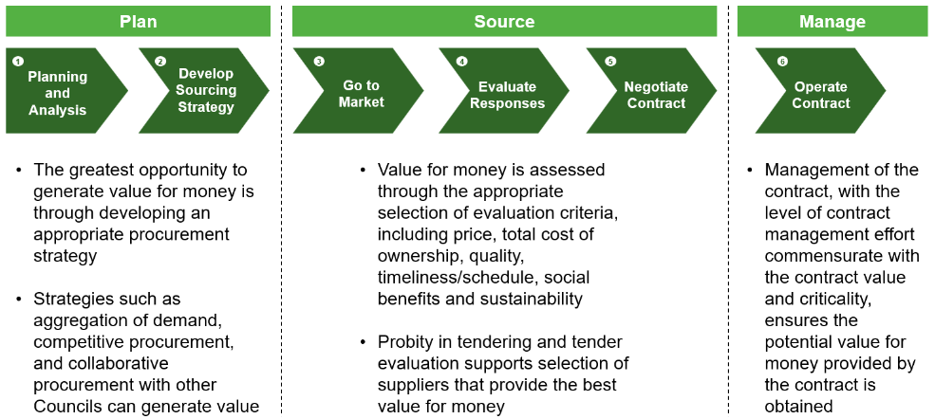

Value for money is a key consideration during the "Plan" stage since this is the greatest opportunity to generate value for Council. The selection of appropriate evaluation criteria ensures that value for money is assessed during tender evaluation. Actively managing contracts ensures that the potential value of a contract is not eroded.
Demonstrating value for money
The Procurement Policy requires that value for money is demonstrated when seeking approval for exemptions from the Policy quotation and tender requirements and for emergency procurement. VFM is also required to be demonstrated when only one quote is received in response to the issue of Requests for Quote to multiple suppliers.

How to Demonstrate Value for Money
Any procurement at CGD deemed necessary to ensure that a balanced assessment of the impact of the procurement as follows: (Value for Money Assessment Vers.1B)
- Procurement policy
- High risk or complex works (will be accompanied by a procurement plan)
- Exemptions, extensions and or variations
- To plan, source and manage

This will require our Value for Money assessment sheet to be completed and sent back to procurement for evaluation.
When required to demonstrate value for money, the checklist below can be used as a guide.
No. | Assessment | Description
1 | Original Contract Outcomes | Does extending the contract aligns with the original contract objectives? Or whether a new contract/engagement aligns with your current procurement objectives or plan?
2 | Supplier performance | Evaluate the current provider’s performance. Report current providers performance to current contract. If not current use market data.  Does any previous or current market knowledge on performance or prior reviews from references or third party (Corporate scorecard/Creditor watch).
3 | Market method VFM | Assessed current market conditions around procurement method chosen to align with value for money, timelines, and current requirements. Should we be approaching the market and would it yield better outcomes. Report market data and methods used on market approach.  Can an internal panel be used from Vendor Panel, MAV, or Procurement Australia.
4 | Fair and Open | Consider fairness to suppliers as part of procurement value for money approach.  Are we are being fair and open to the market as per policy requirements. If we are not taking this out to the market/quoting thresholds why not?  Are we asking for an exemption for this procurement?
5 | Supplier Capability | Have you used this supplier before or has someone suggested this supplier to you?  If this is a new supplier have, we ran background checks and performance reviews on the capability of the supplier?  Has the supplier performed well enough to warrant engagement? how and why this warrants this type of engagement?
6 | Time & Budget Constraints | Is there sufficient budget and time for your chosen procurement process. Include possible extra costs, time spent, risks or systems issues.  Are there time restrictions on the procurement and why? Are there risks on any of the above-mentioned requirements? Could system/technology issues occur at CGD if this procurement isn’t performed (time range, high risk, extra costs)?

Value for Money Assessment Version 1B Snapshot
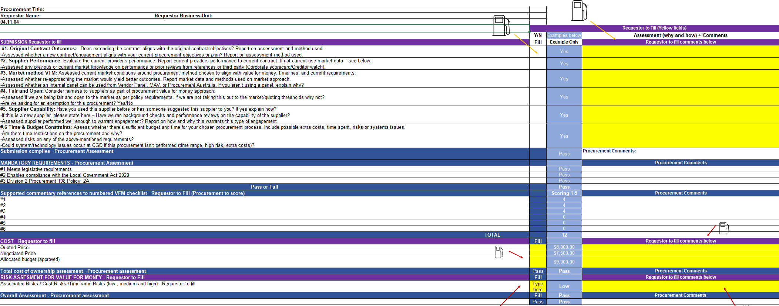

Further Information
The following sources of information can be accessed for further information on value for money.
CGD Procurement Policy | Value for Money Assessment Version 1B

