Exemptions

Quick Reference Guide No. |  | QRG-02
Quick Reference Guide Name |  | Exemptions
Quick Reference Guide Owner |  | Procurement Manager
Version No. | Status |  | Issue Date
0.1 | Current |  | 10 September 2024

Definition
An "exemption" in the context of procurement can be defined as:
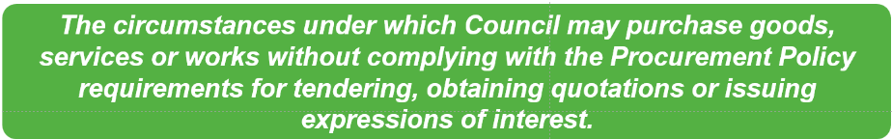

Exemptions in Council's Procurement Policy
The City of Greater Dandenong Procurement Policy (the Policy) is the key document governing procurement within Council.
The Policy describes four types of exemptions:
- Exemptions from Procurement Process
- Council Specific Exemptions
- General Exemptions
- Ad hoc Exemptions
Exemptions from Procurement Process
Appendix 1 of the Procurement Policy states that exemptions from seeking the required number of quotations for the value of the procurement need to be approved via the Exemption from Procurement Process Form.
Council Specific Exemptions
Appendix 3 of the Procurement Policy specifies the following transaction types that are not considered to be procurements of goods and services and that are exempt from the requirements to raise purchase orders, seek quotations or procure under a tender process:
- Rate Refunds
- Refunds to Community Care clients
- Trust Refunds
- Employee Re-imbursements
- Utilities - water, telephone, mobile, gas, electricity, sewerage charges.
- Australia Post
- Community Grants and Sponsorships
- Memberships and Subscriptions
- Couriers
- Petty Cash
- Seminars and conferences
- Travel related expenses
- Goods/service purchased on a corporate purchasing card
- Insurance claims
- Planning application/Building
- Medical accounts
- Purchase of property
These transactions do not require exemption approval.
General Exemptions from Procurement Process
Section 5.10 of the Procurement Policy lists those circumstances that are exempt from tender, proposal, quotation and expression of interest requirements.
In summary, they are:
- Emergency procurement
- Engagements with another government entity
- Purchases from contracts established by another government entity, local authority or local purchasing group
- Contracts entered into in accordance with arrangements approved by the Minister and where Council is able to demonstrate to the Minister that it is not viable to go to public tender
- Extension of contracts while Council is conducting a market tender
- Legal services and insurance
- Novated contracts (with conditions)
- Software licence and maintenance and support renewals (with conditions)
- Utility authorities working on their own assets
- Regional waste management groups
- Operating leases
- Contract over-expenditure
- Variations to the above
The Policy requires that these exemptions are endorsed in accordance with the current Instrument of Financial Delegations.
Note that for legal services, exemption approval is required at the time of establishment of a legal services master agreement or legal services provider panel. Exemption approval is not required when purchasing from those master agreements or panels.
Ad hoc Exemptions
Ad hoc exemptions are those exemptions from Policy that are not Exemptions from the Procurement Process, Council Specific Exemptions or General Exemptions.
Appendix 3 of the Policy states that the Chief Executive Officer may approve ad-hoc exemptions in exceptional circumstances where it can be demonstrated that it is in the best interests of the community to do so. It states that these exemption requests must include an assessment of whether the expenditure represents value for money.

Who Can Approve Exemptions?
General Exemptions must be endorsed in accordance with the current Instruments of Financial Delegation.
All other exemption types must be endorsed by the CEO.

Process for Approval of Exemptions
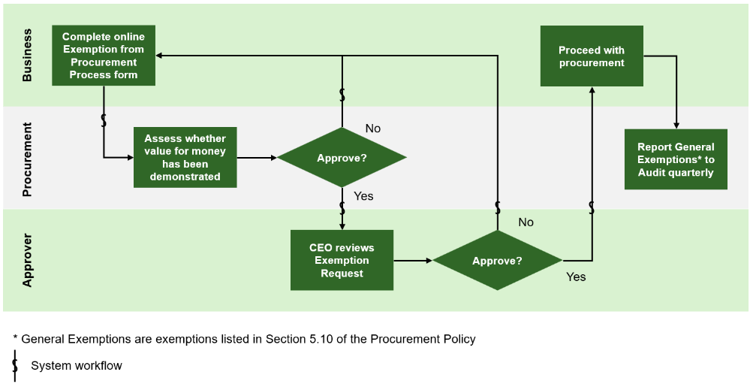
The process for review and approval of exemption requests is shown in the process map below.

The process begins with completion of the online Exemption from Procurement Process form which workflows to Procurement for review and then to the CEO for approval.
Demonstrating value for money
The Procurement Policy requires that value for money is demonstrated when seeking approval for exemptions.
- Section 5.10 (General Exemptions) of the Policy requires contract spend breaches to be reported quarterly by Procurement to the Executive Management Team and to vouch that deviations meet value for money principles
- Section 5.10 states that for emergency procurement, value for money principles still apply
- Appendix 1 states that where only one quotation is received for procurements above $10,000, and it is intended to recommend that the sole quote is accepted, the sole quote must demonstrate value for money
- Appendix 3 states that Ad hoc Exemptions must demonstrate value for money and complete a Value for Money Assessment referenced in QRG-01 Value for Money
Refer to Quick Reference Guide QRG-01, Value for Money, for guidance on how to demonstrate value for money and the assessment.

Further Information
The following sources of information can be accessed for further information.

CGD Procurement Policy

QRG-01 Value for Money

