
Organisational Development
SAMPLE PERSONAL DEVELOPMENT PLAN

This is a sample of Council’s online PDP form. It can be used to help familiarise yourself with the form before starting the online form. It can also be used to help prepare for the annual PDP discussion.
Remember there are a range of other resources available on the PDP page of The Source. Resources include a comprehensive user guide, quick start flow chart, the Core Capabilities document and other useful PDP tools.

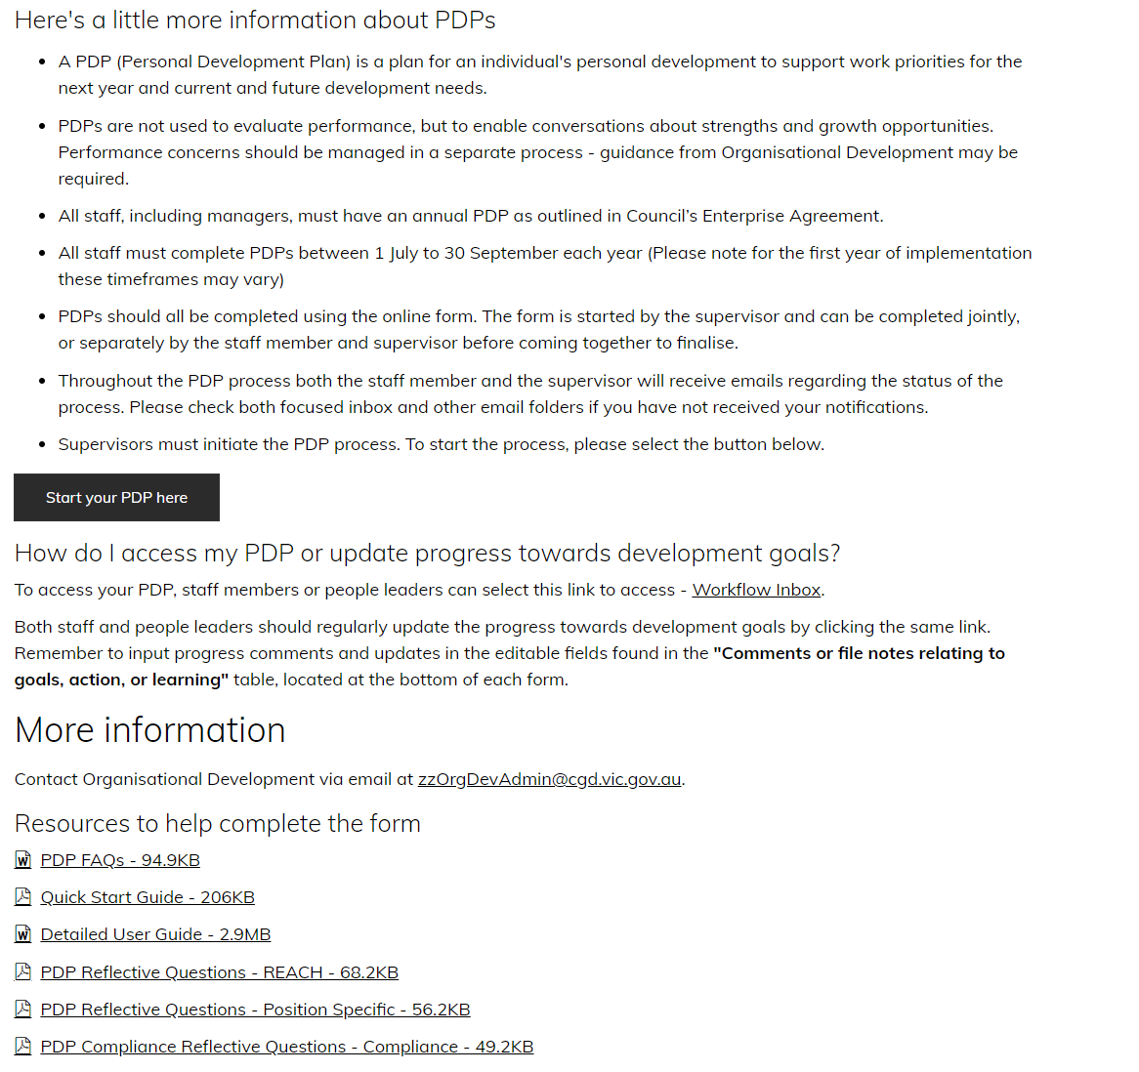
The supervisor initiates the PDP by filling out this page on the online form. The form is found on the PDP page on The Source
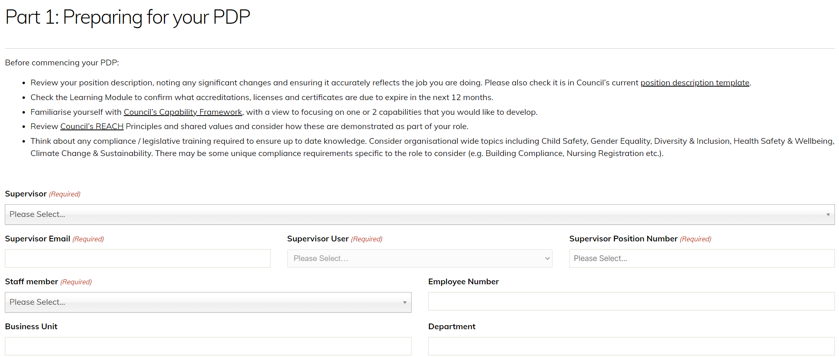
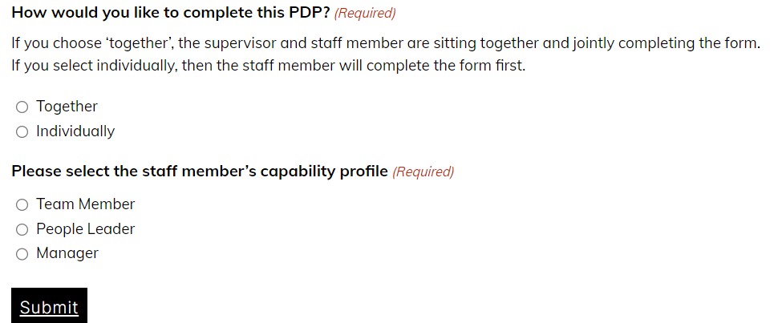
This first page is completed by the supervisor. Once submit is clicked a link to the online form will be emailed to the supervisor and staff member.
The PDP can be done together or individually. For the first time using the online form, we recommend it be done together.
Select the relevant capability profile according to the staff member’s status, i.e. team member, people leader or manager. This will auto populate the correct capability descriptors on the online form. *Reminder - the capabilities are not performance measures but are intended as discussion points and may be used as development opportunities. A development goal is not mandatory for every capability.

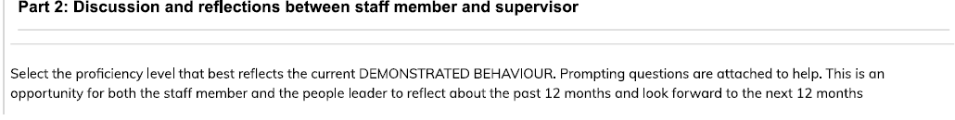
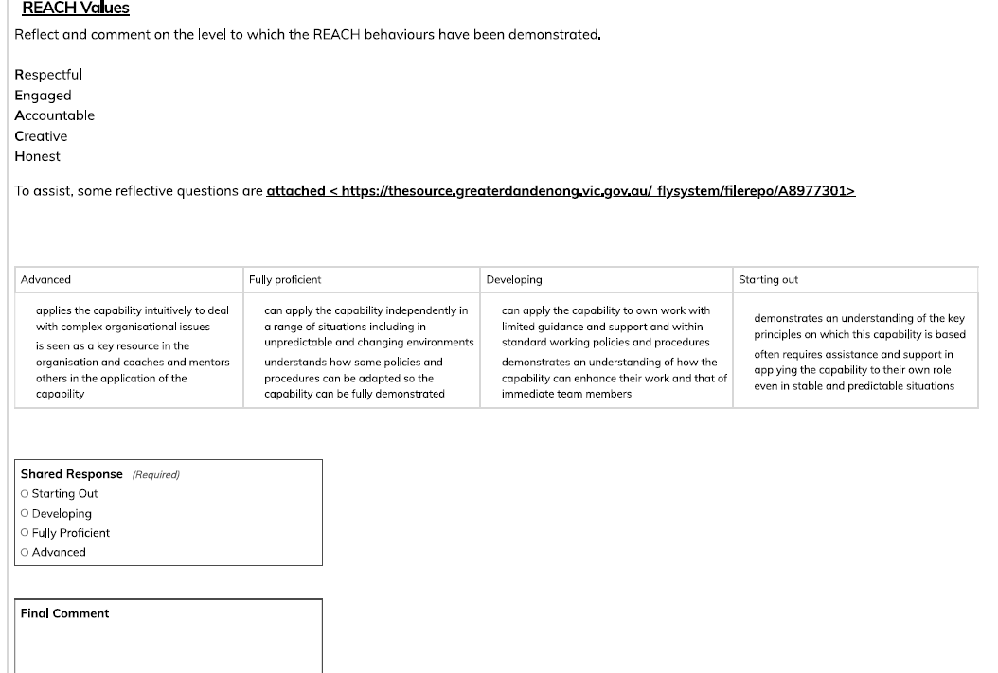

Notes and discussion points on REACH capability – Consider if this is an area you would like to future develop. If so, use the space below to make notes and add these to your development goals which are added towards the end of the process/form

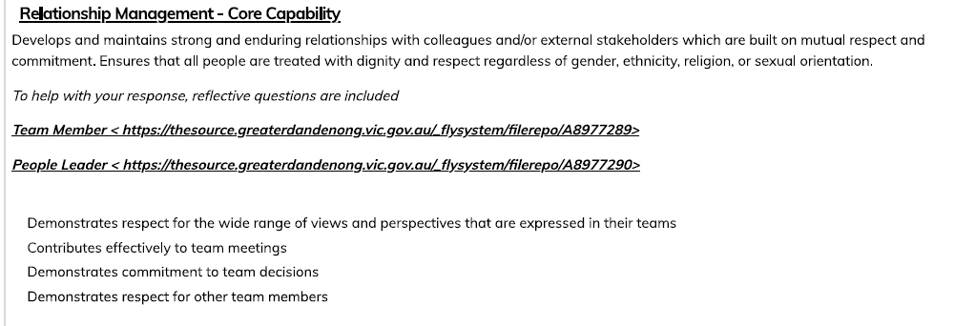

Notes and discussion points on Relationship Management capability – Consider if this is an area you would like to future develop. If so, use the space below to make notes and add these to your development goals which are added towards the end of the process/form

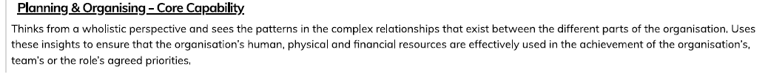

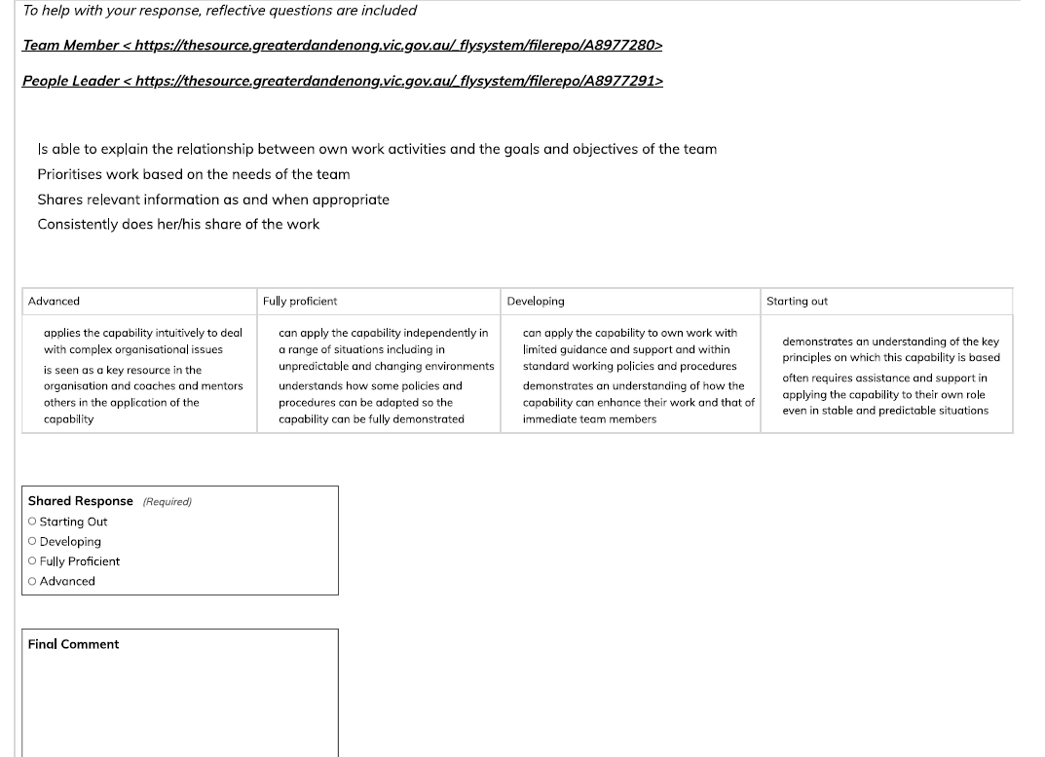

Notes and discussion points on Planning & Organising capability – Consider if this is an area you would like to future develop. If so, use the space below to make notes and add these to your development goals which are added towards the end of the process/form

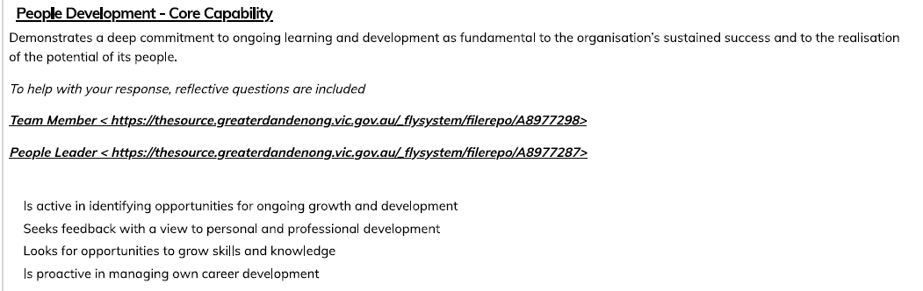

This is the section of the PDP form where future career aspirations should be discussed and noted

Notes and discussion points on People Development capability – Consider if this is an area you would like to future develop. If so, use the space below to make notes and add these to your development goals which are added towards the end of the process/form

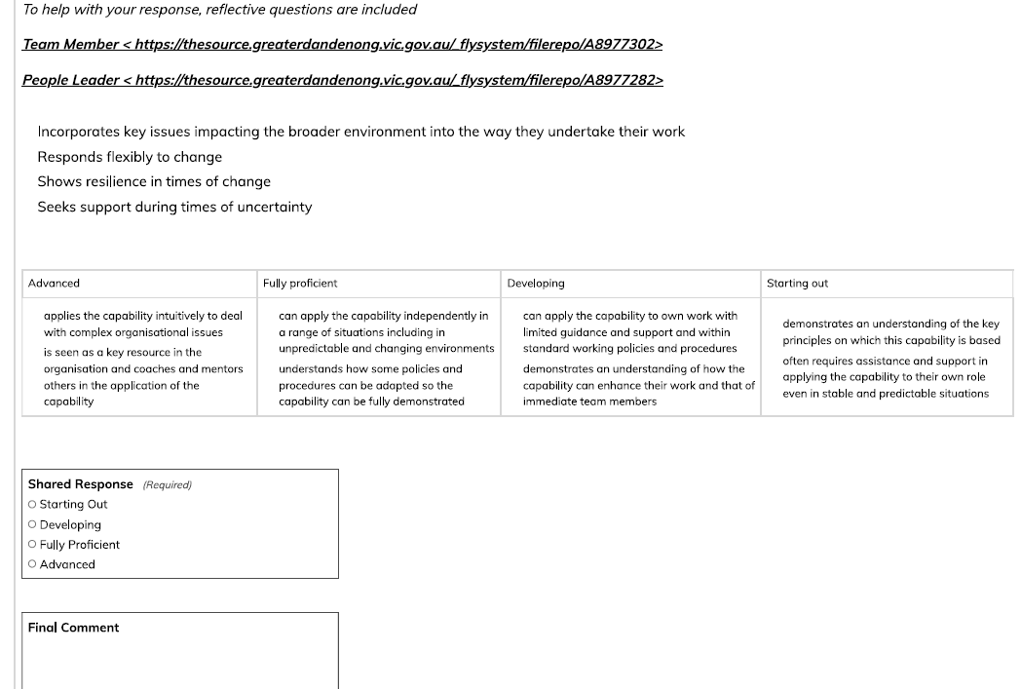

Notes and discussion points on Outcome Orientation capability – Consider if this is an area you would like to future develop. If so, use the space below to make notes and add these to your development goals which are added towards the end of the process/form

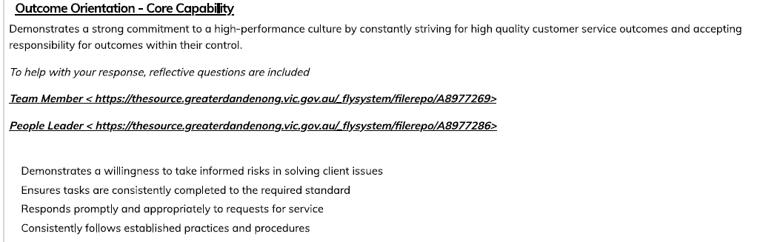

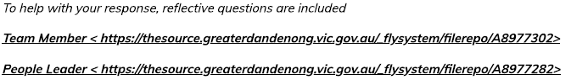
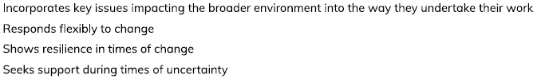

Notes and discussion points on Future Focused Orientation capability – Consider if this is an area you would like to future develop. If so, use the space below to make notes and add these to your development goals which are added towards the end of the process/form

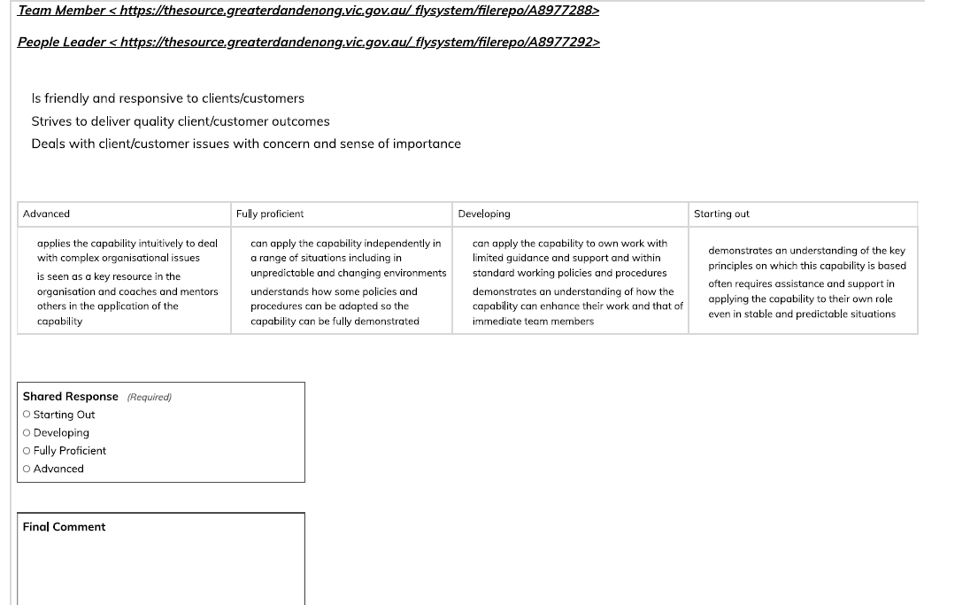
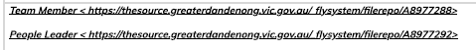

Notes and discussion points on Service Focus capability – Consider if this is an area you would like to future develop. If so, use the space below to make notes and add these to your development goals which are added towards the end of the process/form

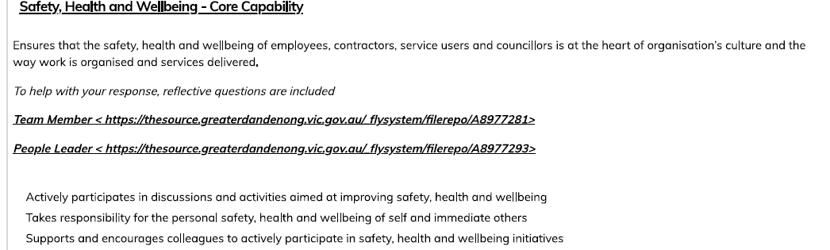

Notes and discussion points on Safety, Health and Wellbeing capability – Consider if this is an area you would like to future develop. If so, use the space below to make notes and add these to your development goals which are added towards the end of the process/form

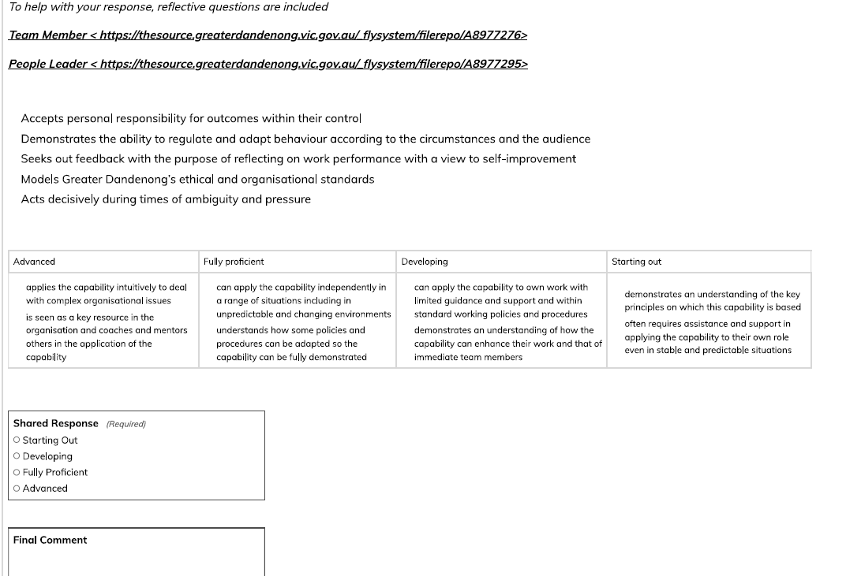

Notes and discussion points on Self Management capability – Consider if this is an area you would like to future develop. If so, use the space below to make notes and add these to your development goals which are added towards the end of the process/form

Part 3 provides an opportunity to review the Position Description each year to ensure continued relevance. The PD template was changed to better meet organisational requirements during 2022 and it is expected that every PD over time will be moved to the new template as each PDP is done.
Your position description can be found against your entry in the Source Organisation Chart.
When you respond ‘no’ to either question, a separate process will commence.
- You do not need to review the PD immediately
- By selecting ‘no’, a separate automated process is commenced
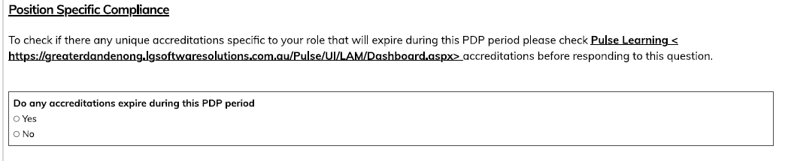

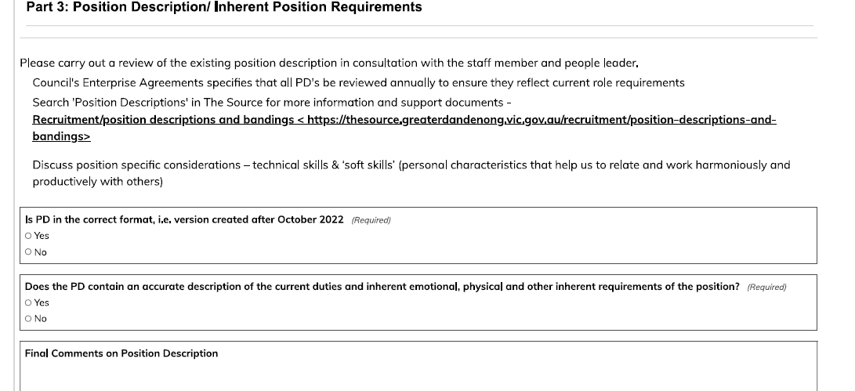
- The supervisor will receive reminder emails starting from a week prior to the nominated review date.
Discussion points re the position description. Check accreditations in PULSE and note any new/expiring accreditations that require action during the coming year here. Add them as development goals later in the form.

Discussion points re Child Safety– Consider if this is an area you would like to future develop. If so, make a note to add this to your development goals which are added towards the end of the process/form
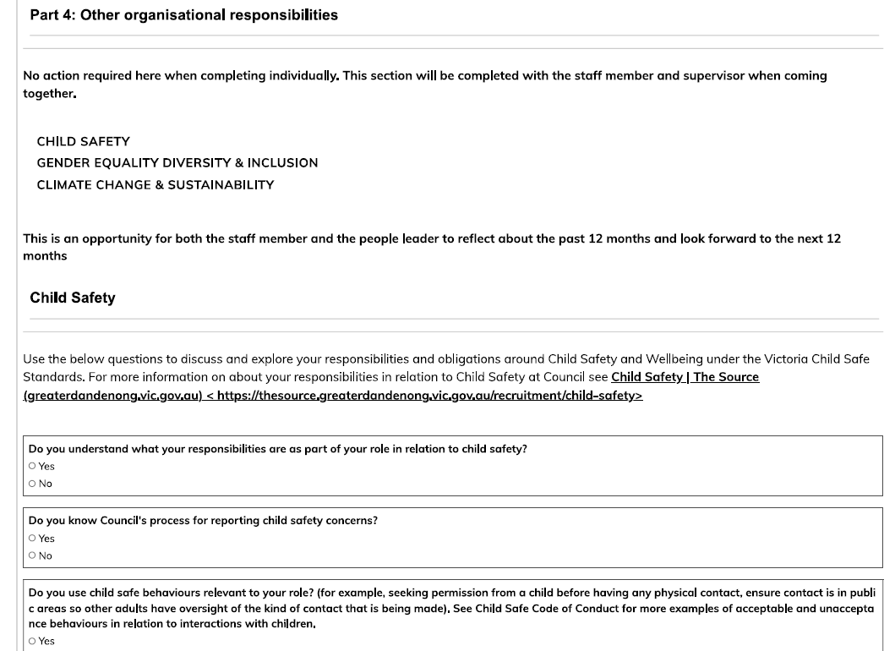
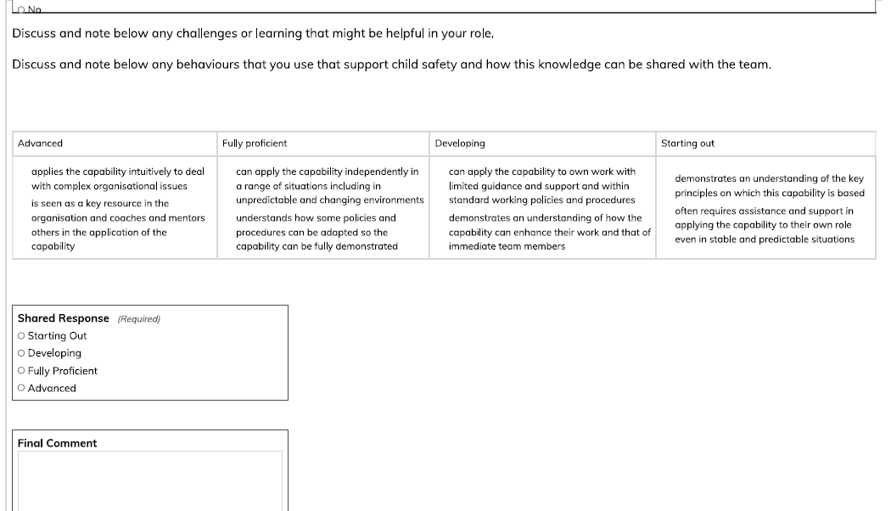

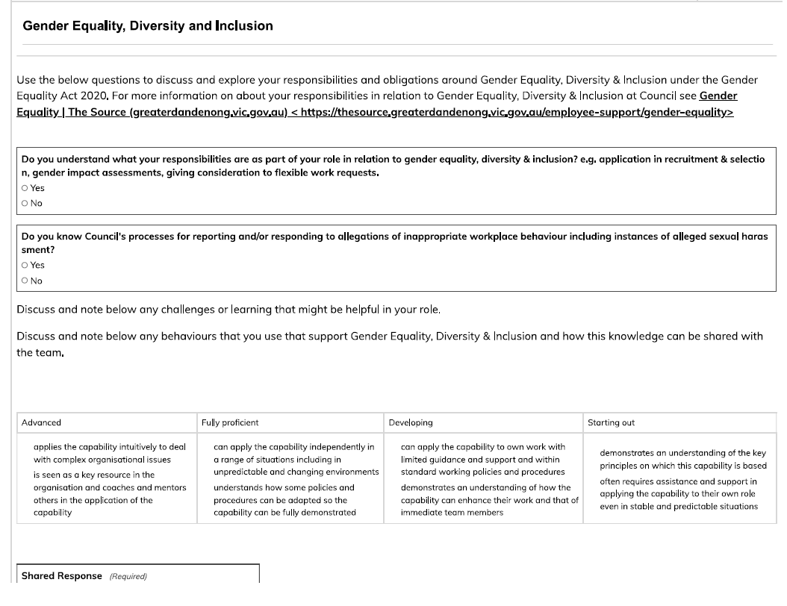
Discussion points re Gender Equality, Diversity & Inclusion– Consider if this is an area you would like to future develop. If so, make a note to add this to your development goals which are added towards the end of the process/form

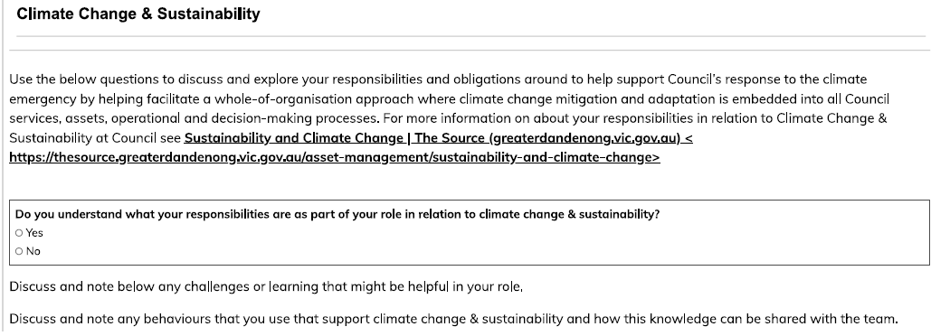

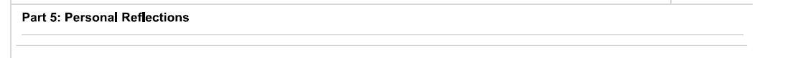

Discussion points re Climate Change & Sustainability– Consider if this is an area you would like to future develop. If so, make a note to add this to your development goals which are added towards the end of the process/form

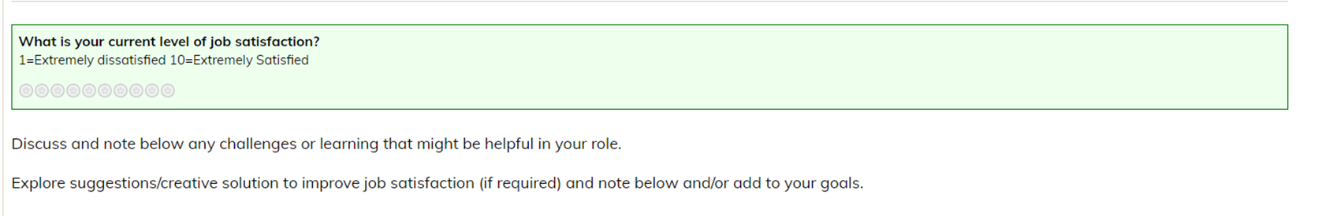
Only the staff member should comment on their job satisfaction & wellbeing. During the joint PDP meeting, then this can be discussed and options/supports agreed

Discussion points re job satisfaction – add any suggestions/creative solutions as development goals

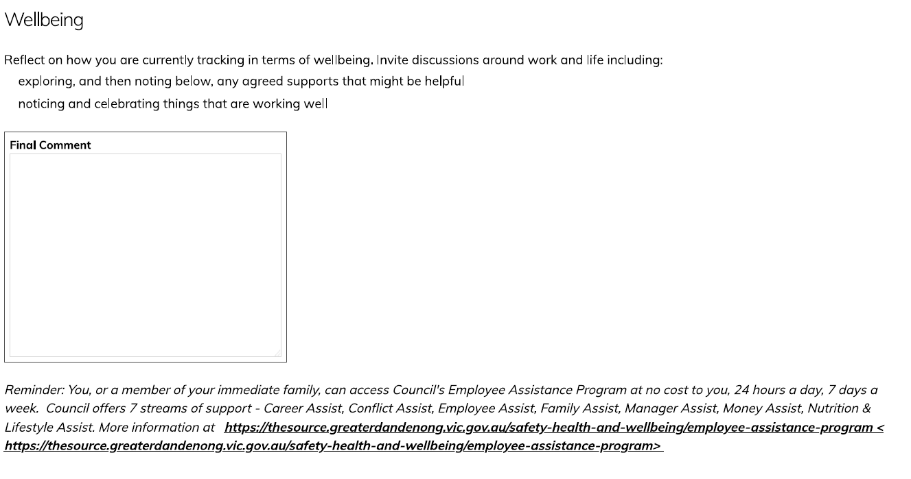

Discussion points re wellbeing

Discussion points re accomplishments
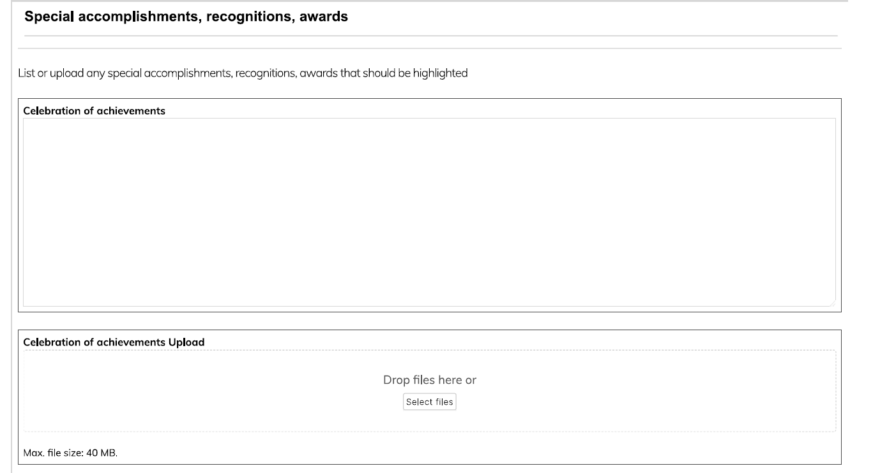


When the form is completed online, a summary of all responses will appear on this page (example below from where the form is completed jointly). The summary assists with setting goals (next step) based on priority needs

When you have reached this point, the online form will automatically display a summary of all ratings entered to this point. Now it is time to insert personal development goals/aspirations, etc for the next 12 months. Remember to also include any expiring accreditations as development goals to ensure these are captured. You may have noted these earlier in this document.
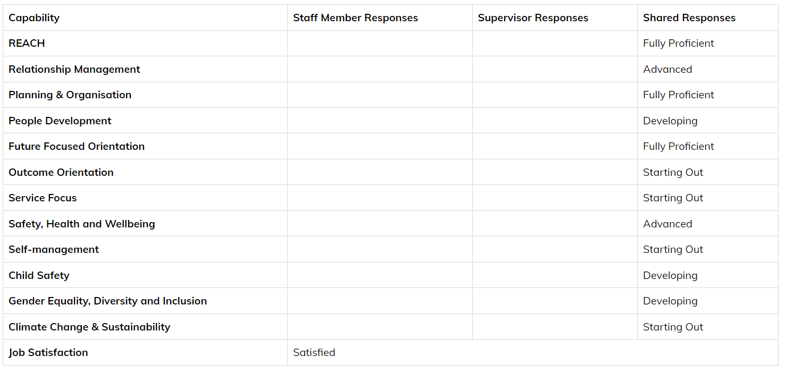

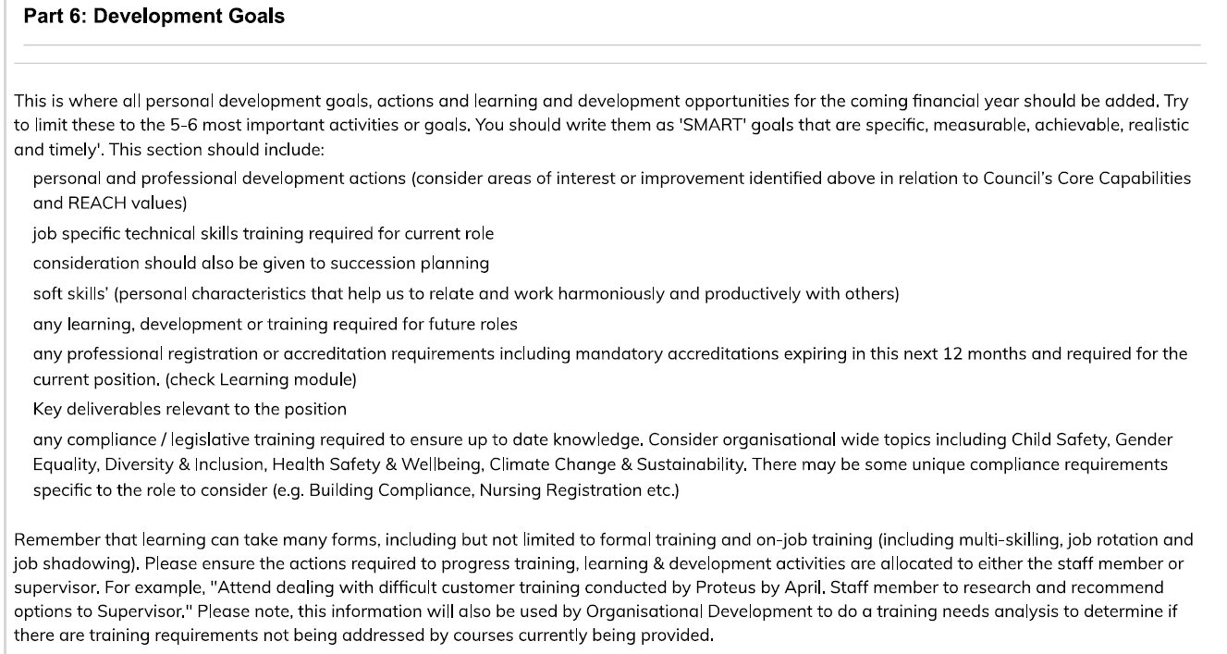

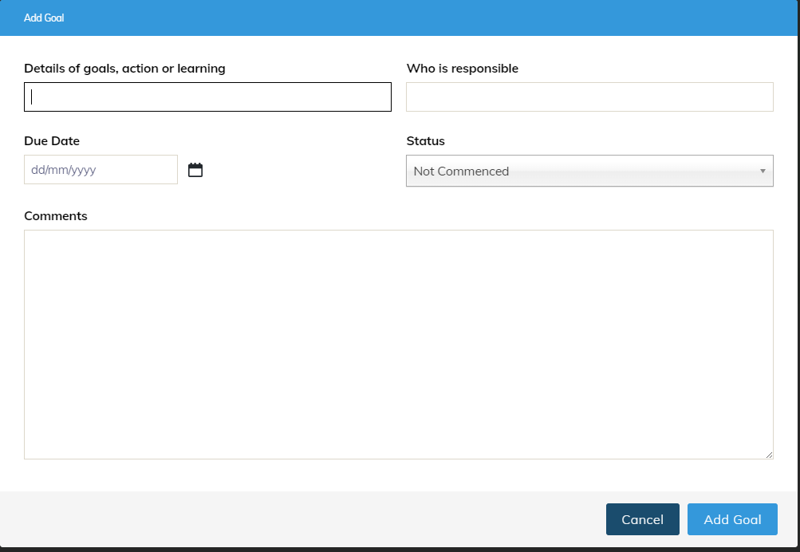
List all draft development goals here.

End of process
Each quarter, an email with a link to the PDP form will be sent to the supervisor and staff member to enable them to add comments about progress.

